End-of-Project Evaluation (EPE)
Triple-S – Water Services that Last
An IRC Initiative 2009-2014
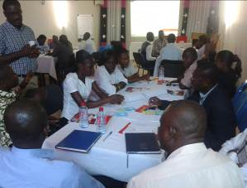 | 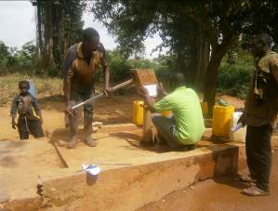
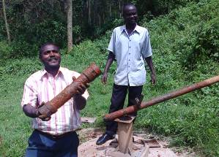 | 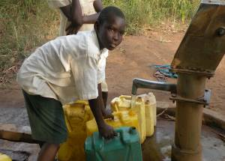
Main Report
Final version – January 2015
Title: End-of-Project Evaluation – Triple-S “Water Services that Last”
Status of the report: Final version
Client: IRC (Project Manager: Deirdre Casella)
Consultant: HYDROCONSEIL (France), Trémolet Consulting (United Kingdom)
Project number (HYDROCONSEIL): 485
Commencement of the assignment: 1 May 2014
Submission of this report: 3 February 2015 (electronically)
Revision number: 3
Contributors: Sophie Trémolet, Bruno Valfrey, Goufrane Mansour and Julie Aubriot
Quality assurance: Sophie Trémolet
If you have comments or questions please write to: hydroconseil@hydroconseil.com
Cover pictures: © HYDROCONSEIL @Triple-S
Table of Content
Executive summary 8
Context of this evaluation 8
What is Triple-S? 8
Summary evaluation 9
Key lessons and recommendations going forward 12
A. Introduction 15
A.1. EPE objectives 15
A.2. Scope for the evaluation 16
A.3. EPE methodology 17
A.4. Report structure 18
B. Design of the Triple-S initiative 19
B.1. What is Triple-S? 19
B.2. Origins of the initiative 19
B.3. What did Triple-S set out to do? 21
B.4. What did Triple-S do? 22
B.4.1. The inception phase 22
B.4.2. Key activities undertaken 23
B.5. Was the Triple-S design fit for purpose? 25
B.5.1. Did the Triple-S project fill a niche in the water sector? 25
B.5.2. Was the Triple-S theory of change appropriate and relevant? 26
B.5.3. What is the relevance of the Triple-S’ principles and building blocks for the sector? 27
B.5.4. Was it relevant to exclude sanitation from the project design? 28
B.5.5. Was the project right to focus on dispersed rural communities? 29
C. Triple-S Management 30
C.1. Overall project organization and management structure 30
C.2. Financial management 32
C.3. Management arrangements for the IWS 35
C.4. Linkages with WASHCost 35
C.5. Monitoring tools & Triple-S dashboard 35
D. Ghana Work Stream (GWS) 37
D.1. Background to the Ghana workstream 37
D.2. Evaluation of GWS design 37
D.3. Evaluation of GWS outputs 38
D.4. Evaluation of GWS project outcomes 39
D.5. Evaluation of GWS direct/broader impacts 40
D.6. GWS evaluation summary 41
D.7. Key lessons and recommendations 45
E. Uganda Work Stream 46
E.1. Background to the Uganda workstream 46
E.2. Evaluation of UWS design 46
E.2.1. Hosting agreements 46
E.2.2. Selection of districts 47
E.2.3. Choice of interventions 47
E.3. Assessment of project outputs 47
E.4. Evaluation of project outcomes 49
E.4.1. Outcome 1 – Decentralized service delivery authorities, providers and users carry out their roles and responsibilities as outlined in the sector policies and guidelines 49
E.4.2. Outcome 2 – National and decentralized service delivery authorities and providers plan, budget, monitor, finance and maintain the required levels of RWS at full scale 49
E.4.3. Outcome 3 – Transparency and accountability mechanisms are in place and used to monitor reliability of rural water services 49
E.4.4. Outcome 4 – Rural Water agencies adapt their policy and practices on the basis of evidence from the experiments 49
E.4.5. Outcome 5 – Decentralized RWS delivery is harmonized and coordinated to achieve higher effective and efficient resource use 50
E.5. Evaluation of impacts 50
E.6. Evaluation summary 51
E.7. Key lessons and recommendations 55
F. International Work Stream (IWS) 56
F.1. Design of the International Work Stream 56
F.2. Outputs 57
F.2.1. What has the IWS done? 57
F.2.2. IWS outputs are of good quality and well rated but a clear roadmap to understand the Triple-S approach is missing 58
F.2.3. The website is useful, but not a “go-to” website 60
F.2.4. Training events were well run and useful 61
F.2.5. Different means were used to influence international actors 62
F.2.6. IWS developed innovative tools to measure outcomes 62
F.3. Outcomes: what has the IWS achieved? 63
F.3.1. A significant number of DPs has adopted SDA principles 64
F.3.2. Some key DPs have changed their implementation procedures 65
F.3.3. Uptake of full lifecycle cost analysis has taken place but there is not enough evidence to ensure that these costs are covered 66
F.4. Activities in non-focus countries 66
F.4.1. Burkina Faso 67
F.4.2. Mozambique 68
F.4.3. Honduras 69
F.4.4. India 70
F.5. Summary evaluation of the IWS 71
G. Overall impact and legacy of the Triple-S initiative 72
G.1. What have been overall impacts? 72
G.1.1. Triple-S helped place Sustainability and SDA on the map 72
G.1.2. The “whole system change approach” has not yet been proven 73
G.2. What is the likely legacy of Triple-S? 74
H. Lessons and recommendations 77
H.1. Develop learning on “how” to achieve change by evaluating actual progress 77
H.2. Refine key messages for different audiences 78
H.3. Consider funding needs in project design 79
H.4. Improve communication about impact 81
I. Annexes 82
I.1. Key dates from the Triple-S project 82
I.2. Questionnaire for international consultation 84
I.3. Results from the international consultation 87
I.3.1. Respondents location 87
I.3.2. Respondents 87
I.3.3. Key survey responses 88
I.4. List of people consulted at international level 114

Acknowledgements
This evaluation was made possible thanks to the invaluable support and contribution of many people. In addition to the interviewees (at international level and country level), the authors wish to acknowledge the exceptional support given to the team on country visits (IRC country teams supported all country visits providing relevant information and facilitating the contacts with the sector authorities and stakeholders).
In particular, in Ghana, Vida Affum Duti and all the staff of the Triple-S project as well as Mr Clement Bugase at CWSA. In Uganda, we thank Jane Nabunnya Mulumba, Peter Magara, Joseph Abisa, Lydia Mirembe, Martin Watsisi and Robert Otim. Other persons provided the team with invaluable information on the non-focus countries and we wish to thank Juste Nansi, Christelle Pezon (for Burkina Faso), Stef Smits (for Honduras), Alana Potter (for Mozambique) and Kurian Baby (for India).
Evaluations can be difficult for those being evaluated and the Triple-S management team at the IRC showed a genuine willingness to learn from the exercise and share their insights. The team provided thorough support and cooperation, which made this huge task possible. A very special thanks goes to Deirdre Casella, who managed the evaluation contract, and all who had the unrewarding task of supporting the evaluation team. The evaluation team would also like to thank Patrick Moriarty, Christophe Nothomb, Ton Schouten, Stef Smits, Sarah Carriger and Harold Lockwood, Julia Boulenouar and Richard Ward from Aguaconsult, as well as many other people for supporting this evaluation and sharing their thoughts along the way. Responsibility for the imperfections in the report remains with the authors.
Abbreviations and acronyms
BMGF | Bill and Melinda Gates Foundation
DWD | Directorate for Water Development (Uganda)
EHSD | Environmental Health and Sanitation Directorate
ELF | External Learning Facilitator
EPE | End-of-Project Evaluation
GWS | Ghana Work Stream
HPMA | Hand Pump Mechanics Association (Uganda)
IAG | International Advisory Group
INGO | International Non-Governmental Organization
IRC | International Water and Sanitation Centre
IWS | International Work Stream
LLCA | Life-cycle Costs Approach
MDG | Millennium Development Goals
MTA | Mid-Term Assessment
MWE | Ministry of Water and Environment (Uganda)
NETWAS | Network for Water and Sanitation (Uganda)
NGO | Non-Governmental Organization
SDA | Service Delivery Approach
SDI | Service Delivery Indicator / Index
SNV | Netherlands Development Organisation
SWAp | Sector-Wide Approach
ToRs | Terms of Reference
TSU | Technical Support Unit
UWASNET | Uganda Water and Sanitation NGO Network
UWS | Uganda Work Stream
QDA | Qualitative Data Analysis
WASH | Water Sanitation and Hygiene
WA-WASH | West Africa WASH (financed by USAID)
WS | Work Stream

Executive summary

Context of this evaluation
The End-of-Project Evaluation (EPE) of the Triple-S (Sustainable Services at Scale) project was carried out by a team of independent consultants from May to December 2014. The objectives of the EPE were to extract and capitalise on lessons from the Triple-S staff and partner institutions. The EPE focused on five areas of enquiry:
- Evaluation of project achievements (outcomes, outputs, methods and impacts);
- Assessment of uptake and vision of Triple-S in the international arena, as well as in focus countries and non-focus countries;
- Evaluation of the project design and its efficacy in terms of implementation;
- Evaluation of project management;
- Assessment of the project legacy.
Separate analyses were conducted at the different levels where Triple-S was deployed. Two country visits to Ghana and Uganda were carried out, during which consultations were held with over 100 stakeholders in each country. In addition, an overall assessment included semi-structured interviews with 30 key stakeholders who have had various levels of involvement in the project and an online survey.
This evaluation is particularly focused on the period that followed the Mid-Term Assessment (from June to October 2012), which served as a call to action at all levels and led to refocusing the project around key activities and experiments, particularly in focus countries.

What is Triple-S?
Triple-S is a six-year multi-country learning initiative that aims to help address the challenge of rural water supply sustainability. The project was implemented by the International Water and Sanitation Centre (IRC) and funded by the Bill and Melinda Gates Foundation for a total project cost of $22,074,261. Its objective was to push for a paradigm shift towards “sustainable rural water services at scale”, i.e. a vision of a world where all people living in rural areas can easily and reliably access water that is of good quality and sufficient quantity, from a source that is reliable and easily accessible. At the heart of this change process is a shift in mission: moving away from the provision of new infrastructure towards the provision of a lasting service. The project aimed to catalyse a global change process in the rural water sector at the national level in two focus countries (Ghana and Uganda) and at the international level through its International Workstream (IWS) and activities in so-called non-focus countries, that in the end included Burkina Faso, Honduras, India, and Mozambique.

Summary evaluation
Triple-S filled a niche in the international WASH sector as it placed sustainability at the centre of its discourse and activities
When originally designed, Triple-S did fill a niche in the international WASH sector as it developed a sustained and systematic approach to promote the sustainability of rural water services, and developed the Service Delivery Approach as a means of achieving this goal.
During its inception phase, Triple-S articulated a series of concepts about how to evaluate the prospects of rural water sector to achieve sustainability (the “principles framework”) and identified the key elements of a Service Delivery Approach (SDA). To support the drive towards sustainability Triple-S developed a “whole-system change” approach, based on three main pillars: (i) promotion and articulation of a service delivery approach; (ii) harmonisation and alignment; and (iii) a learning and adaptive management style to ensure project legacy and conceptualised the way in which change is a long-term process.
Triple-S played a substantial role to place Sustainability and SDA at the heart of international discourse and practices in the WASH sector
Most agreed that Triple-S has been effective at conveying consistent messages about sustainability over several years, which has clearly helped the issue gain prominence in international discourse on water services in general. Triple-S developed a sustained and systematic approach for promoting sustainability of rural services and developed the SDA as a means of achieving this goal.
However, not all of this change in discourse and practices can be attributed to Triple-S. The project came along at the right time, as a growing part of the WASH sector community was starting to take more notice of the acute challenge of ensuring sustainability of existing investment in the sector – although most NGOs and donors did not really know how to achieve sustainability and therefore kept a strong focus on numbers and outputs rather than on service delivery indicators. This also coincided with a shift in focus within the international development community, as it is moving from an exclusive focus on providing access (as captured in the Millennium Development Goals) to one of delivering sustainable services (as captured in the Sustainable Development Goals). Triple-S was therefore successful at “riding and fuelling the wave” of sustainability, even though the precise role that Triple-S played in creating and supporting this wave is difficult to ascertain.
Triple-S’ design and Theory of Change was innovative and ambitious, but how it would fulfil all of its ambitions was not so clear
The Triple-S theory of change (ToC) was based on the whole-system change approach underlying the project and encompassed the three main pillars of the approach. Relevant but somewhat over-ambitious, the ToC assumed that demonstrating the need for change and to adopt an SDA would be sufficient to achieve improvements in service levels and user satisfaction where it was applied, i.e. what was deemed to represent “proof of concept”. However the logical link between this proof of concept and the remainder of the ToC was not clearly established. Even where it was translated into clear outcomes, particularly for the country workstreams, the ToC was found to be overly ambitious compared to what the project could realistically achieve without funding for implementation. This last point remains controversial and difficult to confirm, in the absence of a comparable program that would have similar levels of ambition and funding for implementation. Time is an important aspect of the Triple-S’ “whole-system change” approach: IRC team has repeatedly stated that 6-year was not a sufficient time frame for the project, and that full demonstration of the project approach would have required a longer period – 10 years as initially planned.
Adaptive management has been a key success factor for such a complex project
Key to the project’s success was dedicated project management willing to adapt over time. The Mid-Term Assessment (MTA) of Triple-S conducted in July 2012 prompted a significant shift in focus at all levels of the project. It was a “call to action”, as the project had spent much time analysing the existing situation but had not yet defined a clear plan about how it would bring about change.
IRC proved it had the capacity to develop an adaptive management approach that helped socially develop the concepts behind Triple-S while implementing key activities and working internally to find the best possible organisation for the project. This adaptive management, strongly supported by the Gates Foundation, was vital for the development of such a complex project which clearly stretched IRC’s implementing capacity as it stood in 2008.
Triple-S allocated about two-thirds of its resources to the “outcome based workstreams” (44% to the country workstreams and 21% to the international workstream), whilst about 20% to project management and the rest went to the support workstreams, including activities in non-focus countries. The different workstreams were highly complementary even if, in some cases, it was difficult to clearly define the boundaries and determine where responsibilities had been allocated between them. In addition, the strong link with the WASHCost project proved beneficial for both projects. Although WASHCost appears better known in certain international circles, Triple-S has been key for embedding the WASHCost concepts and approaches on the ground at country level, taking them to scale and facilitating their inclusion in national and local strategies.
Triple-S played a significant role in changing perceptions and discourse around sustainability and adopting a service delivery approach in the target countries, particularly in Ghana and to a lesser extent in Uganda
In those two countries, Triple-S articulated the concepts of sustainability and the service delivery approach in a clear manner and made them accessible to all. It also placed the spotlight on the “district” level (i.e. decentralised government level) as a key level at which to engage and provide capacity-building in order to strengthen decentralisation and coordinate stakeholders in complex systems. It further encouraged all WASH stakeholders to consider local governments as key partners for monitoring, planning and budgeting.
The project impact at ground level and its ability to prove the effectiveness of the “whole system change” approach was limited however
Whilst a change in discourse and practices clearly occurred in the two focus countries, impact on the ground was limited. In Districts where Triple-S invested substantial resources, functionality and user satisfaction either modestly improved or in some cases, it went down.
Such limited impact means that the “whole system change approach” has not yet been proven in the pilot districts. According to the Theory of Change, proving the concept in the pilot target districts would provide strong justification for rolling-out the model and scale-up into other districts. The project’s effectiveness at achieving impact and improving sustainability was mixed, however: this was not fully achieved in Ghana (i.e. no marked improvements in service levels in the target districts during the implementation period) and had mixed success in Uganda due to lack of time and limited embedding within national institutions.
In addition, the decision not to include any “investment” money in the project was risky and not necessarily beneficial to the project. Providing funding for investment in Uganda could have helped boost the functionality indicators in the 5 target districts. It is likely that the combination of no investment money and limited focus on the financing side of the SDA through project activities limited the impact that Triple-S could have had on the ground and, therefore, affected the project’s ability to “demonstrate” that issues in the rural sector could be approached in a different way. Overall, despite several years of sustained efforts in a small number of districts, and with substantial “soft” resources made available to support those districts, sustainable services still remain elusive in those districts.
The International Work Stream outputs are of good quality and generally well-rated and it has overall achieved its expected outcomes
Triple-S outputs produced at the international level were of good quality and were appreciated by sector stakeholders. Outputs available on the website are seen as useful, although there have been some complaints about its density and difficulties with identifying key documents. Training events were well-run and deemed useful by most participants. Triple-S developed a number of interesting approaches to influence other partners (through publications, blogs, the organisation of key events and mostly through personal communications) and methodological tools (such as the Qualitative Document Analysis or QDA) to assess the impact of such activities.
In terms of outcomes, a significant number of DPs have adopted SDA principles following their engagement with Triple-S, notably US-based NGOs and some major bilateral agencies such as USAID, DFAT and DGIS. Some DPs, such as key NGOs, Foundations and funders, have adapted their planning and implementation procedures. However, some key players in the sector seem untouched by Triple-S’ ideas and still focus on financing infrastructure and achieving numbers. Tracking changes in funding allocated by DPs to sustainability issues is complicated by the fact that funding is not comprehensively tracked at present, and that Triple-S has not developed a specific methodology for doing so.
One key objective of the International Workstream was to identify other countries where the Triple-S approach could be rolled out: this was only achieved at scale in Burkina Faso, whereas other countries adopted limited elements of the approach
The initial proposal to the Gates Foundation had proposed to work in 4 countries. When the project’s ambitions were scaled down to two focus countries, the intention to expand was maintained in the project design. It was clear from the start that the full Triple-S approach would not necessarily be replicated in these additional countries, referred to as “non-focus” countries. Instead, the Triple-S initiative would seek to promote the adoption of elements of the approach where appropriate. The initial strategy for the project was to invest substantial resources (about 1 million USD per year) in a country, in order to demonstrate the validity of the “whole system change approach” in a small number of districts within this country. In addition, the initial objective was to identify other countries where the Triple-S approach could be rolled out, either on the same overall model or through elements of the approach.
The approach was rolled out in its most extensive form in Burkina Faso, with funding from USAID as part of the WA-WASH programme. In other countries, Triple-S has had various levels of success with replicating its approach. Activities in other “non-focus” countries were limited and took place mostly through small to medium consultancies (as in India or Mozambique), which did not amount to a comprehensive sector programme. In addition, some limited elements of the approach were also extended to Liberia, Kenya or Timor Leste through third-party funding. The extension of Triple-S and what is meant by the broader “Triple-S” initiative has not been made very explicit to external audience: most respondents to the international consultation were most familiar with Triple-S activities at international level but many did not know of Triple-S’ involvement in Liberia, India or Kenya.
Although sustainability is now clearly on the map, the “how-to” deliver sustainability of rural water services, the SDA approach and the whole-system approach required to deliver it still need to be proven and be better articulated
- At national level, emphasis has been placed on scaling-up as a way of ensuring legacy by enabling the Triple-S approach to be replicated in additional districts. The Ghana Triple-S project has been very successful at identifying new funding or partners to scale up the approach to up to 131 DAs, out of a total of 216 DAs in the country. They also sought to embed their approach in sector institutions through capacity-building and also by supporting the adoption of consolidated sector documents. The sustainability of some of the initiatives, particularly with respect to learning in Ghana, may be at risk however.
- At international level, project ambassadors have been tasked with advocating the service delivery approach going forward. This approach is unlikely to ensure legacy, however, except in very specific cases where the ambassadors have been very closely involved with Triple-S. Given the lack of clear outputs produced at the international level that concisely set out the accumulated learning from Triple-S, coupled with the lack of familiarity with the Triple-S concepts and the lack of clarity of their mandate, the use of these ambassadors to ensure legacy may not be as effective as initially hoped.
- Legacy could also be ensured by IRC itself, which has operated as a backbone organisation for both Triple-S and WASHCost, supporting the change process by socially developing a concept, testing and validating it and subsequently supporting its scale-up. However, working as a backbone organisation to support change requires specific skills and experience, as well as funding and it is very unlikely that IRC will obtain the high level of funding that it had obtained from the Bill and Melinda Gates Foundation going forward. In the absence of such funding, IRC would therefore need to rethink what can be done to promote the service delivery approach. At this stage, in order to help with fostering legacy, it would be useful to collate all lessons learned during the life of the Triple-S project on “how to” promote services over infrastructure into a succinct and practical format that could be easily referred to.

Key lessons and recommendations going forward
Simplifying and prioritising the messages around the Triple-S analysis frameworks and building blocks should be a key area for IRC to work on going forward in order to ensure legacy. The approach articulated by the project is useful but not easily graspable for people looking to implement projects on the ground. Although the principles framework proved to be an effective evaluation tool that successfully helped identify the focus countries in which Triple-S was implemented, it is nonetheless fairly cumbersome to apply. Stakeholders also failed to take full ownership of the 10 building blocks framework. This was the case in the focus countries, where people outside the immediate circle of project implementers were unfamiliar with the building blocks concept.
Triple S should develop learning on “how” to achieve change by evaluating actual progress in countries. Once stakeholders have been made aware of how to achieve sustainability and have decided to move to a service delivery approach, the next key challenge is to work with all sector stakeholders to identify how this can be achieved and this in such a way as to ensure it reflects local priorities. As resources were limited, each of the Triple-S country programmes had to focus on a relatively compact set of experiments and studies, meaning that none of the country work streams were able to work on all the aspects of the service delivery approach in the target districts.
It is difficult to draw clear conclusions on “what works” and “what does not work” to promote change towards sustainable water supply services in rural areas. At country level, it is recommended to reapply the Principles Framework as an analysis grid to evaluate how the rural water sector has evolved over the project implementation period and help lay the foundations for a learning agenda and define areas of priority intervention for the sector as a whole. This would be a good opportunity to “go full circle” on project learning and sector analysis. Failing that, there is a risk that all the valuable analytical work conducted upstream on the project would not be put to best use and thus be quickly forgotten.
Triple S should refine its key messages to address the expectations of different audiences. The project, by emphasising complexity, does not lend itself to simple messages. However, key messages from the project (and especially the “whole system change approach”) need to be carefully crafted to address the expectations of different audiences. It is now time to draw lessons from the Triple-S implementation at country-level and to show how interventions in the different segments of the approach should ideally be prioritised and sequenced. This could be produced as a very practical “how-to” guide for local governments. In addition, some of the building blocks, such as supporting the professional development of community management or the recognition and promotion of alternative service providers, have received comparatively less attention. Clear guidance on support to service providers is critical in order to provide them with direct support, not only for planning and budgeting, but also to help them set appropriate tariffs that cover the necessary costs and involve consumers in the decision-making process to promote accountability.
Triple S should consider funding needs in project design. One key element that the project has been lacking to boost its ability to deliver real impact is funding for actually implementing change. Triple-S has been effective at “raising awareness” and getting people to understand that a change in approach is needed to achieve sustainability. Several activities under the project have led to the development of tools to monitor progress, to budget and plan. However, without corresponding funding, these budgets have remained without finance and improvements could not be delivered.
Lack of funding is also frequently cited as a key constraint to sustaining the approach to learning promoted by the Triple-S project, which is based on fostering the development of learning alliances at national, regional and local levels. Although, over the long-term, identifying and promoting sustainable financial mechanisms (as Water for People did in 6 countries) would be most beneficial to the sector as a whole as it would provide a strong basis for sector self-financing, this is obviously difficult. Other solutions could include developing partnerships with other entities that are able to give or lend money, but are not prepared to enter into a long-term technical assistance contract with the government. Linkages with development banks (such as the World Bank, French Agency for Development, African Development Bank) are needed for this second approach, with these development banks providing investment funding and aspects of the Triple-S approach being simultaneously introduced. Although the last two approaches have been adopted by the project on an ad-hoc basis to increase the chances of post-project sustainability and scale-up, it would be useful to clearly consider the pros and cons of each of these financing models and to determine the implications for the autonomy and flexible learning principles that underline the Triple-S approach. Based on this analysis, IRC should clearly define a partnering and funding strategy for its activities and provide advice to entities seeking to apply the Triple-S approach.
Triple S should improve communication about the actual impact. One area that IRC needs to seriously consider is how it communicates externally on the Triple-S project impacts and, more generally, on the impact of activities undertaken using the Triple-S approach. Some of the tools could be refined, simplified and promoted. IRC should also present more realistic results in its corporate communication and be upfront about the challenges (and rewards) of implementing a whole system change approach to achieve SDA. IRC could be more assertive in terms of measuring the scale and impact of what they have achieved, in communicating this impact and not focusing only on the pilot districts. This would require strong M&E and mean creating a coalition at national level to track funding and results. Finally, going forward, IRC may consider adopting more of a “platform” approach to setting up websites on specific issues that it wants to promote. This would enable them to collate experiences, lessons learned and documentation from a much broader range of stakeholders working on similar subjects. Not only would this highlight that IRC is not alone in working on these areas, but it would also enable IRC to harness its convening power to create a forum through which to share and exchange lessons and that serves as a first point of call for water sector practitioners.
Even though sanitation was not included in the project scope, the Triple-S approach could be applied to sanitation (with modifications) in order to maximise impact. Triple-S could have included sanitation in the project design from the outset but this was not done for a number of reasons, including the fact that many of the initial promoters of the project had more of a rural water background. The inclusion of sanitation in the final year of project implementation is a welcome development, but comes too late to influence what Triple-S has been able to learn during its initial implementation period.
IRC should also broaden its conception of rural water services so as to apply the SDA not exclusively to dispersed rural communities receiving water from boreholes fitted with hand pumps, but also small towns served via small piped networks. The project did very limited work on the “small towns” segment of the rural water supply sector (small piped networks, private operators) despite the fact that the future of water supply services in rural areas (including in terms of sustainability) clearly appears to lie in expanding the number of small piped networks. This is an area that requires further attention as it will become an increasingly pressing issue in rural areas that are experiencing rapid urban development and where service level expectations are rising.

Introduction
In April 2014, the IRC commissioned Hydroconseil and Trémolet Consulting to conduct an End-of-Project Evaluation (EPE) of the Triple-S (Sustainable Services at Scale) project, implemented by IRC from 2008 to 2014. The objectives of the EPE are to extract and capitalise on lessons from the Triple-S staff and partner institutions. The EPE was conducted before the project had formally ended for two reasons:
- To extract and capitalise on lessons from the Triple-S staff as they were still formally involved in project implementation;
- To provide an opportunity to influence end-of-project activities and ongoing IRC activities building on the lessons from the Triple-S project.
The present report summarises findings from the overall evaluation of the Triple-S project, drawing on the evaluation of activities in the two focus countries (Ghana and Uganda), as well as of activities undertaken at the international level and in “non-focus” countries where elements of the Triple-S approach were also applied, such as in Burkina Faso, Honduras, India, Mozambique, Kenya, Liberia or Timor Leste. Activities in the two main focus countries (Ghana and Uganda) are evaluated in more detail in separate reports.

EPE objectives
The EPE covers all aspects of the Triple-S project, at the international level and at country level. The overall objectives of the EPE are to evaluate project achievements, its efficiency and effectiveness in the following areas:
- Evaluation of project achievements (outcomes, outputs, methods and impacts): what has been achieved in focus countries and in the international arena? How has the project performed against the agreed indicators? Were there any unexpected outcomes? What can explain these changes in the project implementation pathway?
- Assessment of uptake and vision of Triple-S in the international arena as well as in focus countries (Uganda and Ghana) and non-focus countries (Burkina Faso, Honduras, Mozambique, India): have rural water sector actors taken up SDA nationally and internationally? What examples of change exist resulting from the uptake of SDA in Ghana, Uganda and the international arena, especially in non-focus countries? Is there evidence of buy-in to the Triple-S approach?
- Evaluation of project design and its efficacy in terms of implementation: how efficient was the Triple-S project design in terms of budget, staffing, country selection, hosting and institutional arrangements, project management arrangements, etc. Were there any major changes along project implementation pathway? What lessons can be drawn from these changes?
- Evaluation of project management: has the project delivered on time and on budget? How have the MTA recommendations been taken into account by Triple-S management? How were the Workstreams coordinated? Was this coordination smooth and efficient? How efficient was the project governance (role of External Learning Facilitators, service delivery champions, ambassadors, International Advisory Group, etc.)? A specific reflection on the Triple-S IWS and its relevance and efficacy will also be considered under that section.
- Assessment of the project legacy: what lasting outcomes have been realised through the “whole system change” approach? How the Triple-S legacy was organised and promoted? Are there any further opportunities of development for SDA?
For the purpose of the EPE, efficiency and effectiveness were defined as follows:
- Efficiency is the extent to which time, effort or budget has been well used to achieve the intended task or purpose. In particular, we focused on measuring the efficiency of the project at achieving the process outcomes as planned, based on indicators extracted from the Mid-Term assessment inputs into the 3 and 6 year check-in;
- Effectiveness (sometimes referred to as efficacy) is the ability of the programme to deliver a certain effect.
The findings of the EPE provided the basis for formulating recommendations for IRC, partners and funding organisations that can be used to strengthen the sustainability of rural water services and the approach to whole system change in the rural water sector (and beyond such as in urban water or rural sanitation).

Scope for the evaluation
Even though this evaluation is for the project as a whole since inception (2008), it is mostly focused on the period that followed the project’s Mid Term Assessment (MTA) and the replanning that followed for the period 2012-2014.
The MTA acted very much as a “call-to-action”, urging the Triple-S project implementers to stop analysing too much and to start acting. Such message was taken on board very seriously by the project implementers and proved “life-saving” for the project. Whereas the project in its initial years had conducted very good research and analysis, it had struggled to find a sense of direction and to clearly articulate how it would deliver its ambitious aspired goals.
The project replanning that immediately followed the MTA resulted in a radical re-think of the way in which the project was going to be managed, deliver against its objectives and measure its own success. Key changes that took place following the MTA were as follows:
- An explicit Theory of Change (ToC) was developed for the project (published in January 2013) and published so as to more clearly articulate the project’s objectives and approach to an external audience. This ToC defined the “proof of concept” in country as achieving an “increase in functionality of water systems in pilot districts” and “increased satisfaction of users with water services in pilot districts”. This was seen as an essential element that would then provide the basis for replication of the approach, through governments adopting an SDA based on what has been proven to work. These indicators were also reflected in corresponding results frameworks in the target countries.
- The project adopted a narrower set of indicators, with specific targets for each. This reflected an increased emphasis on achieving specific outcomes and proving the validity of the “whole system change” approach that was being adopted in order to transform rural water service delivery, away from an excessive focus on new infrastructure towards a Service Delivery Approach to guarantee sustainable services.
- In focus countries, Triple-S adopted an approach based on key experiments. The need to prioritise resources meant that it was not possible to run experiments in all of the 10 building block areas simultaneously. However, this resulted in a slightly unbalanced focus on certain elements of the building blocks approach and an over-emphasis on experiments.
- The underlying approach was seeking to influence a “whole system change” at different levels of government, through the promotion of a culture of learning and experimentation. The selected experiments were developed to allow this kind of culture to blossom in specific areas. However, particular emphasis was placed on developing monitoring systems in both focus countries, perhaps at the expense of some areas that would have warranted probably as much attention in order to deliver results (such as regulation or experiments around the introduction of innovative financing mechanisms). This meant that the experiments could usefully identify where the gaps were and what needed to be done but could not ensure that funding would be available to implement remedial measures or more long-term measures needed to improve the situation over the longer term.
Following the project re-design, new tools were introduced to measure and track performance. These were reflected in the so-called “Triple-S dashboard”, which is openly available to all on the Internet. In making all key management information freely available to all, the project was true to its commitment to transparency and provided a basis for benchmarking project performance. However, as discussed in Section H which draws out lessons and recommendations from the EPE, this has implications for the way in which IRC presents and communicates around the results it has achieved in-country.

EPE methodology
The present report is based on the methodology outlined in the Inception Report for the EPE, which was approved by IRC in July 2014. Because of the complex nature of Triple-S conducting the evaluation implied dealing with diverse audiences, sources and types of information including a broad range of project documentation, secondary data from the countries of intervention, feedback from practitioners, as well as opinions and views of programmes designers and implementers. The main tools mobilised for this EPE are as follows:
- Documentation review and use of secondary data;
- Country visits to Ghana and Uganda, which have included consultations with over 100 stakeholders in each country;
- Semi-structured interviews with 20 key stakeholders who have had various levels of engagement with the project over the years;
- Semi-structured interviews with Triple-S staff and management;
- Online survey targeted at individuals who have been involved with Triple-S at the international level as well as in focus and non-focus countries. We collected 16 responses to the online survey, which is equivalent to a response rate of approximately 20%.
These evaluation tools aimed at covering in a satisfactory manner the large geographic scope of this end-of project evaluation (international arena, focus and non-focus countries) and its wide audience (Table 1).
Table 1: Evaluation tools to be used during execution phase according to targeted audiences
Evaluation tool | Triple S management, staff and IRC | Partners in focus countries | Partners in non-focus countries | Development Partners (DPs) / International arena
Country visits | X | X
Semi-structured interviews | X | X | X | X
Online survey |  | X | X | X
The evaluation team was not able to collect primary data on Triple S performance against its outcomes and impact indicators due to time and resources constraints. However the team relied on secondary data where these exist, including through the Triple-S website, internal reports and publications. One potential issue with the EPE as it was undertaken is that it mostly targeted people who had a fairly high degree of familiarity with the project – it would have been very difficult to do it otherwise, as well as it is not easy to say if this sample of people is representative of the whole WASH sector community. Although it would have been very interesting to assess the familiarity with Triple-S over a representative sample of the WASH sector community, the EPE team did not have the resources at its disposal to do that – and it may not have been conclusive from an evaluation perspective, as IRC always tried to promote Triple-S’ ideas rather than the project (or the ‘brand’) itself.

Report structure
This report is structured as follows:
- Section B provides general background on the Triple-S project and presents our evaluation of Triple-S design;
- Section C evaluates Triple-S management, both in terms of human and financial resources dedicated to the project over the 6 years it was active;
- Section D summarises the main findings of the evaluation of the Ghana Work Stream;
- Section E summarises the main findings of the evaluation of the Uganda Work Stream;
- Section F evaluates the International Work Stream;
- Section G brings together all streams from the evaluation and assesses Triple-S broader impact and likely legacy and country level as well as at international level;
- Section H draws out the lessons from the EPE and provides recommendations for future initiatives to be undertaken by IRC or other actors seeking to influence the delivery of sustainable water and sanitation services at scale.
In addition, Annexes are presented in Section I:
- Annex I.1 presents an overview of the results from the international consultation;
- Annex I.2 contains the list of people interviewed for this EPE at the international level.
Two separate reports contain the full evaluation of the Ghana and of the Uganda workstreams (sections D and E are only summaries of these two separate reports).

Design of the Triple-S initiative
This section provides an overview of the Triple-S initiative, i.e. how it emerged, what its objectives were when it was first initiated and presents the main activities carried out. This provides the basis for evaluating whether Triple-S initial design was fit-for-purpose and whether it was sufficiently flexible to adapt to ongoing changes in the WASH sector.

What is Triple-S?
Triple-S is a six-year multi-country learning initiative that aims at contributing to addressing the challenge of sustainability of rural water supply. In December 2008, the Bill and Melinda Gates Foundation awarded a $22,074,261 grant to IRC to conduct the Triple-S project over a six-year period running up to 30 November 2014.
Triple-S supports a vision of “sustainable rural water services at scale”; in other words, a vision of a world where all rural people can easily and reliably access water that is of good quality and sufficient quantity, from a source that is reliable and easily accessible. Triple-S seeks to contribute to this vision by catalysing a “whole system change” in the sector.
At the heart of this change process is a shift in mission: away from the provision of new infra-structure and towards the provision of service. The service delivery approach championed by IRC through the Triple-S project focuses on long-term provision of water services at scale, as opposed to the implementation of one-off projects at the community level. Sustainable water services require on-going support for service providers and governments in charge of planning and sector coordination as well as a radical shift in the way the main stakeholders, and specifically external aid agencies, operate in the rural water supply sector.
The Triple-S initiative sought to provoke these major changes at several levels. The initial Bill and Melinda Gates Foundation grant (which we refer to here as the “Triple-S project”) funded activities on a large scale in two focus countries (Ghana and Uganda) and at the international level, through its International Work Stream (IWS). IWS activities were themselves divided between project management, sector-level activities and activities in the non-focus countries (such as in Burkina Faso, Honduras or India) with other sources of funding. All these activities taken together are referred to as the “Triple-S initiative” in the present report.

Origins of the initiative
The concept for Triple-S started to emerge in the minds of Ton Schouten (IRC), Patrick Moriarty (IRC) and Harold Lockwood (Aguaconsult) in 2004/2005. Throughout their careers, they had all been confronted to the difficulties of ensuring sustainability of interventions for improving water services in rural areas, as demonstrated by low levels of functionality of rural water supply systems. All three had been involved in the activities of the Thematic Group for Scaling Up Community Management of Rural Water Supply, which had provided them the basis for starting to develop an analytical framework to understand weaknesses in rural water service delivery and ways to address those.
In 2007, IRC presented two concept notes to the Bill and Melinda Gates Foundation, one for the project that would later be known as WASHCost and another for the future Triple-S, an action-research for better understanding the requirement of sustainable water services in rural areas. Triple-S was originally conceived as a bold, long-term initiative to radically improve the sustainability of rural water services through a 10-year transformational process. At the heart of the initiative lied the concept that rural water services are inherently “complex systems”, with many moving parts and a very large number of stakeholders to be influenced, from the local level on the ground to the international arena. As a result, IRC initially asked the Bill and Melinda Gates Foundation to support them for a 10-year project in four countries with a USD 40 million budget, in order to deliver a “whole-system change” at different levels of intervention (at local/national/international levels).
The Gates Foundation was then at a stage when it was formulating its strategy in the water and sanitation sector, having done a number of “landscaping studies” to better understand the state of the sector. These studies had identified that only limited information was available on the costs of delivering sustainable WSS services. Although the Gates Foundation understood the importance of sustainability, WASHCost was seen as “more concrete” and better aligned with its emerging priorities. As a result, WASHCost was granted funding first, while IRC was asked to clarify the Triple-S programme and make linkages with WASHCost.
Box 1: Triple S' companion project: WASHCost
WASHCost was a five-year programme implemented by IRC from January 2008 to May 2013. The main purpose of WASHCost was to achieve measurable improvements in WASH service delivery by improving access and generate accurate knowledge on disaggregated costs of wash services; and by embedding this information into improved decision-making processes in lead organisations in the WASH sector at intermediate, national and international levels. The project received a USD 14.5 million grant from the Bill and Melinda Gates Foundation.
To achieve this purpose, WASHCost had proposed the following main tasks in its initial design:
- Collect and collate information relating to the real disaggregated costs in the life cycle of WASH delivery services to poor people in rural and periurban areas;
- Establish a range of statistical and modelling techniques using factors that influence these costs and identify the cost drivers, so as to enable a comparison among four countries;
- Develop a benchmark criteria for the same areas, which is applicable globally ñ an international database;
- Establish a learning strategy including the development of CoPs at country level, and embed improved pro-poor decision-making processes in lead WASH organisations;
- Develop a free, easy to use web-based ICT interactive tool for sharing and the continuous upgrading of WASH unit cost information worldwide; creating a decision support system that may be embedded into governance systems;
- Map and monitor changes in planning and decision-making processes mainly at country level; and
- Set up a Challenge Fund to support initiatives that update, replicate and scale up the development of good quality data and knowledge to other areas.
The project aimed to inform and influence decisions in four focus countries (Ghana, Burkina Faso, India (Andhra Pradesh) and Mozambique) and at the international level. According to the EPE for the WASHCost project, the project made excellent progress especially in articulating the Life-Cycle Cost Approach (LCCA), spelling out its implications and linking it to the Service Delivery Approach (SDA) (i.e. as articulated by the Triple-S project). The project successfully developed an approach to assess costs and applied it in the focus countries and at least eight other countries. It developed an on-line and off-line training facility that trained more than 1000 people from 91 countries in LCCA and SDA. It established a dialogue with over 70 countries / governments in at least 20 countries and 34 organisations with global outreach. The WASHCost project had a significant impact in terms of getting the international community to adopt the life-cycle-costing terminology that lies at its heart.
Source: WASHCost End-of-Project evaluation, Cross, Frade, & Trémolet, 2013

Following extensive conversation with the Bill and Melinda Gates Foundation, IRC’s proposal specifically put emphasis on better understanding the different service delivery models that could help sustain water services. The Gates Foundation eventually allocated a $24,074,261 grant to IRC for implementing the Sustainable Service at Scale project (SSS, branded as Triple-S. Of this grant amount, $22,074,261 was to be used to develop replicable, country-specific models for sustainable rural WASH services while catalyzing the changes in sector behaviour necessary for models to be applied at national and international levels and the remainder was allocated to IRC directly to strengthen their systems and enable them to manage these two large grants. The projects’ ambitions had to be scaled down, as the Bill and Melinda Gates Foundation was not able to provide a grant for as long as 10 years. The resulting grant was provided for a six-year period in two countries and the onus was shifted onto IRC to identify funding for working in two more countries.

What did Triple-S set out to do?
Triple-S defines itself as an agent of change in the rural water sector. When the Triple-S project first started, it was guided by the vision of sustainable rural water services at scale, which implied that:
- Water supply systems provide a certain level of service, understood to include well-defined characteristics of the service (e.g. water quality, quantity, continuity and accessibility). Service levels vary from a context to another but a service approach implies that users and service providers know these service level characteristics and that services are provided on this basis;
- Water services are sustainable, with sustainability being defined as the indefinite provision of a water service. This is applied at scale, i.e. spread out over large geographical areas and institutionalised.
The initiative set to work towards this vision and to act as a catalyst for the systemic changes required for the vision to materialise. One key activity was for Triple-S to flesh out all aspects of a Service Delivery Approach (SDA), including setting principles and parameters for sustainable services, showcasing and experimenting good practices in a number of countries and advocating the concept of sustainable services at all levels, from service providers to the international community.
Triple-S set to provide robust evidence for its approach and embedded monitoring and learning at the heart of its implementation. As set out in Learning and Practices (2011), Triple-S articulated its learning objectives around two main “narratives”, as follows:
- “Narrative one” consists of telling the story of the rural water sector and changes incurred by it, by observing progress is being made towards sustainable service delivery; and
- “Narrative two” consists of telling the story of the project itself as an agent of change, through an ongoing reflection about Triple-S methods and whether and how they can enable a change towards sustainable services.
Although the language around the two narratives was not used in external communication about the project, these two areas of learning (through experimentation) remained at the heart of the project design and approach throughout the project’s life. IRC management now refers to these two aspects as follows in its external communication about Triple-S:
- The “What”: this relates to “what” the rural water sector needs to do in order to switch away from an almost exclusive focus on new investments (putting pipes in the ground to increase coverage) to one that is focused on sustainable services at scale. Triple-S sought to articulate what the elements of such a Service Delivery Approach (SDA) are and communicate about those in a clear and accessible manner;
- The “How”: this relates to “how” such a change in approach can be influenced in the context of a “complex system” such as the rural water sector. Triple-S sought to demonstrate that a “whole systems change” approach can work to deliver lasting change, i.e. by influencing the different actors whose actions need to be aligned in order to deliver sustainable services. It also develops a vision whereby a “backbone organisation” (embodied by IRC in this context) supports and promotes a shift in culture, to emphasise learning and experimentation and foster change at sector level.
Below, we briefly set out what Triple-S did in practice (with more detail in the subsequent sections that evaluate the three main workstreams for the project) and how learning in these areas evolved over time.

What did Triple-S do?
How the project was going to realise this vision was not very clear at the start. The project kicked off with a relatively long inception phase in order to clarify such a vision. Internal management issues within IRC meant that the project lacked a clear direction even beyond its inception phase. As mentioned in Section A.2, the Mid-Term Assessment for the project, which was completed in October 2012, was a “call to action” for the project, urging project implementers to stop analysing and start acting.

The inception phase
Until June 2010, Triple-S undertook an inception or “project preparation phase”. IRC recruited staff, formed relevant teams and put in place the systems for project management. This period also enabled linking with WASHCost to gain synergies in operational and administrative approaches. Communication on the Triple-S initiative and on the issues of rural water sector also started. Triple-S became visible at international meetings and events (2010 Kampala Water Symposium, IWA conference, etc.).
Triple-S carried out scoping studies in 13 countries to better understand the nature of issues around rural water services and existing service models. This provided a sound basis to sharpen its approach and identify the focus countries where a move towards SDA could be implemented and tested.
Ghana and Uganda were quickly identified as these focus countries, for reasons that have been evaluated in detail in the country-level evaluation reports. Both countries had achieved relatively high levels of water service coverage but were seen to be “at risk” of slippage, i.e. of coverage not being sustained for lack of adequate maintenance. In addition, in both countries, interest from the national authorities was strong and IRC had previous experience (particularly in Ghana, where IRC had conducted country-level activities for the WASHCost project). By the end of the inception phase, MoUs were signed and legal contracts were in place to carry out the “Triple-S action-research” in those two countries.
In addition, on the basis of scoping visits and significant national authority and donor interest expressed for expanding Triple-S in other countries, IRC identified that the Triple-S approach would have potential for being applied in other countries. This was in line with the original intention to mobilise additional funding so as to expand into two additional countries during the life of the Triple-S project. Potential countries that were identified for potential expansion were Burkina Faso (where funding from USAID under the WA-WASH programme allowed such full-scale expansion to take place) and Mozambique (where expected support from the DNA, WSP, DGIS and UNICEF failed to materialise). In addition, during the course of the project, other countries were identified where elements of the Triple-S approach could be applied in a more informal manner without a full scale-up, including in Ethiopia (with support from Finnaid, WSP and Ripple), in India with the Rajiv Gandhi National Drinking Water Mission and later in Honduras, Kenya, Liberia or Timor Leste (with support from AusAID). However, activities in these non-focus countries were dependent on funding and donor and national government interest. Section F.4 briefly evaluates where this additional work could eventually be conducted (or not).
The inception period proved crucial for defining the different work streams for the project. In particular, following inception, IRC adopted an “outcomes based management approach”. This approach enabled linking the Triple-S vision to specific outcomes for each work stream. This outcome-based approach enabled giving orientation to each work stream and provides the basis for evaluating the initiative against its own vision and outcomes.
Three outcome-based work streams were identified, the Ghana Work Stream (GWS), the Uganda Work Stream (UWS) and the International Work Stream (IWS). Outcomes for these workstreams were defined mostly around the three pillars of change that underline the Triple-S approach and the Principles Framework (particularly at the outcome level).
The three pillars of change underlying the Triple-S approach are as follows:
- A Service Delivery Approach (SDA), whereby the focus of the sector moves from building systems to providing a water service that can be maintained over time – with attention to long-term sustainability and post-construction support, such as training for staff, availability of spare parts and supply chains and markets for rural water supply goods and services. This also means putting in place the policies, institutions, planning, financing and governance of the sector to support water services at scale;
- A learning and adaptive sector: WASH sectors should have the ability to learn, innovate and adapt to changing circumstances and demands in order to be better prepared to support a SDA for rural populations well into the future;
- Harmonisation and alignment: improve coordination and harmonisation between donors and within government-led processes, so that everyone is following the same rules, sharing the same concepts and working towards the same goals.

Key activities undertaken
Although all Triple-S activities are intertwined and span across all three outcomes work streams, it is useful to group them into four broad categories, as follows:
- Research into sustainable rural water services at scale;
- In-country activities to promote a Service Delivery Approach;
- Learning, so as to document changes that occurred in the sector and the influence of Triple-S in these changes;
- Catalysing a global change process and outreach to the wider community of practitioners, funders and policy makers so as to disseminate learning and promote coordination and alignment in the sector.

Research into sustainable rural water services at scale
In order to support engagement at country and international level, and to provide a robust evidence-based approach for sustainable services, Triple-S carried out a number of research activities to flesh out the implications of sustainable rural water services at scale.
Triple-S set to identify the factors of and barriers to sustainable water services, and more specifically to answer the following two questions:
- Why have most interventions been unable to provide sustainable water services to rural people, despite significant investment in water supply infrastructure?
- How can the sector meet the challenges that arise after the construction and implementation phase, particularly those related to sustaining service quality and benefits?
To start answering these questions, the Triple-S team commissioned, managed and coordinated a 13-country study of rural water services in Africa, Asia, North and South America. These case studies sought to identify factors and principles that appear to contribute to or constrain the delivery of sustainable rural water services at scale in different country contexts. A common analytical framework, referred to as the “principles framework” was adopted in December 2009 and underlined these studies, at different levels of analysis including at the national level (enabling environment), at the intermediate level (i.e. the local or district government level) and at the service provision level. This principles framework was used in particular to identify policy gaps for sustainable services in the countries and was published in various forms throughout the life of the project.
Findings from this research contributed to the conceptual and empirical basis of Triple-S, which were captured in the project’s flagship publication: Supporting rural water supply: moving towards a service delivery approach (Lockwood and Smits, 2012). The main recommendation from this multi-country study was that real change in the rural water sector will only result from systemic attention (by funders and implementers) to all areas of weakness that threaten sustainable services.
These specific areas of focus were later conceptualised by the Triple-S project as the “10 building blocks” of an approach towards sustainable rural water services. These building blocks were never intended as a coherent, exhaustive or complete set of “everything that is needed to achieve a service delivery approach”. Whereas the principles framework was the original tool developed for the systematic analysis of rural water sectors, the building blocks were conceived as an emergent set of practical elements that need to be addressed in order to increase the prospects of sustainability in the sector.
Table 2 below presents the 10 building blocks of sustainable service delivery as they were originally conceived. As the project progressed, they were given increasing prominence as Triple-S realised that many stakeholders found them easier to grasp than the principles framework. They in fact provided the basis for a series of briefing notes on those aspects and for organising the wealth of material and case studies produced by the Triple-S initiative (on its activities at country level but also on work undertaken by other organisations, such as Water for People in Honduras) under the headings of these 10 building blocks. These building blocks also provided a basis for identifying and selecting activities to be undertaken in focus countries, in the form of experiments or other types of activities.
Table 2: Building blocks of sustainable service delivery
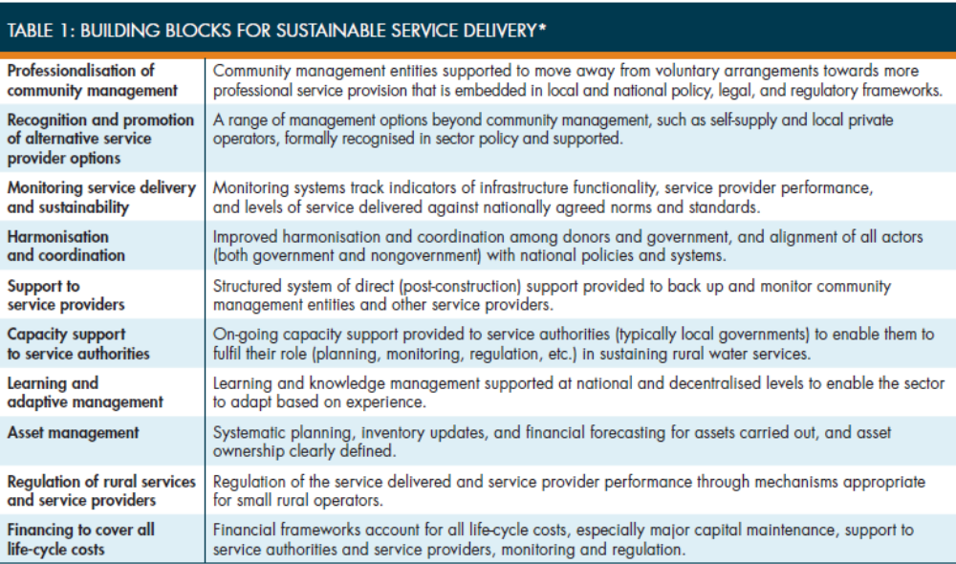

In-country activities
As an agent of change, Triple-S set to implement the SDA approach in two focus countries, Ghana and Uganda and in other non-focus countries (Burkina Faso, India, Mozambique, Honduras, etc.) where interest was identified and funding was available. Activities at country level are examined and evaluated in detail in later sections of this report.

Learning
The learning aspect of the Triple-S initiative mobilised significant resources and was implemented using sophisticated learning strategies and monitoring tools.
In order to learn how the sector could adopt a SDA, Triple-S used a combination of quantitative and qualitative methods to measure and understand changes, including:
- SenseMaker™, software that identifies trends and patterns in narratives about the water sector (from practitioners) and conditions (from users) and allows visualizing such patterns. The software was piloted as a monitoring and engagement tool between January 2011 and September 2012 in Ghana and Uganda and at international level. The objective was to pilot an innovative tool that the sector could then pick up. However, the software was later dropped for reasons that were discussed extensively in a dedicated report. A key reason for abandoning it was that a lot of effort was needed to use the tool when the insights generated were not particularly meaningful and useful;
- The Qualitative Data Analysis (QDA) method, which is a method for assessing documents in a rigorous and reliable manner to identify the presence or absence of particular themes or issues. This method is used in social science and Triple-S decided to apply it to the water sector, as discussed in more detail in Section F.2;
- The “Field Level Operations Watch” (FLOW, now known as AkvoFLOW), which enabled capturing information on the functionality of rural water services. Triple-S set to use FLOW – and encouraged local and national governments to do so - in order to manage, document, analyse and use data on sustainable service delivery.
Triple-S also deployed significant efforts to capture learning related to Narrative 2, i.e. to evaluate the Triple-S’ impact as an agent of change in the water sector. To that end, Triple-S contracted an “External Learning Facilitator” (ELF) to enable critical reflection and improve their way of delivering the sector change. The Institute of Development Studies (IDS) fulfilled the role of ELF at the international level and opted for using QDA for assessing the changes in the sector. External Learning Facilitators were also appointed in the two focus countries.

Dissemination for coordination and alignment
To fulfil its advocacy role, Triple-S carried out a number of activities both at country level and at the international level to sensitise the international communities, including international financing agencies (such as the World Bank, USAID and others) and NGOs, to shift away from infrastructure-focused interventions in favour of service-based models. These activities are evaluated in more detail in the sections that deal with each of the Outcome-based WS.

Was the Triple-S design fit for purpose?

Did the Triple-S project fill a niche in the water sector?
According to the international consultation, the majority of respondents found that Triple-S did fill a niche in the international WASH sector – and also at the national level in the two focus countries (Ghana and Uganda)
Sustainability of WASH investments had clearly been a key concern of WASH sector actors for some time. For example, the “key ingredients for success” for rural water services was one of the main outputs of the Word Bank Small Towns WASH initiative (1998-2001). A considerable amount of work had also been carried out by WSP and others on alternative service delivery models, particularly with a view to foster community ownership and empowerment and the professionalization of rural water service delivery (via various models to introduce private sector participation in rural water services). Leading international NGOs, such as WaterAid, had also expressed concerns about sustainability of their investments and other’s investments and sought to develop internal strategies to improve it. The building blocks developed by Triple-S therefore did draw quite extensively from this existing literature, as well as from the thirteen country studies.
However, although academics and researchers had expressed substantial concerns, sustainability was not the sector actors’ main concern. In the mid-2000s, the sector as a whole was focused on “achieving numbers” in the quest to meet the Millennium Development Goals by 2015. At the time, most sector governments and agencies would pay lip service to the need to strengthen local governments and communities’ ability to manage sustainable services. However, these efforts were somewhat peripheral when compared to the emphasis on achieving “new” coverage, as opposed to sustaining coverage and avoiding slippage.
The Triple-S project therefore filled a niche in terms of developing a sustained and systematic approach to promoting sustainability of rural water services as a goal, and the Service Delivery Approach, as a mean to achieving this goal. The fact that Triple-S has been consistently highlighting’ in a consistent manner over a relatively long period of time helped this concept gain real prominence in the sector’s discourse during the life time of the project, as discussed further in Section G.

Was the Triple-S theory of change appropriate and relevant?
The Triple-S Theory of Change was formally adopted only relatively late in the project life, with the official document published in January 2013
A summary representation of the ToC is shown on Figure 1 below.
This ToC captured well the way in which the project had gradually been conceptualised since inception, including the three main pillars of the approach that drove the expected outcomes from the project (adoption of a service delivery approach; harmonisation and alignment (on government’s plans, with the government in the lead) and a learning and adaptive management style to ensure project legacy). It conceptualises the way in which change is a long-term process which goes through distinct phases, in which it is first necessary to “socialise a concept”, then build consensus on what needs to be tested, test it, prove the concept and then scale up what has been proven. This “staged approach” runs throughout the project, both at international level and in the way country-level activities were conceived.
The wording of the Theory of Change is relatively complex to follow, however, and means that it is more of a conceptual document rather than one concerned with guiding project implementation. It is aligned with the redrafting of the outcomes for the project as a whole.
The ToC included the idea that the proof of concept in country would need to take place in order to support the outcomes and promote impact. In the overall ToC, this proof of concept was laid out in terms that were translatable into quantitative targets, such as “increase in functionality of water systems in pilot districts” and “increased satisfaction of users with water services in pilot districts”. The logical link between this proof of concept and the remainder of the ToC was not clearly established in the rest of the document, however. This notion of “proof of concept” was nevertheless translated into the definition of clear outcomes for the Uganda and Ghana work streams, with quantitative targets for achieving such improvements in functionality and service levels. Given that there was no associated funding to achieve these results, it appears that the ToC was potentially too ambitious compared to what the project could realistically achieve within the timeframe that was set out by its funder. This specific point is discussed further in Section G.
Figure 1: The Triple-S Theory of Change
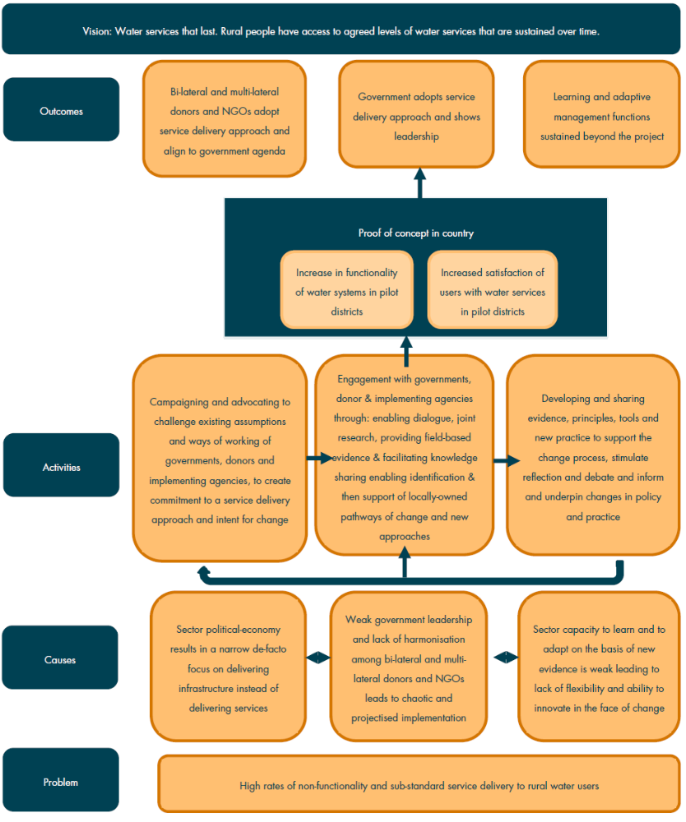

What is the relevance of the Triple-S’ principles and building blocks for the sector?
If relevant, Triple-S principles and building blocks are not clear for external observers and hardly appropriated, including in the focus countries
The Triple-S project produced two slightly different frameworks to articulate what should be done in order to move towards (and achieve) a Service Delivery Approach, including the so-called “Principles Framework” and the “10 Building Blocks”.
The way these two main frameworks interact and build upon each other is not immediately clear for an external observer. Based on discussions and closer examination, it became apparent that the “Principles Framework” was originally conceived as an evaluation framework, to assess the prospects of a given country to achieve sustainable water services, as measured against a number of key dimensions. This approach covers all key components that need to be addressed in order to drive sustainable water services. Such a framework was successfully used at baseline, particularly in the context of the 13-country studies which drew up a comprehensive situation analysis of rural water supply services in a range of developing and developed countries. This 13-country study provided the basis for selecting the countries where the Triple-S project would work at district level, namely Ghana and Uganda.
The Principles Framework is more appropriate as a research and analysis tool than as a basis for designing and implementing concrete actions, however. Therefore, the Triple-S project adopted the “10 building blocks” framework as a way to identify the main areas where actions need to be undertaken to move towards a “service delivery approach”, as opposed to placing an excessive emphasis on extending coverage. This framework has thereafter underlined the project’s communication (particularly on the website, or internally, to communicate across countries) and has provided a basis for selecting priority interventions, or so-called “experiments”, following the project’s Mid-Term Assessment. This selection was done in a consensual manner, in consultation with sector stakeholders in line with sector priorities in the two focus countries.
However, the 10 building blocks framework has not been comprehensively appropriated either, including in the focus countries – or at least in Ghana – where people beyond the immediate circle of project implementers were not familiar with these 10 building blocks. External observers picked up on certain aspects of these frameworks that resonate best with them (such as monitoring or the LCCA, depending on their areas of interest). Going forward, simplifying and ordering the messages according to their level of priority around the Triple-S multiple frameworks of analysis should be a key area of work for IRC going forward in order to ensure legacy, as discussed in Section G below.

Was it relevant to exclude sanitation from the project design?
Sanitation should be reintegrated to the approach to take into account the fact that WASH projects are becoming more integrated
One early decision taken by the project was to focus on rural water supply only, as opposed to both water and sanitation. This was partly a reflection of the background from the project’s initial designers, who had been more extensively involved in rural water supply rather than sanitation, as well as the result of a reflection from a Working Group on Rural Water Supply. It was also linked to the willingness to test and demonstrate the validity of the approach in a narrower area as well as a result of recognising the different institutional frameworks for these two interventions in rural areas. However, this goes clearly against the tide of rural WASH projects which are increasingly becoming more integrated and look to give high priority to sanitation and hygiene (which both require sufficient and sustainable water supply) in order to deliver maximum health impacts. In addition, whereas the WASHCost project did broaden its scope during its lifetime to include the definition of service levels and estimation of unit costs for sanitation and to a lesser extent for hygiene, the Triple-S project did not extend its approach to sanitation despite plenty of evidence that the approach could be applicable and useful in the sanitation arena.
It is only in its final year, when the project was closing down, that the Triple-S project implementers have initiated conversations about how the approach could be applied to the sanitation arena, both in countries and at the international level (for example, the latest WASH Sustainability forum had almost an equal number of sessions in water, sanitation and hygiene). This is a welcome development, although it comes too late to influence what Triple-S has been able to learn in its initial period of implementation.

Was the project right to focus on dispersed rural communities?
Finally, a key focus of the project has been on improving the management of boreholes fitted with hand pumps and shallow wells and very limited work has been done with regard to the “small towns” segment of the rural water supply (small pipe networks, private operators) – when many observers underline the fact that future of the water supply services in rural areas (including in terms of sustainability) lies in the generalization of small pipe networks (and the financial model behind them – cf. for instance the work done by Triple-S in Burkina Faso on this topic, see section F.4.1). Triple-S, especially in Uganda, could probably have been more critical and positioned itself more strongly, as handpumps does not represent a long-term solution in most rural areas there. This is an area that would require further attention in future because it will increasingly be a pressing reality in rural areas that are rapidly urbanising and where service level expectations are rising.

Triple-S Management
This section evaluates the arrangements put in place for managing the project, both in terms of human and financial resources dedicated to the project.

Overall project organization and management structure
Key informants from both IRC and the Bill and Melinda Gates Foundation underlined that the Triple-S project took some time to take shape and take off in terms of activities. Top management of Triple-S has been modified several times before reaching what has been considered by IRC as a sufficiently stable management arrangement from an internal perspective. This is perfectly understandable given, on the one hand, the size and the complexity of such a project; and on the other hand, the fact that IRC was the sole implementer of the project.
Overall, IRC has shown a good capacity to develop an adaptive management that helped socialize the concepts behind Triple-S – at an early stage of the implementation – while implementing key activities (such as the 13-country scoping study, which results were made available quite early) and working internally to find the best possible project organization. This adaptive management, strongly supported by the Gates Foundation (which was closely involved in the project follow-up until at least 2010) was indispensable to develop such a complex, mainly outcome-based and multi-country project which clearly challenged IRC’s implementing capacity as it stood in 2008.
At the beginning of the project, during the inception phase, the project was mainly organized around 3 main sectors / work streams: research (15%), international activities (52%) and project management (33%) – see below for a more detailed financial analysis.
From 2010 onwards, the final project organization was substantially re-designed as activities effectively started on the ground. At least two of the countries – Burkina Faso and Mozambique – were initially considered as “work streams” from a management perspective, even if at the end of the day Burkina Faso was implemented as a completely separate project (see section on IWS) and Mozambique remained at a low level of implementation with only some case studies and small sector influencing elements (with UNICEF, WSP and directly with DNA and other stakeholders in the GAS) due to lack of funding.
The revised project organisation has been stable over 2010-2014, with 2 main types of “workstreams” in a matrix structure:
- Outcome-based workstreams for the two focus countries (Ghana and Uganda) and the International workstream (including non-focus countries);
- Support or cross-cutting (and therefore non outcome-based) workstreams, including research and learning, communication and project management.
This project management structure is shown on Figure 2 below.
Figure 2: Project management structure as implemented over 2010-2014
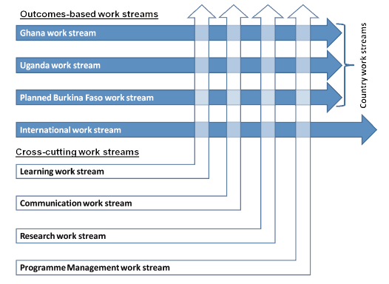

The outcome-based workstreams had clear outcomes and were able to function more or less independently. Financial management of the project was centralized but focus countries were significantly autonomous in terms of decision-making and implementation, which was probably the best possible way to manage the project. The focus countries would draw on resources from the other workstreams as and when it was needed. Support workstreams have proven very useful for the two focus countries, which were able to draw on resources from the international parties (such as IRC and Aguaconsult) as and when necessary. Each of the support workstreams also had one or two liaison persons in the country workstreams who acted as the mechanisms through which to identify support needs, to promote the use of common methodologies, etc. Discussions with the focus country teams in Ghana and Uganda confirmed that from their perspective, the project organization has been beneficial.
The fact that, under the current project organization, resources were drawn as necessary led to a good and efficient use of resources. However, there was some overlap between some of the support workstreams and in some cases, it was difficult to clearly define the boundaries and allocate responsibilities between the workstreams – which comes from the nature of such complex projects.
It would have probably been difficult to imagine a better (or more efficient) project organisation. Having fewer support-based workstreams (so as to avoid overlap and allocate responsibilities more clearly) could have been an option, however, particularly because the boundaries between the learning and research workstreams, for example, were not always clearly defined. In addition, it could have been preferable not to attempt to define the support activities as “workstreams”, but rather as a pool of experts who could assist with specific aspects of the project upon request of the outcome-based workstreams. This is in effect how some of these support workstreams functioned in practice.
The effectiveness of the support work streams did evolve over time and from the headquarters’ perspective, in the early years of the project implementation, there was a clear struggle to (i) create/stimulate demand from the countries; (ii) keep a balance between the learning, communication and research work streams (comparatively, the demand for research was lower than for communication and learning) and (iii) decentralize more the support provided, as the bulk of the project was actually implemented at country level. However, the EPE did not gather evidence that the project organisation described and analysed above would have substantially improved project management.

Financial management
The analysis of the financial management of the project under this EPE has been conducted based on the figures provided by Triple-S management team as per the end of August 2014 (these were the latest available figures). Technically, the Triple-S project was supposed to end in November 2014; although funds will continue to be disbursed until the end of 2014.
A no cost extension was agreed between IRC and the Gates Foundation until May 2015, to allow IRC to produce and submit final products and reports. The project coordinator has confirmed to the EPE team that 100% of the budget will be disbursed by the end of the project.
Analysis of the funds disbursed per year shows that IRC managed to progressively increase its capacity to implement activities and disburse funds, especially at country level.
Figure 3: Disbursements of funds per year from inception phase until 2013-2014 (USD)
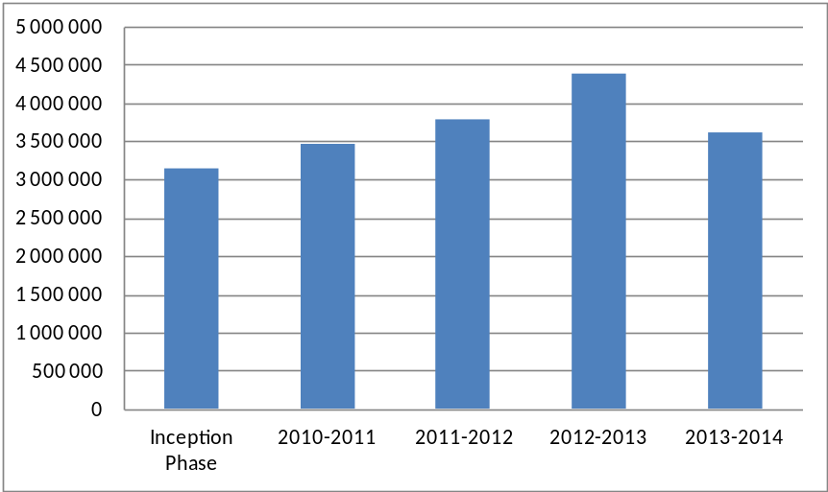
Overall, allocation of funds per work streams over 2008-2014 was as shown below (it can be considered as final as more than 90% of the funds have already been allocated). Triple-S allocated about two-thirds of its resources to the “outcome-based workstreams” (44% to the country workstreams and 21% to the IWS), whilst about 20% to project management and the rest went to the support workstreams, including activities in non-two focus countries (44% of the total funds) as well as the reasonable although relatively high level of funds allocated to project management (20%). The exact proportion of resources dedicated to project management is somehow difficult to estimate accurately, because the management role of the project directors and the project manager are overlapping with their role and participation in international influencing and IWS activities in general.
Figure 4: Allocation of funds per workstream, 2008-2014
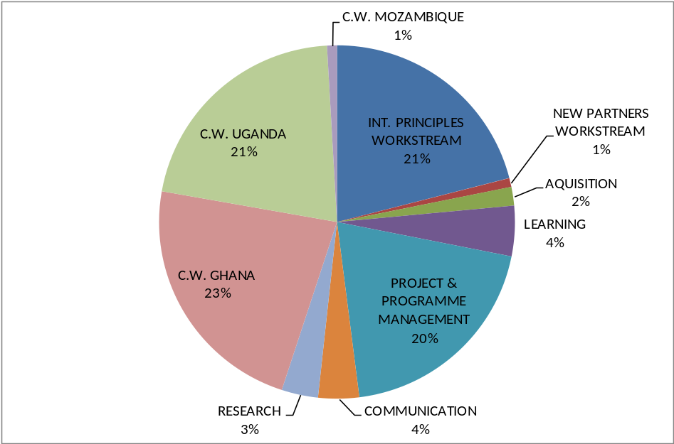

Allocation of funds during the inception phase reflected the focus on research and the weight (and the predominant role) of international activities during the two first years, for key activities such as the 13-country study. During the inception phase a majority of funds were spent at the level of IRC’s headquarters, which reflects the nature of activities implemented.
The respective weight of the project management (33%) was substantially higher during the inception phase than the average weight observed over the long term (20%); this seems mainly due to the fact that allocation of responsibilities (and of funds) between the IWS and project management (especially the more “strategic” aspect of the management) was not completely determined.
Figure 5: Allocation of funds during the inception phase
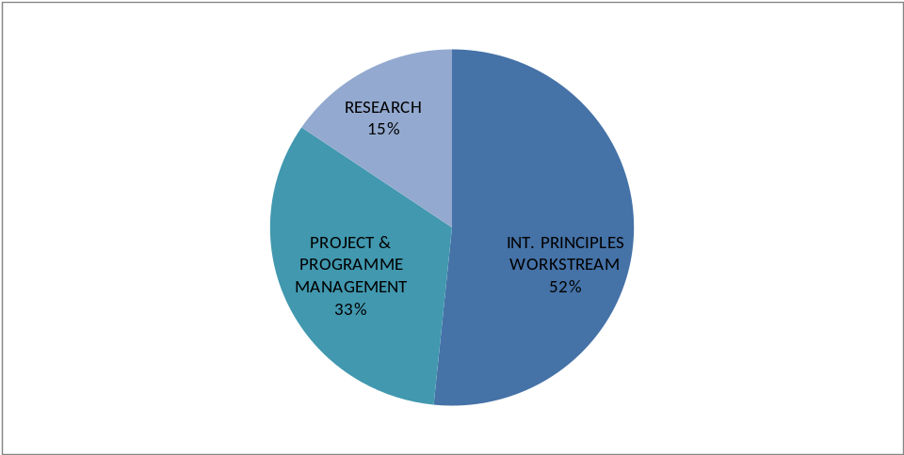

Allocation of funds over time confirms the weight of country-based activities over the 2010-2014 period and the general balance in the project implementation from a financial point of view. Overall, the allocation of funds has been coherent with the project’s expected outcomes and life cycle and with the initial proposal/budget.
Figure 6: Allocation of total grant amount per “sub-project” over time
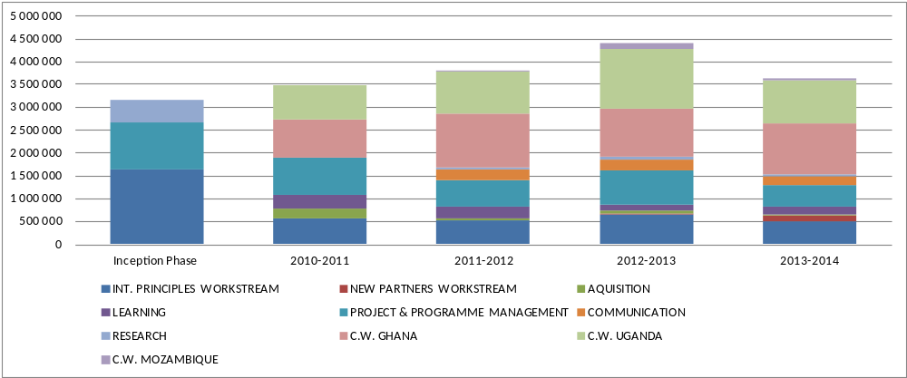
Allocation of funds per main categories of expenditure (equipment, contracted services, supplies, travel/consultants and personnel) has also been coherent with the initial proposal and reflects a sound financial management of the project. The contracted services represent a substantial part of the project costs. They include the Aguaconsult contract for the IWS as well as implementation sub-grants and hosting arrangements for Uganda and Ghana (in Uganda for instance, the Triple-S project has been hosted and financially managed through SNV, even if the overall management was under the responsibility of IRC). The hosting option has been a sound management decision given the financial management capacity of IRC and its level of “institutionalisation” in the two focus countries in 2008-2010.
Figure 7: Allocation of project costs per year and per category (USD)
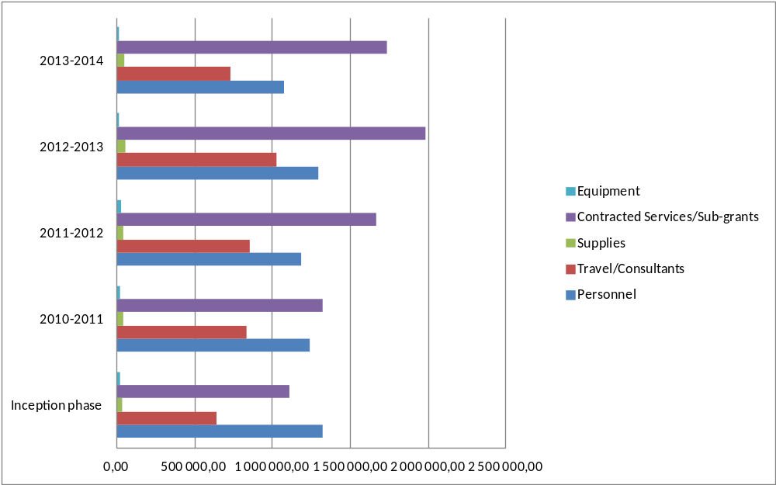
Overall, the financial analysis of the project reveals no area of concern from the point of view of the EPE team and financial management of the project appears to have been sound throughout the implementation period.
Reporting has been of a high quality and respectful of the standards set up by the Gates Foundation. A lot of effort has been given by IRC to manage the project in the most transparent way possible, with innovative tools being developed and used (see section on the dashboard below in this chapter).

Management arrangements for the IWS
The International Work Stream has been implemented under a specific arrangement, as a large part of the activities were sub-contracted to a consulting company (Aguaconsult) with support from key IRC staff (Patrick Moriarty, Ton Schouten, Catarina Fonseca, Stef Smits, Deidre Casella, Sarah Carriger, etc.). From a management perspective, this arrangement has proven to be sound and efficient, including during the inception phase where many key activities needed to be launched quickly to help IRC shape the project.
The boundaries between the IWS and the support workstreams are more difficult to establish than with the two focus countries, because some of the staff involved in the support workstreams (learning, communication and research) got involved in the international activities whereas staff from the IWS also supported country-level activities, particularly following the MTA which urged them to get more involved in activities at country level so as to be able to extract and disseminate country-level learning from the project.

Linkages with WASHCost
In practice, the strong link between the two “companion” projects proved beneficial for both projects (at least until 2013 when WASHCost came to an end), as Triple-S was able to “dovetail” the WASHCost project and build upon the analytical framework that WASHCost had developed with respect to LCCA and service levels. The merging of the international workstreams for the two projects was also a sound decision, since it allowed improving the coordination of efforts for disseminating key concepts emerging from both projects.
Paradoxically, WASHCost appears better known in certain international circles as it may be easier to grasp and to equate with life-cycle costing approaches. However, Triple-S was key for embedding the WASHCost concepts and approaches on the ground at country level, taking them to scale (to some extent) and including them in national and local strategies.
In Ghana, for example, which is the only country where WASHCost and Triple-S were both undertaken, Triple-S proved decisive to embed the LCCA concepts developed by WASHCost, through conducting additional training, either in the context of specific training sessions or through on-the-job training delivered by Regional Learning Facilitators (RLF) at local government level. In fact, staff at CWSA regional level and in the DA in which WASHCost had collected data could not recall the WASHCost project by name, and were not clear on what it had actually achieved. This points to the fact that, at country level at least, WASHCost was largely considered to be a research project, with limited interaction between the DA staff and the project staff.

Monitoring tools & Triple-S dashboard
The “Triple-S dashboard” was promoted in the last two years of Triple-S implementation as a key management tool, providing on-line, fully public and “real-time” information on the project performance, accessible both internally and externally.
It is obviously useful in terms of promoting a transparent approach to project management and of allowing a wider audience to have direct access to the project performance measurement tool. However, its target audience and exact purpose are not entirely clear. As currently designed, the dashboard is very much an internal tool, even though the information is publicly available. It contains a mix of information about project management (particularly on budgets and budget allocations to different activities) and on results achieved in the two main focus countries, in terms of the main indicators (i.e. service levels and user satisfaction). The dashboard’s format, although snazzy and visually attractive, is not that easy to understand and requires a certain amount of off-line explanations in order for the user to be able to grasp what information is being presented and how. It is also very much focused on the implementation of the Triple-S project as a project, when the emphasis should be on ongoing service delivery and what is being achieved (or not).
As a result, the Triple-S dashboard does not appear to be a useful tool for ongoing service level monitoring and benchmarking and it is difficult to see who this tool can be useful for beyond the direct implementers of the project.

Ghana Work Stream (GWS)
This section presents a summary evaluation of the Triple-S project outputs, outcomes and impacts in Ghana, which was selected as one focus country for the project.

Background to the Ghana workstream
Ghana was chosen as a focus country for a number of reasons. According to IRC, Ghana was deemed to be in the “danger zone”, i.e. the zone when countries have reached between 50 % and 80% water coverage but need to ensure the sustainability of such investments. There was an overemphasis on a “donor-driven project-based” culture, with an excessive focus on making new investments as opposed to ensuring the sustainability of existing investments. On the positive side, a strong institutional framework was already in place, with Community Water and Sanitation Agency (CWSA) playing a key role in the rural water sector. Yet, a sector reform process was underway, with a particular focus on strengthening sector coordination through the establishment of a SWAp. Finally, IRC had had a presence in Ghana since the 1990s, through a range of projects including WASHCost. The Triple-S project was seen as a key opportunity to operationalize some of the learning and institutional buy-in that had been garnered through the WASHCost project.
The project was officially launched in Ghana on 17th May 2010. Three districts (in three different regions) were selected for pilot activities in March 2011 and pilot activities at district level started in June of that year. The Medium Term Assessment (MTA) of project activities was conducted in July 2012. Following the MTA, the GWS chose to focus its activities around five main areas (three experiments and two studies), as discussed below in the assessment of outputs.

Evaluation of GWS design
The Community Water and Sanitation Agency (CWSA), the leading government agency for rural water and sanitation services in Ghana, hosted the project. The staff was a mix of IRC staff assigned to the project, Triple-S project staff hired specifically for the project and hosted by CWSA and CWSA staff assigned to work on the project (particularly for financial and administrative management issues). According to Mr Nkum, the External Learning Facilitator, the hosting arrangements were “superb” and proved effective in terms of the delivery of some of the project’s key outcomes.
The project was overseen by three Committees made up of WASH professionals: an Advisory Committee, to provide advice and direction to both the Triple-S and WASHCost projects; a Technical Committee within CWSA, which provided technical direction on Triple-S research, innovations and publications and a Management Committee to handle the day-to-day operational management of the project. In addition the project benefited from the services of an External Learning Facilitator (ELF); Mr Nkum a management consultant. The governance arrangements proved effective in promoting a constructive culture of “co-creation” and learning amongst sector actors.
Triple-S worked in three District Assemblies spread in three regions of Ghana with different hydro-geological conditions: Akatsi DA in the Volta region (South), Sunyani West DA in the Brong Ahafo region (Centre), and East Gonja DA in the Northern region. The choice of target DAs generated added costs (as they were spread out across the national territory) but this provided a strong basis for replication of the approach and sustainability beyond activities at the level of target DAs.
Following the MTA, the Triple-S project focused on five main activities. This allowed improving the project’s focus and strengthening its orientation towards action, as opposed to research. However, it resulted in a somewhat excessive focus on a narrow set of activities. Even though these activities were picked to be “experiments” in areas where additional focus was needed, this introduced a slightly “biased” perception of the project amongst sector actors in Ghana who later tended to equate the Triple-S approach with specific interventions, particularly those that are linked to monitoring service levels, and did not fully appreciate what the Triple-S project had set out to do, including to demonstrate-through-action and to introduce a new way of working in the sector.
As a whole, given the circumstances and the need to prioritise resources, the Triple-S GWS design was “fit-for-purpose” given the state of the rural water sector at the time. The project as a whole went beyond the five main activities and adapted to the changing circumstances of the rural water sector, and managed to promote a real shift towards the adoption of a Service Delivery Approach (SDA).

Evaluation of GWS outputs
The project delivered several types of outputs:
1) An extensive number of high-quality publications were prepared under the project;
2) Support was provided for learning alliances at National level and the setting up of learning alliances at Regional and District levels;
3) The organisation of training workshops and learning events;
4) Capacity support to DA and CWSA staff and on-the-job training.
Overall, project outputs were produced on time and on budget. They were of very high quality and were much appreciated by sector stakeholders. “Versioning” of these outputs could be improved and diversified so as to reach the largest number of stakeholders.
The training programmes appear to have been effective in building capacity at DA and regional levels. Some of the research papers and activities which do not pertain to one of the specific experiments have explored ground-breaking areas and brought significant added-value to the sector. Finally the process for producing outputs was highly participatory, involving the DAs and CWSA, thereby providing a firm basis for institutionalization of the production process.
The five main activities that the Triple-S project chose to focus on following the MTA were:
- Experiment one, Service Level Monitoring. The development and rolling out of a Service Level monitoring framework can be viewed as the “flagship experiment” for the project in Ghana, which has led to clear outcomes in terms of opening stakeholders’ eyes to the sustainability issue and changing mentalities. However, the sustainability of the service level monitoring approach is potentially in question, particularly at the DA level, as there are no clear sources of funding for these activities and resources for monitoring are at risk of being diverted for other priority activities.
- Experiment 2, Reducing Handpump Downtime via SMS: At the time of the visit, it was too early to tell whether this experiment would be successful or not. Several issues were identified with the mobile-phone operating model that has been put forward to date, which meant that a full scale-up (for example, via SMARTerWASH) appeared to be premature. The evaluation encouraged stakeholders to reconsider the model and test a number of alternatives to really identify “what works”.
- Experiment 3, Adopting a LCCA Approach: Dr Nyarko, who had been lead researcher on the WASHCost project, provided training on LCCA, which was the most significant benefit from having conducted WASHCost in Ghana. On the back of this training, Akatsi DA received hands-on support to develop an asset register. The tool developed by the project to prepare an asset register was well laid out and clearly understood by the District Engineer. However, it still had a lot of potential for improvement. The value of a stand-alone asset register is likely to be limited if it does not allow for automatic adjustments and is not linked to a budgeting spreadsheet. Finally the training on asset management organized in Akatsi prompted the Sunyani West DA to take up the approach and start replicating it on its own.
- Study on Learning Alliances: The study on Learning Alliances is a well-designed and well-written study, with great insights in the nature of learning at play and how Triple-S learning strategy fits into the overall learning framework in the Ghana WASH sector. However, it remains a study with a relatively limited influence on the learning outcomes
- Study on Sector Coordination and Alignment: The study is a well thought through and extremely thorough document that was prepared in a consultative manner, with substantial involvement from the Sector Working Group (SWG). It analysed the level of coordination and aid effectiveness in the Ghana water sector based on a broader framework for evaluating aid effectiveness and was able to draw very useful comparisons with other sectors, such as the health sector.

Evaluation of GWS project outcomes
This evaluation is based on the three outcomes defined following the project redesign. It examines whether these outcomes have been fully or partially achieved:
- Outcome 1 – Service delivery approach, defined as “Rural water sector monitoring, planning and financing in pilot districts and at national level is guided by clearly defined indicators, models, guidelines and frameworks for service delivery”.
This outcome was largely achieved for water sector monitoring. Due to Triple-S intervention, service level indicators have been defined and tested in pilot districts. These definitions have then been adopted and mainstreamed by CWSA through the preparation of CWSA manuals. The replication of the approach received funding from a series of funders, which will allow carry out baseline assessments in 131 districts throughout the country. In terms of planning and budgeting, there was evidence of change within the pilot DAs that have adopted the LCCA concepts in order to carry out their planning and budgeting following training they had received through WASHCost or through the Triple-S project. As regards financing, there was not much evidence of financing being guided by clearly defined indicators, models, guidelines and frameworks for service delivery, either at the DA level or at the national level. In addition, a lack of available financing has proven to be a major constraining factor for implementing the budgeted activities, which limited the project’s ability to generate impact on the ground, in terms of an improvement in service levels and sustainability. Overall, however, the objective of promoting a Service Delivery Approach (SDA) has been achieved, both in the target DAs and at national level.
- Learning and adaptive management, defined as “A learning agenda in Ghana is strengthened and services concepts, policies and best practices in rural water are being promoted through strategic partnerships and learning platforms”.
Contribution towards this outcome has been mostly done through publications and the setting up of learning platforms at national, regional and district level. However the performance of these learning alliances has been varied. It is only in the Northern Region that the regional learning alliance appears to be strongly established, thanks to the local presence of NGOs (both international and local) that are willing to take it forward (such as UNICEF and SNV). On the other hand, the learning alliance at the District level in East Gonja appears to be much weaker, which indicates that having a strong learning alliance at the regional level does not necessarily influence the success of the learning alliance at District level. In general the setting up of learning alliance platforms at national, regional and local levels responded to a strong need and appeared to be much appreciated by sector actors at all levels. Those learning alliances have promoted and supported a culture of learning within the sector, which has grown particularly at national level.
The Triple-S project maintained substantial flexibility in the design of the learning alliance platforms so as to best respond to local needs. It must be said however that the relevance of the discussions held under the Learning Alliances, particularly at the DA levels, is not always clear and the likely sustainability of these learning alliances varies substantially from one region to another. One key constraint commonly cited for their sustainability is limited available funding. In addition, although the concept of learning alliance has been partly assimilated, a more structured framework for learning in the rural water sector has not been fully developed. To overcome difficulties in terms of getting people together for meetings at regional or district levels, more extensive use of internet-based tools could be considered so as to reach a broader audience.
- Sector coordination and alignment defined as “Rural water service delivery is based on nationally agreed sector operational documents and guidelines and government provides leadership in coordinating the sub-sector”.
The project developed a multi-pronged strategy to achieve this outcome, including through the Introduction of a common platform of technical engagement; the formulation of common agreed sector operational documents by pulling all the best practices into common documents and using the process to build consensus on how water services delivery should be organised; organizational change and reform processes through periodic reflection sessions aimed at addressing the inherent organizational issues and fostering consensus and joint actions on critical issues required to clarify CWSA’s role; and finally supporting the enabling policy and operative environment for a harmonized sector. From the above strategies it can be said that the preparation of documents was a vector for driving organisational change within CWSA, and influencing them to work in a more coordinated manner through the Technical Committee and beyond.
Triple-S also contributed to the preparation of the National Community Water and Sanitation Strategy. Although it was clear that Triple-S played a substantial role in the preparation of this strategy, this involvement was considered to be less successful, largely because the resulting strategy is still relatively unclear and does not provide adequate guidance for the sector, particularly in terms of defining its financing strategy. Though the CWSA strategy document is useful for clarifying roles and responsibilities of the different sector actors, it is not so clear in terms of defining a future strategy for CWSA and how it would evolve from its current role as technical support provider to one of regulator. One key area for consideration is how CWSA would be funded, i.e. whether CWSA should be funded via government budget transfers, fees-for-service (when providing technical assistance to service providers) or via license fees applied to regulated entities, or a mix of these three main types of funding. Finally, when Triple-S was originally conceived, a project objective was to contribute to the definition of a SWAp approach for the sector but this has not materialised as yet, despite significant efforts from sector actors. This failure cannot be attributed to Triple-S but this means that full coordination is not yet achieved.

Evaluation of GWS direct/broader impacts

Expected direct impacts have not been achieved
Expected direct impacts at DA level have not been achieved. By the end of the project (i.e. Year 6), it was expected that there would be a reduction by 10% in number of systems rated non-functional, an increase of more than 10% in numbers accessing basic service levels and 60% of the users would express satisfaction in pilot districts. However, instead of improving, service levels have actually gone down in some of the pilot DAs. However monitoring has increased transparency in terms of results achieved at District level, and the project has not shied away from sharing these results with the sector at large, which can see as a clear benefit over the project based approach.
The circumstantial reasons for under-achievement vary from one DA to another. Nevertheless there are several potential explanations for this inability to achieve the expected impacts. First, improving service functionality is not simply about making emergency repairs but it is about adopting a Service Delivery Approach. This concept has neither been fully tested nor has it been proven in the target districts, given that not all elements of a SDA were introduced in those districts. For the full impacts to be achieved, it would have been necessary to drive change through government systems so that the service-delivery approach would be fully implemented during the lifetime of the project, but this has not happened. In addition, unexpected changes in the overall macro-economic and political context during the Triple-S implementation period resulted in budget cuts at the highest level and delays in fund transfers. Other potential reasons include the fact that it may have been too early to assess impacts or that the Theory of Change for the project might have been over-ambitious for a project of its kind, with no associated funding for investment. These potential reasons are evaluated in more detail in the full case study on Triple-S intervention in Ghana.

Broader impacts have been achieved through scaling-up of the approach
The ultimate indicator of whether other sector actors have bought into the approach is whether they decide to scale it up for broader replication. The Ghana Work stream has been very successful at mobilising additional funding sources for continuation of its approach. Some of the Project scaling up of the Triple-S approach include: the SMARTerWASH project, the Conrad Hilton Foundation project, as well as the scaling up to an additional two 2 DAs in the Volta Region (and potentially two more) from funding channelled via UNICEF. One key issue however, is that several of these projects are only replicating specific elements of the so-called Triple-S SDA approach, which means that overall change in the system is unlikely to be reached in those cases either. On another note, the GoG itself has not shown much willingness to invest into scaling-up of the approach, nor indeed into the rural water supply sector as a whole, despite having made repeated commitments to increasing sector funding. Finally the Triple-S project did pave the way for consolidating IRC’s position in Ghana through the opening of a permanent office, which can continue promoting the Service Delivery Approach beyond the life of this particular project.

GWS evaluation summary
This section presents the overall lessons learned from the EPE, based on a summary of the evaluation, which is presented in detail in the UWS report and briefly in the sections above. The rating scale reads as follows:
Outstanding: exceeded expectations / key achievement of the project
Good: comfortably met expectations
Satisfactory: barely met expectations, with some caveats
Unsatisfactory: did not meet expectations / critical area for the project

Evaluation area | Evaluation questions | Summary Evaluation | Rating
Project design: was the project design fit for purpose and flexible to adapt to circumstances? | Were hosting arrangements well designed and effective? | - Hosting the project in CWSA was the best solution given the institutional context  - Hosting arrangements in CWSA proved fit for purpose and effective  - As Triple-S staff were embedded in CWSA, they acted as “critical friends” but their ability to question some key strategic positions by CWSA was somewhat limited  - Project management has been very effective with an ability to attract excellent personnel and driving them to high standards
 | Was the process for regional/district selection adequate and rigorous? | - Districts were selected to reflect a range of geographic conditions and based on demand  - The choice of target DAs (spread across the national territory) generated added costs but provided a strong basis for replication of the approach and sustainability beyond activities in the target DAs
 | Were the governance arrangements effective? | - The governance arrangements were effective in promoting a constructive culture of co-creation and learning amongst sector actors  - The External Learning Facilitator played a very useful role to challenge project thinking
 | Did the pre-MTA activities provide a sound basis for project definition? | - The pre-MTA activities allowed building a very in-depth picture of the sector and identify bottlenecks  - Some aspects identified during MTA as needing attention (such as the Service Delivery Models and in particular the COM model) were not followed through in sufficient detail
 | Were the interventions selected post-MTA selected based on a sound analysis of critical needs? | - The set of interventions selected allowed the project to better focus project activities  - This selection resulted in perhaps an excessive focus on a narrow set of activities (with a particularly strong focus on monitoring) not reflecting the full Service Delivery Approach  - The selection of project experiments was based on extensive consultation with actors
Outputs  Which outputs have been produced, what is their quality, how have they been perceived? | Have the output been produced according to schedule and expected level of effort and cost? | - Project outputs were produced on time and on budget.
 | What is the quality of outputs produced? | - Project outputs were of very high quality and much appreciated by sector actors  - Some research was ground-breaking and bring significant value-added to the sector, such as the research on district level WASH budgets.
 | How are these outputs perceived by WASH actors? | - Training programmes were effective at building capacity of sector actors  - The process for producing outputs was highly participatory, involving the DAs and CWSA, thereby providing a strong basis for institutionalisation of the process  - The “versioning” of these outputs could be improved and diversified to reach the largest number of stakeholders
 | Experiment 1 – Service level monitoring | - This can be seen as the “flagship experiment” for the project in Ghana, which has led to clear outcomes in terms of changing mentalities and practices  - One key issue relates to the sustainability of the monitoring approach at DA level beyond the initial baseline data collection
 | Experiment 2 – Reducing handpump downtime via SMS | - At the time of the visit, it was too early to assess success of this experiment  - We identified several issues with the design of this experiment which meant that full scale-up (via SMARTerWASH) appeared premature. We urged the parties to reconsider the model and test alternatives to really identify what works
 | Experiment 3- Adopting a LCCA approach | - Training on LCCA has been well received and has motivated some DAs to take on the approach without Triple-S support  - The asset registry tool still had much scope for development at the time of the visit  - The value of a stand-alone asset registry is likely to be limited. A move towards a strategic financial planning approach (including demand, revenues and costs) should be considered.
 | Study on Learning Alliances | - The Study on Learning alliances was of great quality, with important insights for how learning is currently being done and should be done in the sector  - It is not a full-blown “experiment” but a stand-alone study, with limited potential impact
 | Study on Sector Coordination and Alignment | - The study is a well thought through and extremely thorough document that was prepared in a consultative manner and allowed identifying areas of weakness in a very open manner  - The fact that the MWRWH commissioned IRC-Ghana / Triple-S to conduct the study is a testament to the fact that IRC-Ghana (largely through the Triple-S project) has been able to position itself as a fair and honest broker in the sector  - Although corrections have already been made on the back of the study, its impact is difficult to assess in isolation from other initiatives to strengthen sector coordination
Outcomes:  How do project outcomes measure against expected achievements (post-MTA)? Are there unexpected outcomes? | Outcome 1 – Service delivery approach | - Outcome 1 was largely achieved for water sector monitoring: the monitoring framework and tools developed with Triple-S support are now widely adopted by the sector  - The sector has broadly adopted the Service Delivery Approach terminology  - Financing is still not guided by clearly defined indicators, models, guidelines and frameworks for service delivery, either at the DA or national levels
 | Outcome 2 – Learning and adaptive management | - The setting up of learning alliance platforms at national, regional and district levels responded to a clear need and was much appreciated by sector actors  - The likely sustainability of these learning platforms varies substantially from one region to another and alleged funding constraints are getting in the way  - A structured learning framework for the rural water sector is still lacking
 | Outcome 3 – Sector coordination and alignment | - Triple-S made a substantial contribution to the definition and adoption of nationally agreed sector operational documents and guidelines, particularly for monitoring  - Contribution to the definition of a viable sector strategy and to the sector SWAp was more limited, partly because these aspects were beyond what Triple-S could really influence
Impacts:  Is there clear evidence that the agreed impact targets in Ghana have been achieved? | Impact at district level on functionality, access to basic services and user satisfaction? | - Service levels have not markedly improved and in some cases have deteriorated.  - Several potential reasons have been identified, including the lack of sufficient time to measure impact but also more fundamentally, questioning the Theory of Change for the project and the ability for a project of this type to deliver the expected impacts
 | Impact at district level on other governance aspects | - Awareness of WASH-related issues has clearly increased at DA level  - DAs have only been able to mobilise limited funding for WASH sector, despite a significant improvement in their budgeting practices
 | Broader impact through replication and scaling-up? | - Significant scaling-up through donor funding, even prior to garnering evidence on “proof-of-concept” (e.g. Hilton Foundation, UNICEF, DGIS SMARTerWASH)  - Very limited (hardly any?) scaling-up with GoG funding, except through the WB loan. This can partly be explained by limited ability to borrow and rapidly deteriorating macro-economic indicators during the project period, which might have relegated the rural water supply sector down the list of priorities.

Key lessons and recommendations
A number of key lessons can be extracted from implementation of the project in Ghana, both for stakeholders in Ghana itself and for the Triple-S project as a whole:
- Operationalizing the Service Delivery Approach, the Triple-S “building blocks”” should be revisited so as to make them more explicit and helpful for sector stakeholders and provide the basis to strengthen the learning agenda. The Principles Framework could be revisited and applied again to analyse how far the Ghana water sector has progressed since the start of the Triple-S project;
- Providing a stronger framework for service level benchmarking and ensuring that benchmarking results lead to long-lasting service improvements, at sector level, compiling a “State of the Rural Water and Sanitation Sector” should be encouraged to gather all monitoring data being produced in the wake of the Triple-S project and based on frameworks and tools developed by the project;
- Supporting a nation-wide debate and a concrete strategy for increasing sector funding. Financing is repeatedly cited as the main stumbling block for improving sector performance and needs to be comprehensively addressed. Triple-S findings should provide the basis for an in-depth review of sector financial arrangements and formulation of concrete proposals to secure funding flows. Based on these estimates, it would be essential to revisit initial proposals formulated by the Triple-S project in order to identify realistic and innovative financing options. Dedicated funding mechanisms for the sector, if established, could consider introducing results-based financing mechanisms in order to strengthen the reliability of the approach;
- Evaluating what can be done in the sanitation sub-sector. An area that has not yet been explicitly considered for replication is that of sanitation services, even though there would be obvious parallels and benefits from replicating the Triple-S approach in the sanitation sub-sector, with some key modifications. As one sector stakeholder put it, “water and sanitation are bedfellows, so the replication is not an offence” therefore a similar process could be developed for the sanitation sub-sector, building on the lessons of Triple-S in the rural water sector, particularly in terms of building consensus around a sustainable sector approach and encouraging learning and sharing.

Uganda Work Stream

Background to the Uganda workstream
Uganda has been selected as a focus countries for three main reasons, namely: good WASH sector institutional structure and coordination mechanisms (SWAp in place for more than a decade); IRC’s previous project experience and institutional contacts; and the overall good access rate in the rural sector, despite the alarming and decreasing rates of water point functionality (especially regarding handpumps and point water sources in general).
The project has been implemented through a five-partner consortium, having been administratively hosted and financially managed by SNV. The project was officially launched in Uganda in April 2010 and national and district-level activities were started immediately in two districts (Kabarole and Lira) that are very different in terms of population, climate, governance and district level, water resources and recent history – the Northern region has faced major population displacements during and after the insurgency and the situation has only come back to normal recently.
The Mid Term Assessment (MTA) of Triple-S conducted in July 2012 prompted a significant revamp of the project, both at international level and for the UWS. Recommendations relating to knowledge management and better engagement with stakeholders had great impact on the project in Uganda, especially regarding the need to gather evidence, which translated into identifying “experiments” to be conducted from 2012 onwards. The UWS chose to focus its experiments around five main areas: analysing the performance of service delivery models; facilitating local monitoring of rural water service delivery; developing a business model for hand pump mechanics’ associations; using mobile phones to improve functionality of rural water sources; adopting a sub-county model to improve operations and maintenance; strengthening learning and capacity to adapt through learning alliances; and updating the District Implementation Manual to improve harmonisation and coordination.

Evaluation of UWS design

Hosting agreements
The Triple-S UWS was implemented through a consortium of five partners consisting of the Ministry of Water and Environment; Network for Water and Sanitation (NETWAS); Uganda Water and Sanitation NGO Network (UWASNET); SNV Netherlands Development Organisation Uganda; and IRC International Water and Sanitation Centre. A Project Steering Committee (PSC) composed of representatives of these organisations provided general guidance to the project and reviews/approves annual work plans and budgets.
For technical reasons (IRC did not have a country office in Uganda at the beginning of project implementation), the project was administratively hosted by SNV, which managed the human resources, costs and logistical issues related to project implementation. Although administrative management by SNV was inevitable, it led to double reporting for staff.

Selection of districts
Districts were selected based on sound criteria, including governance and existing projects/NGOs likely to be influenced by the Triple-S concepts and/or use the outcomes of the experiments. The contrasted profiles of the 2 pilot districts enabled the Triple-S team to assess how the local context would influence the way Triple-S would be implemented.

Choice of interventions
The 2012 Mid-Term Assessment (MTA) of the project recommended focusing on the implementation of a set of experiments. The choice of these experiments was perfectly in line with sector priorities and they were selected based on an extensive consultation process with sector stakeholders. As a result, most experiments were relevant in the context of the state of the water sector in Uganda in 2012. However, Triple-S focused only on boreholes with handpumps and shallow wells, meaning very limited work has been completed on the “small towns” segment of the rural water supply (small pipe networks, private operators) sector. This is despite the fact that many observers highlight that the future of water supply services in rural areas lies in the expansion of small piped networks. Triple-S in Uganda could probably have undertaken a more critical assessment of the interest of focusing too much on a level of service which is not a long-term solution in most rural areas.

Assessment of project outputs
A majority of expected outputs have been produced (there are only a few still pending completion) and the effort and costs have been expended as planned. According to most stakeholders, overall, outputs are of high quality and very relevant, notably District Implementation Manual (DIM), Hand Pump Mechanics Association (HPMA), Service Delivery Models (SDM) and Sub County Water Supply and Sanitation Boards (SWSSB). This is presented in greater detail in the table below.
Table 3: Overview of key project outputs (experiments)
Experiments | Assessment of the situation in July 2014
Updating district implementation manual to improve harmonisation & coordination | - New version of the DIM delivered in 2013, ‘popular version’ published in January 2014 and uploaded onto the Ministry website in June 2014.  - Revised DIM delivered slightly late due to use of a thorough participatory approach.  - Large-scale dissemination (printed copies, presentation in seminars, websites).  - Revised DIM regarded as one of Triple-S’s key contributions to the sector and is regarded as a good quality document by all stakeholders.
Using mobile phones to improve functionality of rural water sources | - Triple-S helped demonstrate that the M4W system is feasible, useful and worthwhile implementing at district level. However, it has only been scaled up to a limited extent, despite all the interest shown in the system by the MWE.  - Due to the lack of results for the second round of data collection in the districts using M4W, it is very difficult to determine whether it has had any impact on the functionality of the water points.
Developing a business model for handpump mechanics’ associations | - Triple-S played a key role in developing Handpump Mechanics’ Associations (HPMAs) by: documenting existing initiatives; sharing lessons within learning platforms and developing specific guidelines; building the capacity; and developing a business model for HPMAs facing significant financial sustainability problems.  - Although there is a viable market for HPMAs, this market is unstable and affected by the willingness of users to pay for their services, as well as the falling investment being made by local district government in rehabilitating water supply facilities.
Facilitating local monitoring of rural water service delivery (SDIs) | - Service Delivery Indicators (SDIs) were designed to provide a more ‘local’ perspective on service delivery with a specific focus on users’ level of service; service delivered; service management level; service authority and level of support mechanisms.  - The challenges encountered during the first phase of data collection (use of mobile phones) have now been overcome.  - The second round of data collection only took place in August 2014. This late delivery will make it difficult to conduct a comparative analysis of the two sets of data and draw conclusions. It will also mean that Triple-S has not been able to use the results from this experiment to advocate for use of SDIs at sector level.  - Despite a lot of resources spent on engaging with the MWE/DWD and strategic partners and working to convince them of the benefits of using and up-scaling the SDIs, there has been limited success so far.  - Overall, it was very ambitious to introduce two major innovations at the same time: ICT to collect data in real time and a large set of indicators, including new concepts such as users’ satisfaction.
Adopting a sub-county model to improve operations and maintenance | - In conjunction with MWE, Triple-S piloted the concept of expanding the mandate of the current Water and Sanitation Boards (WSB) for piped water supply to include supporting O&M of standalone water sources in Kabarole and Lira Districts.  - The experiment has reached its tipping point: ownership and possible scaling up by the Ministry through the Technical Support Units (TSUs) and Umbrella Organisations. The scaling up has already started in other regions.  - There is evidence of uptake with new boards having been established in the 2 focus districts and elsewhere. The Ministry is also considering extending (part of) the conditional grants to the sub-county level, to provide the newly created boards with investment money.  - Despite their success, sub-county WSBs face major capacity and finance issues. Overall, this new model remains fragile.  - The experiment became operational late in the implementation of the Triple-S project as Boards were only formed by the end of 2013, making it difficult to draw conclusions from this experiment or to develop tools and guidelines.
Strengthening learning and the capacity to adapt through learning alliances | - The learning experiment is a “cross cutting” Triple-S activity that borrows from all the other experiments (especially the HPMA, Sub-county WSB, M4W and SDI experiments) with the aim of establishing and maintaining learning platforms throughout the country at all relevant levels: district, regional and national.  - The learning process is envisaged as a loop that starts with proper documentation of interesting initiatives, is followed by a multi-stakeholder analysis that contributes to collective learning, which then feeds back into sector coordination.  - The impact of the learning platform on sector level dialogue is seen as very positive by all sector players. Current discussions around setting-up a “knowledge management hub” as a good way of making the learning process set up by Triple-S more sustainable and long lasting – but it is not in place yet.
Analysing the performance of Service Delivery Models (SDM) | - The research study report on SDM, published early in 2014, demonstrates that: a large majority of rural users have access to a sub-standard level of service and that reliability is higher in the 2 districts where management innovations have been put in place; users’ satisfaction with the service is generally higher than the level of service itself; and that, from a service authority’s perspective, the main issues are the institutional gap at sub-county level, the limited resources at both sub-county and district levels and poor coordination between stakeholders.  - Conclusions have been used to justify the focus of the Triple-S intervention and feed into the learning dimension of the project at all levels.  - However, it is limited by the fact that the research focuses exclusively on standalone water points, ignoring the other levels of service, such as piped water networks that correspond to another SDM (the WSSB model). This strategic direction may ultimately diminish the impact of Triple-S’s contribution to bringing change and innovation to the rural water sector, as the long-term situation in the sector has not really been taken into account.

Evaluation of project outcomes
This section briefly presents the main changes in terms of discourse, policies and practice that can be attributed to the Triple S project.

Outcome 1 – Decentralized service delivery authorities, providers and users carry out their roles and responsibilities as outlined in the sector policies and guidelines
The SWSSB model is now recognised as a viable option for professionalising the management of RWS and is now fully included in national policies and tools. However, although this constitutes a highly promising model, it also faces a number of issues (capacities, fee collection by WUCs) that not all players are convinced they will be able to solve. In parallel, Triple-S has demonstrated and tested the potential of HPMAs, which are now fully integrated into RWS policies, strategies and guidelines. Triple-S has broadened their perspective in terms of the business model, access to market and capacity. However, HPMAs are still in need of financial, training and capacity-building support to reach their full viability. As a result of Triple-S intervention, districts have taken a more prominent role in organizing the water services, promoting sound management and cost recovery.

Outcome 2 – National and decentralized service delivery authorities and providers plan, budget, monitor, finance and maintain the required levels of RWS at full scale
From a strictly technical point of view, the M4W experiment has been successfully implemented in the focus districts. MWE, DWOs and most stakeholders have shown a lot of interest in the system. However, although interest in focus districts appears real, there is little evidence of any uptake of the concept and technology in other districts and certain issues remain, such as weak connection to the main M&E framework, complexity. The cost of operating the system is also seen as a barrier for full nationwide scale up. At the same time, the efforts made by Triple-S to engage the MWE and the districts with LCCA have triggered limited results, especially with regard to planning and budgeting.

Outcome 3 – Transparency and accountability mechanisms are in place and used to monitor reliability of rural water services
Triple-S has demonstrated that intensive community mobilisation and new institutional arrangements at sub-county level could improve transparency and accountability and have positive impact on the systems’ ownership and functionality (although this last point is difficult to demonstrate as sub-county committees have only been operational for a limited time). In concrete terms, it has triggered a more proactive attitude among users and WUCs, who now more actively report faults and place request for their facilities to be repaired. At the same time, Triple-S has demonstrated the benefits of the SDIs and their capacity to explain key factors affecting functionality, such as the responsiveness of HPMAs or capacity of the district to invest in major repairs and maintenance. However, uptake by the sector has been limited as stakeholders still have doubts about the cost of managing such a sophisticated set of indicators on a real time basis. As a result, SDIs are currently seen as complementary to the “Golden” indicators and the approach has not been scaled up.

Outcome 4 – Rural Water agencies adapt their policy and practices on the basis of evidence from the experiments
Triple-S substantially (and durably) changed not only the way learning was envisaged in the rural water supply sector, but also the link between learning / research and policy. A further major contribution of Triple-S has been to promote new models after demonstrating their benefits and feasibility in the two focus districts. Although restricted to the standalone water points, performance analysis of existing SDMs helped stakeholders to collectively understand the problems that needed to be addressed and led to the two most successful experiments of Triple-S in Uganda – the HPMAs and the SWSSBs. Finally, the learning alliance experiment that involves establishing the “knowledge management hub” still needs to be “made official” at sector level as, so far, there is no evidence that this will be implemented and that the MWE and districts will provide the resources required.

Outcome 5 – Decentralized RWS delivery is harmonized and coordinated to achieve higher effective and efficient resource use
The new District Implementation Manual (DIM), jointly developed by all stakeholders, is now considered a reference document for harmonising the approaches used by both government and non-government organisations to design and implement RWS projects. At the same time, the set-up of coordination meetings and structures (DWSCC) has helped improve coordination at district level. Districts also demonstrate the political will and clear leadership required for taking over coordination and harmonisation activities and have furthermore budgeted for part of the coordination costs. Nevertheless, coordination remains an issue at sub-county level as SWSSBs are still quite fragile.

Evaluation of impacts
This section presents the main lessons to be drawn from the country project, as well as the main recommendations for enhancing achievement of the Triple-S vision of in-country sustainable water services at scale.
- No direct impact on functionality rates of water sources has been observed. This can be explained by the fact that the use of the M4W system increased the number of water points being monitored and that, as the new institutional arrangements (especially the HPMAs and the SWSSBs) only became fully functional in 2013, it is still too early to observe any medium-term or long-term impacts on key indicators, such as the functionality rate.
- Very positive impact on governance at district level. This impact comes from three main factors: the learning aspect and the fact that all key stakeholders participated in the MSLPs; the work undertaken at sub-district level to enhance governance and accountability (introduction of a new governance level (SWSSBs)); and reinforcement of the district authorities’ leadership.
- Triple-S significantly changed the face of the RWS sector... without really managing to put in place all the elements required for achieving the service delivery approach as initially planned. Several explanations can be provided for this: the time required to completely re-orient the sector from its current infrastructure-based approach to a fully service-based approach is more than 5 years; whilst the well-structured WASH sector was an advantage at the beginning of the project, ultimately, a structured sector is probably less easy to change; also, as a project, Triple-S was unable to really influence stakeholders to make the necessary investments, which made it very difficult to demonstrate the validity of its underlying concepts.
- Contrasting results in terms of scaling-up and replication. Some elements have been replicated and disseminated: the revised DIM is now used throughout the sector; the HPMAs and the SWSSBs “package” have definitely taken off and are now thoroughly incorporated in policies and strategies; and the Triple-S multi-stakeholder learning approach has been replicated in other regions and included in other ongoing projects or projects being prepared. Triple-S concepts have been promoted and the impact of this is clearly visible within the group of IRC’s ‘close’ partners. However, the initial ambition of provoking a complete system change at sector level has not been achieved. Although IRC is now a key player in the WASH Sector in Uganda, it has been unable to secure the necessary resources to continue and potentially scale-up the whole system change in the sector in a long term perspective.

Evaluation summary
This section presents the overall lessons learned from the EPE, based on a summary of the evaluation, which is presented in detail in the UWS report and briefly in the sections above. The rating scale reads as follows:
Outstanding: exceeded expectations / key achievement of the project
Good: comfortably met expectations
Satisfactory: barely met expectations, with some caveats
Unsatisfactory: did not meet expectations / critical area for the project

Evaluation area | Evaluation questions | Summary evaluation | Rating
Project design: was the project design fit for purpose and flexible for adapting to circumstances? | Were hosting arrangements well designed and effective? | - Piloting the project through a multi-stakeholder consortium was the best possible choice  - District team and activities were completely embedded within TSU and WSDF  - Administrative management by SNV led to double reporting for staff
 | Was the process for regional/district selection adequate and rigorous? | - Districts were selected based on existence of projects/NGOs likely to be influenced  - Although quite similar in terms of access, districts differed with regard to other factors (especially climate, hydrogeological conditions and recent history)
 | Were the governance arrangements effective? | - Partners have all been involved and active in the consortium  - Triple-S managed to develop a close working relationship with the Ministry & local governments
 | Did the pre-MTA activities provide a sound basis for project definition? | - Documentation of key sector innovations and experiences started early  - Most of what later became the 7/8 ‘experiments’ had started before the MTA  - Focus of pre-MTA activities was mainly on learning activities (including internally)  - Overall, pre-MTA activities provided a sound basis for project definition (none of the areas explored before MTA were really abandoned during the re-organisation process)
 | Were the interventions selected post-MTA based on a sound analysis of critical sector needs? | - Close involvement of Triple-S in sector coordination groups at national and district levels enabled maximum alignment with sector priorities  - Experiments were designed following an extensive consultation process (several events organised in 2012, including a Triple-S research seminar in September 2012)  - Focus on standalone water points only was more questionable
Outputs: Which outputs have been produced, what is their quality, how have they been perceived? | Have the outputs been produced according to schedule and expected levels of effort and cost? | - The majority of expected outputs have been produced (a few are still pending completion)  - Levels of effort and cost as noted in initial plans have been respected  - Some outputs have been produced quite late (final SDM report, for instance)
 | What is the quality of outputs produced? | - District Implementation Manual: excellent quality  - Using mobile phones to improve functionality: average quality  - Development of business models for HPMAs: good quality  - Service Delivery Indicators (SDIs): average quality  - Sub-county model to improve operations and maintenance: good quality  - Strengthening learning and capacity to adapt: excellent quality  - Analysing the performance of Service Delivery Models: average quality
 | How are these outputs perceived by WASH stakeholders in the country? | - Most outputs have been perceived very well by WASH stakeholders in the country  - Most relevant/useful outputs according to perception: DIM, HPMA, SDM and SWSSB  - Outputs related to learning are extremely well perceived as a major contribution to the WASH sector, especially at national, regional and district levels  - Work on M4W and SDIs is perceived as useful, but many stakeholders (including the MWE) expressed concerns regarding costs and capacity to upscale those experiments
Outcomes: How do project outcomes measure against expected achievements (post-MTA)? Are there unexpected outcomes? | Outcome 1 | - Triple-S has demonstrated and tested the benefits of SWSSBs as a new SDM  - Triple-S has demonstrated and tested the potential of HPMAs and has broadened their business model and capacity-building perspective  - However, HPMAs are still in need of support (will the districts be able to provide it?) to reach their full viability; SWSSBs are a very promising model but face major issues (capacities, fee collection by WUCs) and not all stakeholders are convinced that they will be able to overcome all the O&M and functionality challenges
 | Outcome 2 | - MWE and DWOs + stakeholders have shown a lot of interest in the M4W system  - Triple-S managed to demonstrate the technical feasibility of the system  - The M4W is still not connected to the main (national) M&E framework; complexity and cost of operating the system are seen as barriers to a countrywide scale up  - Efforts undertaken by Triple-S to engage the MWE and the districts with LCCA have triggered interest but with limited results, especially with regard to planning and budgeting
 | Outcome 3 | - Triple-S has demonstrated that intensive community mobilisation and new institutional arrangements at sub-county level could improve transparency and accountability, and have a positive impact on ownership and functionality of the systems  - Triple-S has demonstrated the benefits of the SDIs and their capacity to explain factors affecting functionality; however, uptake by the sector is limited, with SDIs seen as complementary indicators, and the approach has not been scaled up
 | Outcome 4 | - The intervention of Triple-S substantially (and durably) changed the way learning was envisaged in the rural water sector and the link between learning / research and policy  - A major contribution of Triple-S to the RWS in Uganda has been to promote new models after (and while) demonstrating their benefits and feasibility in the 2 focus districts  - Multi-Stakeholder Learning Platforms have proven to be very successful at national, regional and district levels (but a little less successful at sub-county level)  - The learning alliance experiment still needs to be made official at sector level
 | Outcome 5 | - The new District Implementation Manual has been completed, disseminated and well-received by all sector stakeholders, including the MWE and the DWOs  - District level coordination meetings and structures (DWSCC) are now in place and enable more efficient follow-up and increased harmonisation by the districts  - The 2 focus districts demonstrate strong political will and clear leadership for taking over coordination and harmonisation activities; districts have budgeted for (part of) the related costs
Impacts: Is there clear evidence that the agreed impact milestones in Uganda have been achieved? | Impact at district level on functionality, access to basic services and user satisfaction? | - User satisfaction seems to have increased (if improvement in water fee collection can be taken as a sign that rural users are more satisfied with the service)  - There is no evidence of a positive impact on functionality rates in the 2 focus districts
 | Impact at district and national levels on other governance aspects? | - Very positive impact can be observed on governance in the 2 focus districts  - Triple-S changed the face of the RWS sector... without achieving a “complete system change” due to the limited time available and pre-existing structure of the sector
 | Broader impact through replication and scaling-up? | - Some elements of Triple-S are currently being replicated (and partially scaled-up) through inclusion in national policies/strategies and in new projects/programmes  - Level of replication is variable across the Triple-S experiments. MSLPs, HPMAs and SWSSBs are in the process of being scaled-up, scale-up is less obvious for M4W and SDIs

Key lessons and recommendations
This section briefly presents the lessons to be drawn from the UWS and the main recommendations for enhancing the achievement of the Triple-S vision. Some recommendations are valid not only for IRC, but also for the larger consortium of actors involved in Triple-S and willing to bring forward the legacy of the project.
- Enhance focus on the learning dimension to continue promoting the Service Delivery Approach, even if IRC’s resources are limited in the coming years.
- Document Triple-S key achievements and promote legacy through a single briefing document showcasing Triple-S’s major achievements and areas that require further exploration, as well as a “learning agenda” to be used as a research programme endorsed by the MWE itself.
- Keep the consortium alive (and possibly expand it to new stakeholders) as it is a good vehicle through which to continue promoting the Triple-S legacy.
- Conduct an independent assessment of the M4W and SDIs experiments as, at the moment, there is very little evidence that they will be scaled up and that they are sustainable (especially in terms of cost and complexity).
- Revisit the building blocks and make them more operational by developing a clearer roadmap to enable sector stakeholders to expand beyond monitoring and planning immediate remedial measures.
- Expand the perimeter of “rural water services” to anticipate forthcoming changes as piped networks are becoming more and more important in rural areas, including in small communities.
- Support service providers and focus more on the private sector by providing capacity-building and by documenting international lessons in this area.
- Focus on the financing aspects by developing research and innovation to obtain further information on the exact costs of implementing a full Service Delivery Approach in the rural sector, as well as to identify and develop more locally-based financial resources for the sector through increased user participation and the smarter use of available public funding.
- Seek partnerships with organisations implementing projects. Now that Triple-S has come to an end as a project, IRC could partner with “infrastructure implementing” organisations to share its expertise on the learning / institutional / capacity-building / monitoring / SDA aspects of the sector.
- Engage more in sanitation as this sub-sector also needs a “complete system change”, particularly to shift away from an infrastructure-based approach towards a service and demand-based approach. Focusing on sanitation would be a good way to recycle the Triple-S legacy within a new sector.

International Work Stream (IWS)
This section evaluates the International Work Stream (IWS) based on a similar outline to the one for the country-level workstreams. It seeks to identify the contribution that IWS, together with the activities in non-focus countries, made to Triple-S overall impact at international level. Evaluating the impact of such activities in isolation is relatively difficult and subjective. In fact, the Theory of Change for the project did not assign specific impact targets for the IWS. For this reason, we consider the impact of Triple-S project as a whole in Section G rather than try and identify the specific impact of the IWS.
The IWS has developed a number of analytical tools in order to measure “take-up” from the project’s messages at the international level. In doing so, the project has developed a number of tools that could be relevant for other projects looking to measure changes in mind-sets and behaviours at an international level, such as the Qualitative Document Analysis (QDA). The evaluation contained in this section is partly based on the project’s own analysis, combined with the results of the international consultation undertaken as part of this EPE. Full (anonymised) results from this international consultation are presented in Annex I.2.

Design of the International Work Stream
The notion of an IWS did not appear in the original Triple-S proposal and documentation, although the proposal had set out explicitly its intention to “see the support of service delivery adopted globally within a reasonable timeframe – approximately 10 years”. However, it quickly became apparent that dedicated resources would need to be applied to influence actors and institutions, particularly Development Partners, over and above the focus countries and targeted districts.
Even before the project had formally established an “International Workstream”, activities were initiated at the international level, so as to lay the basis for the identification of focus countries and the definition of an overall analytical framework for the project.
The International Workstream (IWS) was created in mid-2010 as one of the 3 outcome workstreams for the project (see Section C for more details). Even though activities in non-focus countries were not strictly part of the IWS, we evaluate them in this section as well given that an expected outcome of the IWS to generated interest at international level beyond the focus countries which would result in the replication of the Triple-S approach in other countries beyond the initial two focus countries.
A key design decision was to coordinate the international components of WASHCost and of Triple-S, a decision that was formalised in a note in February 2011. This was a sound decision, given that Triple-S approach built upon concepts and tools developed by WASHCost (particularly with respect to the cost and service analysis tools). This also allowed cost savings and better coordination in terms of external image, as different actors were aware or sensitised to different degrees to both projects (for a while, it would be fair to say that awareness of WASHCost was greater than that of Triple-S, particularly in the international area outside of the US NGO scene).
Table 4 below sets out key dates that led to the formalisation of the IWS and highlights some of the key activities undertaken by this workstream.
Table 4 - Key dates for the International Workstream
Date | Key activity
2009-2010 | - Inception phase: selection of countries, defining the approaches, launch international research
2010 | - Mid-2010 – The “outcome-based” approach is defined. 3 work streams with outcomes appear: Ghana, Uganda and IWS– it is envisaged that Triple-S will build on synergies of WASHCost work, especially at international level  - Initial results from 13 Country Study  - International symposium and first sustainability forum in Kampala
2012 | - March 2012 –Third Sustainability Forum in London  - June-October 2012 – Mid-Term Assessment: a key recommendation is for IWS to get more involved in activities at country level  - November 2012: IWS Vision, which redefined the workstream’s outcomes and introduces intermediate outcomes (incl. coalitions and allies, individual champions, etc.)  - 2012 – Publications of two Qualitative Data Assessments (QDAs) documents on policy and practice, which constitutes the “baseline”
2013 | - Following MTA, IWS more involved in countries’ workstreams  - March 2013 – Fourth sustainability forum in Washington DC  - December 2013 – Ambassadors meeting in London
2014 | - July – Sustainable Forum in the Hague, reaching out to European actors in addition to US NGOs  - November – Second round of IWS QDAs

Outputs

What has the IWS done?
The IWS (together with other supporting workstreams) produced a wealth of outputs and activities. A rapid overview of the types of outputs and activities that have been undertaken under the leadership of the IWS or with their significant contribution is presented below.
Box 2 - Overview of outputs and activities undertaken by IWS
Publications and documents available on “waterservicesthatlast.org” website
- Papers outlining the Triple-S Service Delivery approach (e.g. briefing notes on the Building Blocks, Theory of Change)
- Country-level case studies (e.g. 13-country publication on rural water service delivery, country-level baseline assessments)
- Research reports, particularly on specific experiments ongoing at country level
- Case studies of other organisations’ experience with sustainable services (e.g. Water For People)
- Governments' policies, strategies, manuals, procedures that Triple-S contributed to
- Think pieces and blogs to trigger sector dialogue
- Communication materials (e.g. videos)
- Academic journal articles

Organisation of events such as:
- Symposium on rural water held in Uganda
- Sustainability fora (through the www.sustainablewash.org set up in 2012)
- Learning workshops
- Ambassadors workshops, aimed at sector practitioners who have been asked to promote the Triple-S approach beyond the project life so as to ensure legacy

Setting up of coordination platforms or participation to existing ones
- Contribution to the establishment of SustainableWASH.org, which acts as a Community of Practice on sustainability and organiser of some of the Sustainability Fora
- Animation of discussion groups on RWSN

Direct communication and engagement with individuals and institutions (referred to as “invocacy”): email communication, face-to-face contacts

As in the rest of the project, the MTA had a substantial impact in terms of redefining the project and its activities. In essence, the MTA encouraged the project staff to start moving from analysis and concepts to the application of these concepts into practice. Whereas it acknowledged that the IWS had created an “encyclopaedia of knowledge and documents on SDA approach”, the evaluators recommended that the IWS should work on integrating lessons from what Triple-S achieved in country into international documents, so as to build understanding around the “how-to” for sustainability and create an evidence base for how-to achieve change towards rural water service delivery.
The IWS also laid the basis for the establishment of a lasting collaboration with “like-minded” organizations, including IRC, WSUP, Water for People and a few others, such as the Millennium Water Alliance, which aims to achieve the end state of “Everyone Forever”, which is achieved when 100% of households, schools, clinics, and businesses receive a sustainable water and sanitation service. The collaboration was set up in 2013 to share lessons learned and seek to align future programming on those principles. Many of the principles underlying Everyone Forever build on Triple-S’s approach, such as the principle of working at the level of a whole district (rather than in isolated communities) or to act as Acting as resource brokers and coaches to support and strengthen alignment and action by local and national governments and service providers.

IWS outputs are of good quality and well rated but a clear roadmap to understand the Triple-S approach is missing
Quality of the outputs. Publications available on the website are of high-quality and have been produced through a collegial process which ensured good quality assurance. The written publications provide a good mix of theoretical papers, case studies, briefing notes or blogs. Some of the reports are overly long and dense, however, and more targeted at a “research community” rather than sector practitioners. Several reports provide different versions of the same concepts (for example, on the principles framework) and a clear hierarchy between those documents is lacking, making it difficult to establish by an external observer. As the project closes down, the website will presumably continue existing (unless it is absorbed in the broader IRC). It would be useful to use this as an opportunity to reorganise the website to bring out key resources that can serve as an introduction to a theme, with more detailed and technical resources provided as a reference.
Type of outputs produced. The integration of international level outputs and lessons from the ground (particularly from the focus countries), which the MTA had been calling for, has partly taken place through the website which collates information from all aspects of the project. Some of the latest products of the IWS have sought to integrate findings from the focus countries, so as to provide more learning on the “how” to achieve sustainability. However, these learnings are in part juxtaposed to the international messages and provided merely as examples, rather than analysed in detail. In particular, there are no cross-country comparisons, which could compare and contrast experiences in an objective manner to extract learning about what works and what does not work in different contexts. The fact that Triple-S worked extensively in only two countries meant that the possibility to extract cross-country lessons was perhaps limited.
The Triple-S project has produced a wealth of documentation over the years in multiple geographies but it is not necessarily easy for an external party to understand what has been done and where to find material. As a result, it seems that a good overview document setting out key learning from the project and providing a “way-in” for an external observer (or someone whose degree of familiarity with the project is limited) is still lacking at this stage (although it could still be produced as part of the project’s legacy).
The nearest document that exists to this type of introductory document are PowerPoint presentations that have been presented at Ambassadors’ workshops, particularly towards the end of the project (participants at some of the earlier Ambassadors’ workshops have noted that the key messages from the project were still relatively vague whereas this seems to have improved in later meetings).
However, these presentations inevitably remain brief and general. A “middle point document”, i.e. in between a general presentation of the project approach and detailed documentation appears to be missing, at least in report format. Such a document would need to synthesise key learnings from the project on the ground (particularly in focus countries) and provide further guidance on the “how to” transition towards a Service Delivery Approach. Additional discussion on what could be done to capitalise and disseminate Triple-S rich learnings over the years appears in Section H.1.
Usefulness of the outputs. The degree of familiarity of WASH sector stakeholders with these outputs varied quite considerably from one respondent of the international consultation to another and from one type of output to another, as shown on Figure 8 below. The outputs that were deemed most useful were the papers outlining the Triple-S SDA (such as briefing notes on the building blocks) whereas the least useful (at least on the Triple-S website) were the Governments’ policies, strategies or manuals that the project has contributed to.
Figure 8 – Evaluating the usefulness of Triple-S publications for sector practitioners
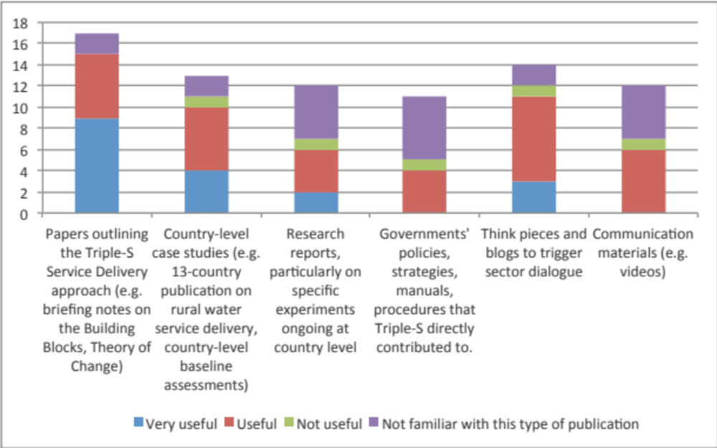
Source: results from the EPE international consultation
On the whole, as shown on Figure 9, respondents to the international consultation for the EPE found that the Triple-S outputs were very useful compared to other sector publications. Some respondents found them “somewhat useful” because they were not finding exactly what they were looking for, i.e. they did not find the outputs sufficiently concrete or practical.
Figure 9 - Usefulness overall of Triple-S outputs
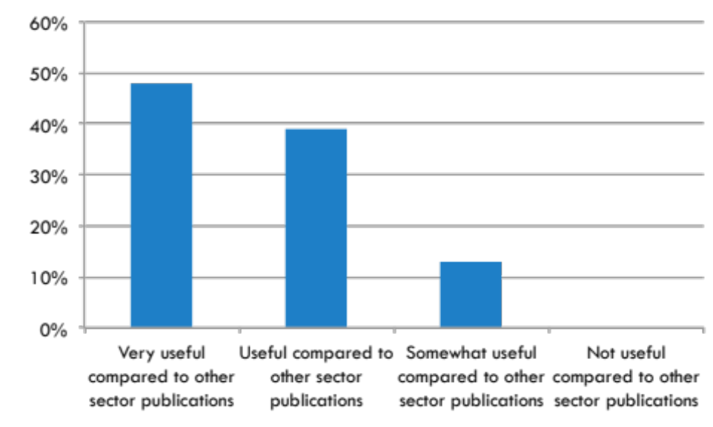
Source: results from the EPE international consultation

The website is useful, but not a “go-to” website
The Triple-S dedicated website, www.waterservicesthatlast.org can also be seen a lasting output for the project, although the website itself will be integrated into the IRC website. It was launched in June 2011 and currently acts as a repository for all outputs produced by the project, including all published outputs from the focus countries as well as some outputs from the so-called “non-focus countries” and outputs documenting the experience of organisations that apply approaches similar to that of Triple-S (such as Water for People in Honduras). It is well organised and regularly updated. It was set up by the Communications workstream with country workstreams taking ownership of their particular area, with on-going support from the Communication Workstream.
According to the ELF, the Triple-S project’s web presence steadily grew over the life of the project, from a relatively weak base prior to the MTA. Between June 2011 and December 2014, it was estimated that the website was consulted by approximately 25,000 independent users. In 2013, the website had had 15,000 unique visits, with 56,500 page views from 174 countries. In 2014 (up to 7th December), these figures had gone down slightly, as the website had had 13,042 visits, with 44,425 page views from 166 countries, although 63% of viewers were based in six countries, including the Netherlands (19% of viewers), Uganda (13.3%), the US (12%), the UK (10%), India (4.55%) and Ghana (4.3%). Although these are respectable scores, this performance is relatively modest when compared to other websites that act as portals on a certain theme. The maximum number of hits on a single day (which is generally linked to the publication of a blog or flagship publication) was reached on 12th July 2013, with 164 users, which indicates that none of the blogs or publication has truly “gone viral” or has managed to attract the attention of a broader audience or mainstream media.
According to the international consultation, most respondents found that outputs available on the website were useful. However, some respondents complained that the website itself was difficult to navigate because it was particularly dense. They mentioned that it was therefore difficult to identify key documents and “absorb” them.
Some respondents, particularly hailing from the NGO community, indicated that additional versioning of the outputs on the website would help in making the documentation more accessible. This could include very brief notes summarising the approach, Frequently Asked Questions, short videos explaining key concepts or “top tips” aimed at various audiences. They indicated that it was difficult to send a long report to an NGO partner and that it was sometimes difficult to identify material for them to circulate to their partners.
In addition, the website was seen by some as a fairly “closed” website and not a “go-to” website on rural water services, as shown on Figure 10. According to the international consultation, 20% of respondents visited the website more than once a month which is the same percentage as those who had never visited the website (even though they had had some degree of involvement with the project over the years or their area of expertise is very close to the project’s focus). This was in contrast with the Rural Water Supply Network website, for example, which acts as a gateway for material on rural water supply (not specifically focused on sustainability) and is deemed to contain more technical / practical content which is more relevant to sector practitioners.
However, all respondents who provided an opinion on the website said it was a good source of tips and information and some said they would recommend it to others. They also found that the blogs were always thought-provoking and useful.
Figure 10 - How often do you visit the website?
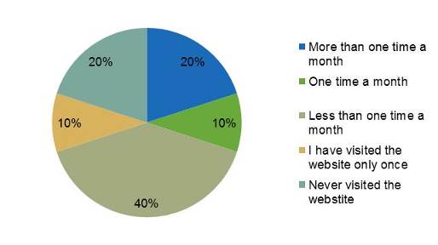
Source: results from the EPE international consultation

Training events were well run and useful
The IWS conducted numerous training events over the period, with an estimated 74 events and 4,590 trainees for IWS between 2010 and 2014 according to Triple-S statistics. This includes both WASHCost and Triple-S international events after the international activities were coordinated.
Only 30% of the individuals consulted through the EPE international consultation had taken part in Triple-S training however: of those, 70% thought that the training events were “useful” and 30% “very useful”. Nearly all (85%) thought training led to a change in their practices. Some of the respondents regretted the lack of training material on SDA for university courses so as to reach the future water and sanitary engineers as they are getting trained, rather than when they are already on the job.

Different means were used to influence international actors
The IWS was creative and strategic in its thinking about how to influence international actors so as to lead them to modify their policies and practices. Three sets of influencing approaches were used throughout the project life:
- Technical influence: producing and disseminating ‘evidence’ from Triple-S research and collating and analysing the research outputs of others, through the production of case studies, tools and through technical assistance and provision of training;
- Personal influence: through “invocacy”, via informal interactions, networking and consistent mining and strengthening personal contacts and identification of internal champions within target and ally organisations;
- “Political” influence: through outward communications and campaigning work, both done independently and through participating in major sector initiatives with the aim of advocacy and ‘systems change’.
“Invocacy”, a term coined by the Triple-S project to describe active ongoing contacts with certain organisations or individuals within those organisations, was big part of the IWS activity. This involved engaging actively with those individuals through numerous emails, phone calls and face-to-face meetings. This has worked well, thanks to the personal networks of key individuals from the IWS (Harold Lockwood) or from IRC (Catarina Fonseca), except in certain cases (such as the AfDB), where engagement has had limited success. By contrast, a significant achievement has been the adoption of the “sustainability clause” by DGIS, thanks to a mix of all different means stated above, and particularly political influence.

IWS developed innovative tools to measure outcomes
Triple-S IWS developed innovative methodological tools to monitor success against the outcome indicators, for both the IWS and the country-level workstreams. The External Learning Facilitator (various individuals appointed through the Institute of Development Studies in the UK) led on the adoption and development of these methodological tools. They carried out monitoring of email logs and webstats, semi-structured interviews with key stakeholders and led (in coordination with the IWS) on the application of the Qualitative Document Analysis (QDA). This is a method for assessing policy and practice change based on the analysis of written documents in a structured manner.
Two main QDA exercises were conducted in 2011 to provide a base line, one on Development Partner (DP) policy documents and one on Development Partner practices. These two documents were released externally in 2013 only, thereby limiting their potential take-up by external actors. In terms of policy, Triple-S undertook a review of 11 major WASH DP documents originated in 2008/09, including from funders (e.g. African Development Bank, Inter-American Development Bank, UNICEF, DANIDA, etc) and implementers (such as WaterAid or Water for People). The review was conducted using the 10 building blocks as an analytical framework, i.e. by evaluating the extent to which the topics underlying these building blocks were considered in policies and practices. The review, amongst other things, confirmed the lack of planning based on consideration of full Life cycle costs for rural water supply and that monitoring focused on access rather than sustainable services. This was confirmed in the review of practices, which also got lower average scores than the policy review confirming the policy to practice gap.
A second QDA was conducted right at the end of the project in order to identify whether any changes had taken place as a result of the Triple-S project. Only three DPs of the original grouping had formally updated their policy documents between 2011 and 2014 (WaterAid, AfDB, AusAid) with one new entry, USAID. Several, including Water for People, UNICEF, WaterAid were on the cusp of releasing new documents for 2015, so it was not possible to assess changes. USAID, who have released a WASH policy for the first time, were found to be strong on monitoring, learning, capacity support and average on life cycle costs. WaterAid have improved on paper with respect to direct support, alternate service providers and professionalization of community management. AfDB, despite not having actively engaged with Triple-S had a strong policy highlighting coordination, alignment and capacity building.
Although the tool is interesting in itself, it could have been applied in different ways so as to provide a stronger basis for collaboration with other actors. First, the written documentation may not be representative of what those institutions are actually doing on the ground. So ways to combine the review of written documents together with semi-structured interviews would have provided a richer basis for analysis, although more subjective and less rigorous. The terminology to describe certain concepts and approaches may also vary from one institution to the next, and the strict application of the building block framework meant that there was limited scope for variations in terminology. This limitation is clearly acknowledged in Triple-S’s own assessment of QDA results.
The document exposed “gaps” in policies and practices of certain organisations: in several cases, this was followed by active engagement from the Triple-S project to work with these organisations to address gaps.
Finally, although the External Learning Facilitator (IDS) played a substantive role in the QDA, commissioning an external party to carry out this type of analysis may have ensured more impartiality in the results.

Outcomes: what has the IWS achieved?
The International Workstream adopted 3 main outcomes:
- Outcome 1. Policy – A significant number of DPs will have adopted service delivery principles in their policy dialogue and strategic guidelines, including a greater emphasis on capacity-building, post-construction support and life-cycle costing.
- Outcome 2. Practices – A significant number of operational DPs will have adopted aspects of the service delivery principles in their planning and implementation procedures (procurement, tendering and contracting, monitoring indicators for success) and will coordinate more closely with national priorities.
- Outcome 3. Financing – There will be up-take of full life-cycle cost analysis by a significant number of DPs and a trend towards greater support for non-capital expenditure by both national governments and DPs (i.e. for capital maintenance costs and direct, and indirect costs for capacity building, monitoring and learning, post-construction).
In addition, the IWS adopted 5 intermediary outcomes, as follows:
- Coalitions and allies: strengthening or forming new coalitions in different organisational spheres, for example, within the international NGO sector, within bi-lateral donors or within the lending banks
- Individual champions: identifying and supporting individuals within our allies and target organisations who can work with us to support change from within their organizations
- Knowledge for change: DPs have an understanding of service delivery, life-cycle costing and related concepts and why these represent an improvement over ‘business as usual’ for delivering sustainable rural water at scale
- Capacity for change: DPs (both as individuals and as organizations) have the tools, methods and skills to be confident of executing the change; this is the ‘how to’ relating to changing approaches, planning, budgeting, coordination, implementation and monitoring
- Incentives for change: organisational drivers exist within DPs to change the way they work and be based on peer pressure (“We see everyone else picking up these ideas so we should too”) or on the influence of communications and messaging (“We are aware of this/believe this” or “this is what we should be doing differently”).
The way in which these three key outcomes and 5 intermediary outcomes were intended to interact with each other were explicitly laid out in the IWS Programme logic, as shown on Figure 11 below. An additional, “sixth outcome” according to the IWS programme logic was that these changes in policy, practice and financing at the level of governments and development partners would result in acquisitions for IRC, i.e. through the adoption of the Triple-S approach by other actors or in other countries. This was met with varying degrees of success depending on the target countries as detailed in Section F.4 below.
Below we evaluate the extent to which the main three outcomes have been met.
Figure 11 - IWS Programme Logic
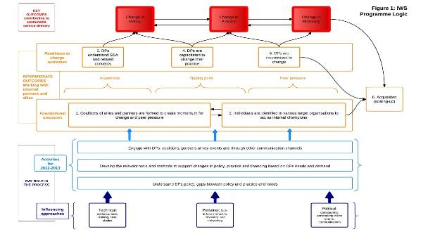

A significant number of DPs has adopted SDA principles
A significant number of DPs has adopted SDA principles following their engagement with Triple-S. The project had a particularly strong influence on US-based NGOs, particularly those who had not been particularly focused on sustainability previously.
The project tracked the way it engaged with DPs and other partners through a “take-up” table, which tracked the way in which those had adopted SDA and LCCA concepts. These estimates were gradually refined, with the inclusion of confidence and likely impact scores. According to the ELF’s latest report (covering the period up to June 2014), the IWS had far exceeded its uptake goals: it states that the IWS uptake database showed that 15 donors and 16 INGOs were using SDA terminology, 30 organisations had changed their internal practices to support SDA and 19 organisations were actively funding SDA approaches.
A number of US-based NGOs, which had previously been focused on new infrastructure investments, were particularly influenced by their interaction with the Triple-S project. This influence was channelled through alliances with existing WASH NGO platforms in North America, such as the Global Water Alliance and through the organisation of Sustainability Fora, initially in North America and then in Europe as well. For some of these US-based organisations, engagement with Triple-S was “transformational” whereas others (such as the Hilton Foundation or the Water for People) found that their approaches were already closely aligned. The project had comparatively less influence over bigger funders, particularly development banks such as the African Development Bank or DFID, although the impact on AusAID (now DFAT) and USAID was significant. By contrast, interviews conducted for the purpose of the evaluation found that some NGOs in non-English speaking countries thought that Triple-S had mostly repackaged concepts that had been around for some time in the sector and had had limited value-added, except in the area of communication.

Some key DPs have changed their implementation procedures
Some key NGOs / Foundations have adapted their planning and implementation procedures, either because they already accepted the model (e.g. Conrad Hilton, WfP) or became convinced as a result of the project (e.g. Rotary).
A number of other funders, such as DGIS have adopted and are now promoting sustainability clause in the projects that they fund: work on the DGIS sustainability clause was carried out by IRC and Triple-S and can be seen as a direct spin-off and ripple effect from Triple-S, even though these activities were not directly funded by the project. Other funders have changed their implementation procedures such as AusAid in Timor Leste.
Paradoxically, one of the key WASH sector funder that Triple-S was not able to influence in a substantial manner is the Bill & Melinda Gates Foundation itself. This however is largely a reflection of the way that the Foundation independently evolved during the life of the project rather than in reaction to the project itself. The box below provides some analysis on how the relationship with the Gates Foundation evolved during the life of the project.
Box 3 - Triple-S and the Gates Foundation: from a "flagship" to a "legacy" project
The Triple-S project started, shortly after WASHCost when the Gates Foundation was still a relatively newcomer in the WASH sector. They had identified the sector as one where they wanted to get involved in but they were not initially clear about the best point of entry and the best strategy to enter the sector. Following a series of landscaping studies conducted partly with IRC and in response to IRC’s application for funding, they decided to support these two projects which at the time and still are their largest combined grant to a single organisation in the sector. These projects were different in their modes of operation from the Foundation was used to funding in other sectors such as health or education and were not easy to get through. However they were initially seen as “flagship” projects for the foundation in the sector.
A few years into implementation, however, the Foundation clarified its approach to funding and decided to focus on projects with a clearer technological angle and/or projects that could have a clear traceable impact, which goes against the inherent messiness of a “whole system change approach” which posits that a lot of learning and experimentation needs to take place in order to achieve change. Around the same time, the Project Officer for the project changed. Rachel Cardone, who had been closely involved in the early conception of Triple-S and its initial implementation, left the Foundation and responsibility for the project was taken on by Jan-Willem Rosenboom, amongst many other projects. In addition, the Foundation decided to focus almost exclusively on sanitation and hygiene with almost no remaining involvement in the water sector. All these factors meant that Triple-S went from being a flagship project to being a “legacy” project for the Foundation, i.e. one that was not directly in line with their main priorities.
As a result, the Gates Foundation did not contemplate funding a second phase or any scaling up of the project. However, according to Jan-Willem Rosenboom, the project has produced satisfactory results and would have had a high chance of receiving scaling-up funding from the Foundation had it not been for this change in strategy.
In other cases, even though some organisations have substantially modified their policies relative to SDA during the period of the Triple-S project, their practices have not necessarily evolved very much. For example, USAID has adopted innovative policy principles but is still preparing projects for fairly conventional infrastructure-based projects.

Uptake of full lifecycle cost analysis has taken place but there is not enough evidence to ensure that these costs are covered
Triple-S uptake table indicates that the move towards the adoption of full lifecycle costs has taken place in the case of some sectors donors and implementers. This was largely the result of the combined efforts from Triple-S and the WASHCost project to get the terminology around lifecycle costs adopted in practice as a basis for planning and budgeting.
However, we note that neither WASHCost nor the Triple-S project have developed and even less so applied methodologies to track funding to the sector on a consistent basis, except at a very limited scale for some pilot districts in Ghana for example. In addition, it may be that full lifecycle costs have been budgeted for, but as we have seen in Ghana and Uganda, it does not necessarily mean that corresponding funding has been mobilised in order to cover those costs, which is not surprising as this is a long-term change process. In the absence of a clearly defined and applied methodology for tracking costs, it is therefore not possible to evaluate whether this outcome has been reached or not.

Activities in non-focus countries
The project’s original intention was to identify countries where the approach could be scaled-up and additional funding leveraged in order to ensure take-up of the approach beyond the focus countries.
The initial proposal to the Bill and Melinda Gates Foundation had proposed to work in 4 countries. When the project’s ambitions were scaled down to two focus countries, the intention to expand was maintained in the project design. It was clear from the start that the full Triple-S approach would not necessarily be replicated in these additional countries, referred to as “non-focus” countries. Instead, the Triple-S initiative would seek to promote the adoption of elements of the approach where appropriate. The initial strategy for the project was to invest substantial resources (about 1 million USD per year) in a country, in order to demonstrate the validity of the “whole system change approach”. In addition, the initial objective was to identify other countries where the Triple-S approach could be rolled out, either on the same overall model or through elements of the approach.
The approach was rolled out in its most extensive form in Burkina Faso, with funding from USAID as part of the WA-WASH programme. In other countries, Triple-S has had various levels of success with promoting elements of its approach. Activities in other “non-focus” countries were limited and took place mostly through small to medium consultancies (as in India or Mozambique), which did not amount to a comprehensive sector programme. In addition, some limited elements of the approach were also extended to Liberia, Kenya or Timor Leste. The extension of Triple-S and what is meant by the broader “Triple-S” initiative has not been made very explicit to external audience: most respondents to the international consultation were most familiar with Triple-S activities at international level but many did not know of Triple-S’ involvement in Liberia, India or Kenya. Below we review specific experiences and learning in Burkina Faso, Mozambique, Honduras and India.

Burkina Faso

History and set-up
In Burkina Faso, IRC is managing a small component of a USAID-funded, 3-country, 5-year project called WA-WASH (WA stands for West Africa). The project started in 2010 and is expected to end in October 2015. The project is implemented by a consortium of international partners led by the Florida International University (FIU). Coordination within the consortium has been complicated. The project had a late start; the budget was cut and several components initially proposed by IRC (capacity building, knowledge management and Niger) had to be abandoned. As a result in the framework of the “Triple-S” component of WA-WASH, IRC only worked in 2 communes instead of 8 as initially envisaged – with also a lot of activities and engagement from IRC at regional and national levels.
Sector institutional set-up and Triple-S implementation modalities are very different in Burkina Faso when compared to those in Uganda and Ghana. Rural municipalities are very small (around 30,000 inhabitants each) and capacities are extremely low (most elected persons cannot read; there are no budget transfer from the central government for water and sanitation; and municipalities have very limited access to technical support except in the framework of some specific projects).
It is important to note that Burkina Faso was one of the focus countries for WASHCost, the companion project of Triple-S. Building upon WASHCost (which had already accomplished a lot in Burkina Faso when WA-WASH became fully operational in 2011-2012), IRC had developed an excellent knowledge of the sector in the country and a fully operational team.

Major results and outcomes
Despite very difficult terrain and low budget, Triple-S in Burkina Faso has achieved impressive results in a relatively short period of time:
- Triple-S provided strong inputs at national level: Triple-S in Burkina Faso launched a very interesting (and documented) debate about service levels and technology mix in rural areas, demonstrating that when taking a long term perspective, hand pumps could be more expensive than small pipe networks (see for instance the blog post: “The performance of piped water systems versus handpumps in rural growth centres”, based on data collected under the Triple-S component of WA-WASH);
- The project conducted quality baseline study in 8 communes (even if direct intervention has been limited to 2 communes) – see the “Fiches d'information niveau de service d'eau potable” available on www.waterservicesthatlast.org website;
- Capacity building activities at local level (“internalization”) were aimed towards the decentralized branches of the Ministry in charge of water (see for instance “Triple-S forme des agents de l’Etat sur la politique de gestion décentralisée des services d’eau”);
- The project made an interesting contribution on the service delivery indicators and more generally to monitoring and evaluation of WASH services in rural areas. In April 2014, IRC co-hosted with pS-Eau an international conference on this topic in Ouagadougou, allowing the IRC team to present some of the results from the Triple-S / WA-WASH project.

Main lessons from Burkina Faso as a non-focus country
This was the first fully-developed attempt to implement Triple-S in another country. Some interesting lessons can be drawn for the EPE from the Burkina Faso experience:
- Although Triple-S was branded as such in Burkina Faso (which is not the case in the other non-focus countries), key elements of the Triple-S approach, and most notably the building blocks “package” was not put forward. Triple-S in Burkina Faso never intended to deliver a “whole system change” in the sector (even if some key aspects of the WASHCost and SDA approaches have been brought by IRC to be debated at the national water sector level): this was probably realistic considering the limited resources available under WA-WASH for this type of activities;
- Key factors that can explain the excellent efficiency of the Burkina Faso version of Triple-S are: a small but skilled team, quick decisions and actions (as soon as the WA-WASH project took off), very good access to sector stakeholders including government officials, and the presence of other very active NGOs in Burkina Faso;
- Triple-S in Burkina Faso used more concepts, material and tools from WASHCost than from Triple-S itself. This can be explained by the fact that Burkina Faso was a focus country for WASHCost, but also by the fact that the Burkina Faso team did not wait to get results from activities in Triple-S focus countries;
- The Triple-S Burkina Faso used the IWS to access information / tools / ideas and showcase what was done in Burkina Faso. This was done through the Triple-S website and notably through the blog section (see posts by Juste Nansi and Christelle Pezon) and also in association with international events (learning retreats, conferences organized at international level or in Burkina Faso). Exchanges with the IWS were also supported by the fact that a key player from the IWS, Julia Boulenouar of Aguaconsult, also got extensively involved in Burkina Faso WA-WASH activities;
- There were only limited exchanges between Francophone and Anglophone countries within the Triple-S initiative. Some key documents from the Burkina Faso experience have been translated into English but not the other way round. As a result there was little cross-fertilization between Burkina Faso and the focus countries (exclusively English speaking), which is really unfortunate.

Mozambique
The other country where the Triple-S project had high hopes to expand into at the start of the project was Mozambique. IRC had developed a good partnership with the Direcção Nacional de Águas (DNA) through WASHCost, for which Mozambique was a focus country. However, Triple S activities were limited, mostly due to lack of funding and due to the fact that the institutional context was not deemed very conducive to introducing a service delivery approach.
Triple-S had to scale back its initial ambitions in Mozambique, and mostly operated through a number of diverse small contracts identified through IRC’s local representative in Mozambique but which do not amount to a country programme. Triple-S made contributions to case studies on how to improve the implementation of the national water rural programme (Programa Nacional de Abastecimento de Água e Saneamento Rural or PRONASAR).
As PRONASAR’s results were increasingly controversial, DNA undertook two initiatives to identify approaches to enhance the sustainability of services through the community-based management model. The first initiative, supported by the Water and Sanitation Program (WSP) was to study water supply systems that have been working effectively for more than five years. The second initiative, which built on the first one, was implemented by IRC through Triple S, and in partnership with UNICEF Mozambique. As part of this initiative, Triple S supported the development of four case studies to document experiences in the One Million Initiative, a large scale rural water, sanitation and hygiene programme jointly implemented by the Government of Mozambique and UNICEF, with financial support from the Government of the Netherlands, in order to distil lessons and experiences from rural water and sanitation activities in provinces in central Mozambique, including on community participation and training at district level (PEC Zonal) and on Community-Led Total Sanitation (CLTS). The purpose of the case studies was to identify lessons learnt and offer recommendations to PRONASAR for the revision of manuals (e.g. the Rural Water Implementation Manual, Manual de Implementação de Programas de Água Rural – MIPAR), and to provide guidance on how to move from standalone WASH projects and programmes to integrated and harmonised initiatives that build the capacity to deliver WASH services that last.
IRC had hoped to implement Triple S in Mozambique (beyond contribution to case studies) from 2012, through the Mozambique country programme. It aimed to support DAR to:
- Evaluate and strengthen the performance of the national sector collaboration forum, the Grupo de Água e Saneamento (GAS) provincial fora (e.g. through exchange visits);
- Integrate international best practices into the monitoring of PEC zonal and CLTS;
- Document and evaluate lessons learned from monitoring findings;
- Share and integrate the lessons learned from testing an improved monitoring model.
However, such expectations were dashed by the inability to secure funding for a broader programme in Mozambique, which would have been funded by AusAid through the LogWASH project. In fact, as AusAid changed its priorities, the contract was never signed. In addition, revising the MIPAR and improving sector coordination was no longer seen as a priority by the GoM and PRONASAR started being criticised by a number of actors for being too slow at delivering results. As a result, the context for bringing in the Triple-S approach appeared increasingly risky and the intention to expand into Mozambique through a full-blown Triple-S programme was abandoned. IRC retains a presence in the country and is pursuing consultancy opportunities that are in line with the Triple-S approach as they emerge.

Honduras
In Honduras the involvement of Triple-S has been limited and – apart from during the 13-country study – Triple-S has not been branded as such (like in Burkina Faso). Main vehicles for introducing the Triple-S approach and concepts in Honduras were through three partnerships with Water for People and with a coalition of NGOs including WfP, IRC, CARE, CRS and other national and international NGOs (Millennium Water Alliance). Water for People’ motto “everyone forever” was used a lot in Honduras – even if focus was more on the ‘everyone’ than on the ‘forever’ part of the approach.
Triple-S’ intervention in Honduras was conducted through 3 main activities:
- The 13-country study during inception phase; this not only consisted of doing the study itself, but supported IRC’s ongoing work in promoting sustainability and also contained several stakeholder dialogue events around the topic;
- The case study on the WfP project in Chinda (Stef Smits, 2011, Cobertura total: ¿Para siempre? – Sistematización de la experiencia de Water for People en la municipalidad de Chinda, Honduras, IRC – also translated into English);
- The technical and financial support to the establishment of a coalition of NGOs including Water For People, IRC, CARE, CRS and other national and international NGOs – originated under the umbrella of the Millennium Water Alliance, called Para Todos, Por Siempre (PTPS) which is the translation of “Everyone, Forever” in English.
These three Triple-S activities were actually a rather small part of overall IRC’s activities in Honduras. IRC has a country programme in Honduras under its core funding (and additional funds from UNDP. In addition, IRC over the years has done projects for other funders, including UNDP and the IDB, contributing to its country programme in Honduras. In total, the volume of the core and externally funded projects represents around 100,000 USD / year. Excluding the 13-country scoping study, total funds dedicated to in Honduras under Triple-S are estimated at around 80,000 USD over 2010-2014.
At the moment, the decision to continue the country programme in Honduras in the coming years is still pending; in partnership with WfP, IRC submitted a project proposal to the Inter-American Development Bank (IADB) but this new financing has not been secured yet.
Legacy of Triple-S in Honduras should be assured through the PTPS coalition of NGOs, officially launched in April 2013 and which is now taking shape (10 members). The coalition has secured partnerships with Government structures and promotes an harmonized approach in at least 28 selected municipalities – the idea is to demonstrate that 100% coverage can be reached in a given areas through a joint effort of several partners and focus on sustainability. The coalition is working a lot on documenting lessons learnt and advocacy. Municipalities are now strongly promoting the “everyone forever” idea and impact has been further enhanced through a strong partnership between the coalition and the association of Municipalities. Through the coalition, IRC and other partners also contributed to the new SIASAR monitoring M&E system, through which rural water supplies developed recently in the WASH sector – municipalities are ranked (at national level) from A to D according to the level of coverage and sustainability of services, which offers a good baseline to measure progress in the group of 28 municipalities.
IRC also influenced the development of the new WASH policy (supported by IRC through its country programme with financially supported by UNDP). Content of the policy clearly reflects the concepts and ideas behind of Triple-S’ building blocks. Lessons from Honduras have been taken to the regional / Latin America level through publications and participation in workshops and conferences.

India
In 2012, IRC decided that India should be a focus country for implementing Triple-S, the main reason being that it would be the opportunity to implement Triple-S at scale. India was considered to be a “low hanging fruit”, as the Indian government was heavily investing in improving water services and sustainability was at risk. Triple-S’ objective was to provide “limited input” to introduce management ideas in the sector and enable improvements so as to improve the sustainability of coverage. The deployment of the Triple-S programme in India relied mostly on IRC representative in India, Dr Kurian Baby, who worked on promoting the sustainability agenda in the country through conducting studies, hosting or taking parts in events and forging partnerships with other organisations. There are also plans for IRC to set up a full country programme in India, but this goes beyond the Triple-S project.
Although the vision was to develop a large impact action-research programme in several Indian states, Triple-S’ activities in India have in fact been limited and very much focused on advocacy for sustainable services. Triple-S developed two concept notes for six states on sustainable rural services.
With a view to align government policy with the SDA, Triple-S organised several activities:
- A Roundtable in New Delhi in March 2013 on sustainable services at scale. Funded through Triple-S as well as through the IRC South Asia programme, the roundtable gathered 60 high-ranking people;
- A 2-week training program in 2012/2013 for 70 top-ranking officials in different states (this was supported by UNICEF with a focus on SDA). Triple-S representatives in India (and from IRC) also participated in numerous meetings with presentations on the Triple-S programmes. Other activities to promote the issue of sustainability included a Memorandum of Understanding signed with the India Training Institute to develop curriculum material focused on sustainable service delivery at scale. Triple-S also documented the experience of Water for People with supporting community water supply schemes in West Bengal;
- In addition, IRC, together with Cranfield University and 4 Indian research institutes, developed a research programme, funded by the Department of Foreign Affairs and Trade, on supporting community water supply in 20 rural water programmes across India. Though not a direct Triple-S activity, this research drew heavily on the concepts and ideas developed through Triple-S and WASHCost, which is why the findings of this research were also placed on the www.waterservicesthatlast.org website.
India has already a strong policy framework for rural water supply. Triple-S’ likely potential to influence Indian policies was therefore limited. Triple-S influence probably contributed to small (although important) changes in Guidelines: for example, following interaction with the Triple-S project, the National Water Mission (from the Ministry of Water and Sanitation) changed the Guidelines for calculating the cost of services to incorporate cost categories for replacement costs.

Summary evaluation of the IWS
Overall, Triple-S outputs produced at the international level were of good quality and were appreciated by sector actors. This is reviewed in more detail in the next section, as part of the evaluation of overall impact.

Overall impact and legacy of the Triple-S initiative
This section of the evaluation examines what the overall impact from the project has been and how the legacy from the project is likely to be maintained.

What have been overall impacts?

Triple-S helped place Sustainability and SDA on the map
Opinions about the IWS were somewhat divided in the international consultation about the overall impact of the project. Some respondents stated that Triple-S had had a significant effect on their approach to the rural water sector and that it had triggered a radical change in mindset: “Triple-S opened our eyes”. By contrast, others stated that the main contribution of the IWS had been to clearly articulate messages around sustainability but that the discourse had been around for some time. Those, who were in a minority, would nevertheless indicate that a substantial contribution from the Triple-S project had been to articulate key messages around what needs to be done to achieve SDA.
The majority of interviewees stated that the Triple-S had been effective at conveying consistent messages about sustainability over several years, which had clearly helped the issue gain prominence in the international discourse on water services at large, as reflected for example in high-level declarations made by ministers of water and ministers of finance at the High-Level meeting organised by Sanitation and Water for All (SWA) in Washington in April 2014. One interviewee stated that Triple-S had kept “banging on about it” in a consistent manner over a relatively long period of time and managed to create a buzz around the terminology, which gave this concept real prominence in the sector’s discourse. In this respect, we can clearly identify a “before” and an “after” Triple-S in terms of what the sector cares about and how success is defined. It appears clear that Triple-S filled a niche at international level, in terms of developing a sustained and systematic approach to promoting sustainability of rural services as a goal, and the SDA as a mean to achieving this goal.
Not all of this change can be attributed to Triple-S IWS, however. To use a simple image, Triple-S was not the earthquake that created the tsunami of sustainability. Instead, the project came at the right time, as the entire WASH sector community was gradually taking more notice of the very severe challenge of sustainability of existing investments in the sector and the entire development community was considering how to evolve from the Millennium Development Goals towards Sustainable Development Goals. Instead, Triple-S was the strong wind that kept the wave going for a longer period of time and ensured that ripple effects would be felt in a number of countries where it has been active over the years. Triple-S was therefore successful at “riding and fuelling the wave” of sustainability.
The precise role that Triple-S played in creating and supporting that wave is difficult to ascertain. According to the international consultation, 23% of respondents thought that the change would not have taken place without Triple-S and 60% of them thought that Triple-S had fostered the change but that the change would have taken place anyway, as shown on Figure 12. This is based on a small sample size, however, as only 13 respondents chose to answer this question. A significant number indicated that the Triple-S message was also relayed by other NGOs (such as Water for People) and thereby contributed to raise awareness around the issue of sustainability. Others, however, indicated that development partners were already interested in sustainability and that Triple-S’ contribution had been marginal.
Figure 12 - Triple-S role in the adoption of a Service Delivery Approach in the rural water sector
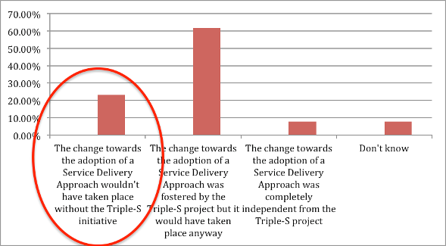
The Triple-S project also played a significant role in changing the conceptions and discourse around sustainability and adopting a service delivery approach in target countries, particularly in Ghana and to a lesser extent in Uganda. In those two countries, Triple-S has articulated concepts of sustainability and service delivery approach in a clear manner and made it accessible to all. More concretely, Triple-S made a major contribution to unpacking the factors affecting sustainability at all possible levels (including the most “local” level) and to developing tools and approaches to work on all those factors. They have also effectively managed to create a “buzz” around those concepts, through the organization of events such as the sustainability fora.
Another very positive influence has been to place the spotlight on the “district” level (i.e. decentralised government level) as a key level at which to engage and provide capacity building, so as to strengthen decentralization and coordinate actors in complex systems. Other actors in the sector either tend to work at the central government level or at the level of implementers on the ground. Following the approach put forward by Triple-S, more actors are willing to consider the local government level in rural areas (and small towns) as a key set of interlocutors to engage with in terms of monitoring, planning and budgeting.

The “whole system change approach” has not yet been proven
According to the Theory of Change for the project, which was defined retrospectively for the project following the MTA, proving the concept in the pilot target districts would provide a strong justification for rolling-out the model and scaling up in other localities. The project’s effectiveness at achieving impact and improving sustainability was mixed however.
In Ghana, significant results were achieved in terms of shifting the sector’s mind set towards a Sustainable Delivery Approach, both at national and local level. However, the expected impacts were not fully achieved (and for some of them, not by far), as there was no marked improvement in service levels in the target districts during the implementation period. Several reasons were put forward for such limited impacts, including the fact that the implementation period was relatively short (hence it is difficult to see observable impacts), that funding was not made available or released to implement the actions identified as necessary but also that, most importantly, that it would have been difficult for the project to deliver substantial change with no associated financing made available for investments. However, the project was much more successful at bringing coherence and alignment in the sector, and clarifying roles and responsibilities. The basis for sustainability of the approach might well be in place, as IRC worked through the lead agency for the sector, CWSA.
In Uganda, success is more contrasted. On the one hand, the consortium is strong and was managed in a participatory manner; on the other hand, the hosting arrangement did not give Triple-S in Uganda the same level of access – or ‘embedding” within the national institution responsible for rural water than in Ghana. Time allocated to the project was probably too short in Uganda (as initially highlighted by IRC when it applied for funding to the Bill and Melinda Gates Foundation). Although 6 years is already a long time for project implementation, some experiments would probably have reached their “tipping point” after a couple of years, assuming that Triple-S (or like-minded organizations) would continue to provide adequate inputs and support, which is unfortunately not the case. More time (and more work on the financing side) would have led the project to a point where the experiments could have started to “resonate” one with another, unlocking the possibility of a true systemic change at sector level. In addition, in Uganda, although the institutional framework was relatively well defined and this was seen as a positive factor initially, it also proved relatively rigid and difficult to change as a result.
The choice of not including any “investment” money in the project was a very strong one but also a risky one. At the end of the day, it remains to be seen whether that was beneficial for the project or not. Providing funding for investment in Ghana and Uganda could have helped boost the functionality indicators in the target districts. It is likely that the combination of no investment money and limited focus on the financing side of the SDA limited the impact that Triple-S could have on the ground and therefore affected the ability for the project to “demonstrate” that issues in the rural sector could be approached in a different way.
This means that, despite several years of sustained efforts in a small number of districts, with substantial “soft” resources made available to support those districts, the concept of “everyone forever”, remains somewhat elusive in those districts. What is somewhat surprising is that such understanding is not necessarily widely shared within the organization or beyond. For example, some IRC staff who are familiar with the Triple-S project although not directly involved were not aware until very recently that service level results had been somewhat unsatisfactory and that therefore the Triple-S model had not yet been proven. Similarly, this situation is not necessarily reflected in IRC’s external communication about the project’s impact. For example, IRC’s communication brochure states that in Ghana in 2012-13, “50,000 people in three pilot districts can trust that if their service breaks down, it will be put right by local government”. Although the numbers of beneficiaries are based on the population that was reached by the Triple-S project in those three pilot districts, the actual impact of the project would have needed to be put into perspective, given that having monitoring systems in place does not necessarily mean that those systems will automatically be put right by the local governments. Funding is often a key limiting factor (amongst others) which means that the issues may not be immediately addressed. This brochure was prepared before difficulties to reach the targets had fully materialised and therefore reflects more the initial project’s ambitions rather than actual results on the ground.

What is the likely legacy of Triple-S?
In its last year of operation, the project has reflected on how its legacy could be ensured, both in the focus countries and at international level. Even though sustainability is now clearly on the map, the “how-to” deliver sustainability of rural water services, the SDA approach and the whole-system approach that is needed to deliver it, would still need to be proven and be better articulated.
Scaling up elements of the Triple-S approach in focus countries will keep it alive in the near term. Triple-S project implementers in the focus countries have placed emphasis on scaling-up and expansion as a way to ensure legacy (so that the Triple-S approach could be replicated in more districts). They have also sought to embed their approach in sectors’ institutions, through building capacity and also supporting the adoption of consolidated sector documents. Such a strategy has been particularly successful in Ghana, where elements of the Triple-S approach are now being scaled up in up to 131 DAs, out of a total of 216 DAs in Ghana at present (thereby reaching 60% of the total number of DAs in the country). Once this additional external funding (coming from the Hilton Foundation, the SMARTerWASH project or the World Bank), it will be necessary to identify national-level sources of funding to consolidate the legacy of the project (for example, to ensure that monitoring is conducted on a regular basis and monitoring results are benchmarked over time and across DAs or to ensure that budgetary allocations for sustainability are effectively transferred to DAs).
The use of Triple-S project ambassadors at international level is unlikely to ensure legacy at international level, except in very specific cases. At the international level, emphasis has been placed on building a network of “Ambassadors” for the Triple-S approach, i.e. a range of leading sector stakeholders and representatives from institutions that have either been indirectly or directly exposed to the project over recent years. They have been tasked with advocating the Triple-S service delivery approach going forward. However, given the lack of clear outputs produced at the international level that spell out in a systematic (or synthesised??) way the accumulated learning from Triple-S, the use of such a medium to ensure legacy may not be as effective as initially hoped for. The so-called “project Ambassadors” have therefore received a rather amorphous mandate. It is not clear that those who had not been previously sensitised to the Triple-S approach and tools will be willing and interested to perpetuate the Triple-S approach. For those who are very familiar with the approach and have effectively embraced it in their own practices, “spreading the word” will be much easier, as it will be part of representing their own organisation’s approach rather than the Triple-S approach per se. Rather than prescribing a specific language or organisational lens, the project in its final year has encouraged its “ambassadors” to articulate key messages in their own language.
Another vehicle to ensure legacy of the approach is of course IRC itself. The project lead implementer has been singularly transformed through the implementation of two large and linked-up projects that have been WASHCost and Triple-S. Some additional funding was in fact provided by the Bill and Melinda Gates Foundation (linked to the Triple-S project) to help strengthen internal systems so as to be able to manage such large multi-country initiatives. In the two focus countries for Triple-S, IRC has functioned as the “backbone organisation” that IRC sees as necessary to promote the “whole system change” approach. This is a terminology from the Collective Impact movement that IRC started introducing when it adopted the “whole system change” approach terminology towards the end of the Triple-S project. The role of such a backbone organisation can vary depending on contexts and on the process for change in that particular context. Primarily, IRC sees the role of this backbone organisation to support the change process by socialising a concept, testing it, validating it and supporting the scaling-up of such a concept later on.
Working as a “backbone organisation” to support change takes specific skills and experience, as well as funding. IRC obtained funding to act as the backbone organisation in two countries (approximately USD 1 million per country per year). Going forward, however, it is unlikely to obtain such a high level of funding for this type of activities over 5 years in other countries. In fact, efforts undertaken to secure this level of funding in other countries have not met with much success so far, except on a smaller scale in Burkina Faso. In the absence of such funding, IRC would therefore need to rethink what can be done to promote the Triple-S approach short of what they sometimes describe as “the full shebang”, i.e. to understand what “light-touch” initiatives can lead to similar outcomes, albeit perhaps over a longer time scale. As initially envisioned by the project’s designers, getting multiple stakeholders to embrace the Service Delivery Approach across multiple geographies is a vast task, even for a project of this size, and it is still “unfinished business”. At this stage, one thing that would definitely help with fostering legacy would be to capture all lessons learned on the “how to” promote services over infrastructure during the rich life of the Triple-S project in a succinct and practical manner that could be easily referred to. This should be done by incorporating the website into IRC’s website and through a webinar series.

Lessons and recommendations
This section draws out the main lessons from the country-level and international work streams and formulates recommendations to enhance the prospect of achieving the Triple-S vision of sustainable water services at scale.

Develop learning on “how” to achieve change by evaluating actual progress
Once stakeholders have been sensitized to achieve sustainability and have decided to move to a service delivery approach, a key challenge is to identify how this can be achieved in consultation with all sector actors and by reflecting local priorities.
The hypothesis underlying the Triple-S project was that a “whole system change approach” is needed and that such an approach should be well articulated and promoted in order to enable its widespread adoption. Such an approach is complex to formalize and to implement in practice, however. This is particularly the case because, at the root of the Triple-S design, is the idea that rural water sectors are “complex adaptive systems” (consisting of multiple actors and relationships, all of which need to work together effectively for services to be delivered) and that driving change in such systems can only be done through promoting learning and consensus-building, rather than based on a magic recipe that can be applied uniformly everywhere (the “silver bullet” approach to the sector problems).
In such a conception, change can only come from within the system itself, rather than being driven by external actors. Where the country is ready to embrace change, this has worked well (as in Ghana, Uganda and to some extent in Burkina Faso). However, where the national context is less conducive (as in Mozambique) or where actors are so numerous and the scale of the country so vast (as in India), creating consensus around the need to change and fostering change has proved much more challenging.
This “whole system change” has somewhat been lost with local partners or with other development partners looking to replicate the “Triple-S approach”.
In Ghana, for example, the selection of experiments resulted in a very strong focus on developing a service level monitoring framework, first on a pilot basis in the target districts, then formalized through sector documents and rolled out to 131 DAs (out of a total of 216 DAs in the country). Other partners that were involved in “rolling out” the so-called Triple-S approach have tended to equate it to monitoring systems in some cases, particularly when they were not so familiar with the overall approach. Focusing on monitoring was definitely the right thing to do in terms of identifying an “entry point”. However, this was done somewhat at the detriment of other areas of focus (such as regulation, or the definition and testing of innovative financial mechanisms to cover the costs of sustainable WASH service provision), which received comparatively less attention and are nonetheless very critical elements of the SDA.
In Uganda, the experiments selected after the MTA focused mainly on monitoring (SDIs, M4W), learning, developing/testing new management models (sub-county WSS boards, handpumps mechanics associations) and coordination / harmonisation (one of the most successful and well-known experiments was to develop a new version of the District Implementation Manual). Visibility of some specific experiments (M4W, Subcounty boards, HPMAs) together with the very limited number of experiments on financing / regulation / asset management issues and the fact that only some experiments were duplicated in the framework of other projects led to progressively put in the background the idea of influencing the whole of the sector – at least in the framework of the triple-S project itself.
Because resources are limited, each of the Triple-S country programme had to focus on a relatively compact set of experiments and studies. These were selected in consultation with sector actors to be complementary of others’ efforts in this area. The Triple-S project teams identified where they could make the best contribution, given what others were doing in other areas (i.e. other building blocks).
This means that none of the country workstreams had the opportunity to work on all of the building blocks in target districts. However, because the efforts undertaken simultaneously by others were not systematically tracked by the project (as opposed to what the project did itself), it is difficult to draw clear conclusions about “what works” and “what does not work” to promote change towards sustainable water supply services in rural areas.
At country level, we recommended that now would be a good time to reapply the Principles Framework as a grid of analysis to evaluate how the rural water sector has evolved during the project implementation period and help lay the basis for a learning agenda going forward and defining areas of priority interventions for the sector as a whole. This would be a good opportunity to “go full circle” on project learning and sector analysis. Failing that, it seems that all the valuable analytical work that had been conducted upstream in the project would not be put to best use and would run the risk of being quickly forgotten.
Some of the “legacy” documents that are now being released, such as the document “Experiences and lessons from the Triple-S initiative in Uganda” which was released in December 2014 presents itself as a collection of stories as told by the individuals who were involved in the inception and implementation of the Initiative in Uganda. As it stands, it is a well written and engaging document, which provides the “human touch” behind what can otherwise appears as a relatively dry collection of technical publications. However, we would argue that a more concise and systematic evaluation of where the sector was five years back and where it is now, conducted based on the Principles framework (or an adaptation of this analytical framework) would be very useful for external audiences and sector experts.

Refine key messages for different audiences
The project, by emphasising complexity, does not lend itself to simple messages. However, key messages from the project need to be carefully crafted to address the expectations of different audiences.
Based on the results of the international consultation and the EPE team assessment, it appears that a clearer articulation of what the “Triple-S” approach is and how it can best be introduced would be needed and would benefit sector actors. This would allow going beyond the relatively simple messages that are disseminated through external presentations (such as the Ambassadors meetings) and would also reflecting learning from activities at country level in a more comparative and consolidated manner. This could take the form of an overall guidance document (aimed at funders or other organisations looking to adopt a similar approach), which would clearly set out “what” needs to be achieved (i.e. a Service Delivery Approach) and “how” this can done (through sector coordination, experimentation, ongoing learning, sharing, harmonisation and adaptive management). Such a guidance document could make ample reference to the Triple-S project’s experiences and learning, in the two focus countries, in the “non-focus” countries and at international level.
The Building Blocks approach has so far provided a good framework for conceptualizing the service delivery approach. As the project wraps up, there is a need to articulate how each of these building blocks interacts with the others and how priorities can best be defined. For example, although monitoring is critical to the Service Delivery Approach, for initiating and verifying progress on the path to progress, it is not sufficient in and of itself to achieve change.
At present, all 10 building blocks are presented at the same level, when some are entry points whilst others are sub-set of others (for example, asset management could be seen as a subset of financing to cover all life-cycle costs). Such approach to presenting the building blocks appears to be largely deliberate, the idea being that countries are presented with a series of “levers” or areas where action is needed in order to deliver whole system change.
Each country would then need to define their own strategy to foster change in those 10 areas and any other that might be relevant in the country context. However, as the prioritization process following the MTA demonstrated, it would be very difficult for any project, organization or sector at country-level to initiate change in all 10 areas simultaneously. This may not even be possible or wise, as it would be essential for such an initiative to identify what others are doing and how to best fill the gaps.
In this area, lessons from the Triple-S implementation at country-level (particularly in focus countries but also elsewhere) should be drawn, either as part of the final documentation of the Triple-S project or through tools that capture the Triple-S approach. This could show in particular how interventions in the different building block areas should ideally be prioritized and sequenced. This could be produced as a very practical “how-to” guide for local governments. Rather than specifying a rigid pathway, such guide could present learning from the Triple-S project implementation but leave ample potential for country level variations and learning at the local level.
Some of the building blocks that received comparatively less attention are those of supporting the professionalization of community management or the recognition and promotion of alternative service providers. These aspects were not addressed by the Ghana workstream although it was partially addressed in Uganda where the project contributed to the establishment of umbrella organisations. This could partly be the result of the fact that Triple-S in its design is very much focused on the local government unit as its target interlocutor, in its drive to operate at the level of a whole district or territorial area. This is indeed a very useful scale to operate at, as local governments in rural areas typically receive limited direct technical assistance.
However, clear guidance about what these local governments can do to support local communities have received comparatively less attention, due to the fact that the project was mostly focused on strengthening District level staff. Interesting examples of such activities include the development of the District Operations Manual with Triple-S support in Ghana. Given that it is local communities that are usually service providers (as opposed to district-level governments), it would be critical to provide direct support to them as well, including in terms of planning and budgeting so as to design adequate tariffs reflecting necessary costs (and partial subsidies, if available).
In addition, despite some limited experiments, the approach has not been very explicit about how to deal with consumers or below the DA level and how to involve them more in the decision-making process or in holding service providers to account so that they deliver a better service going forward.

Consider funding needs in project design
One key element that has been missing from the project to boost its ability to deliver actual impacts is funding for actually implementing change. Triple-S has been effective at “sensitizing” and getting people to understand that a change in approach is needed to achieve sustainability. Several activities under the project have led to the development of tools to monitor progress, budget and plan. But without associated funding, those budgets have remained unfunded and improvements could not be delivered.
We can draw a parallel with the CLTS approach in the sanitation sector: the project has in many ways shown that “triggering” and changing mindsets is critical and that it can be done, when data is systematically gathered and transparency is improved. In the pilot DAs, this has resulted in improved planning and budgeting, to reflect the whole range of costs that need to be considered. However, when it comes to investment, lack of available funding has meant that only limited investments could be made (in the case of CLTS, in unimproved or flimsy latrines; in the case of some districts targeted by Triple-S, in some immediate “remedial measures”, such as mending pumps or replacing those that are obviously not working) but that these investments are not sufficient to sustain change over time, with a considerable risk of “slippage”.
Lack of funding is also frequently cited as a key constraint to sustain the approach to learning promoted by the Triple-S project, which is based on fostering the development of learning alliances at national, regional and local levels. For example, in Ghana, in regions where CWSA is no longer receiving grant funding from bilateral donors (such as in the Volta region, which had long been supported by DANIDA), it is proving extremely difficult for them to carry out their technical assistance functions for the district assemblies and also to consider keeping a learning alliance going beyond the life of the Triple-S project.
There are several potential solutions to address this “lack of funding” issue:
- “Systemic solutions” would involve investing much more effort into identifying and promoting sustainable financial mechanisms for all sector actors, which would enable covering all costs that have been identified through the budgeting process or through other strategic financing planning exercise. This type of effort would be the most beneficial for the sector as a whole in the long-term, as it would provide a strong basis for the sector to finance itself. It is obviously difficult, which is potentially one reason why both WASHCost and Triple-S have shied away from identifying sustainable financing mechanisms to cover the costs that are identified as necessary to be covered (including Opex, Capex, CapManEx but also direct and indirect support costs). It also remains highly dependent on the willingness of national (and local) governments to assign funding for WASH, something over which the Triple-S project only has limited influence;
- Project-based solutions – one potential alternative would be for IRC to either mobilize its own funding for hardware or to partner with other entities that are able to give or lend money but are not prepared to enter into a long-term technical assistance contract with the government.
The first approach is the one that Water for People has applied in six countries, including Bolivia or Uganda for example, as they otherwise apply a similar approach to supporting local governments. It has been used to some extent in follow-up work from the Triple-S project, particularly in Ghana through the Conrad Hilton Foundation grant. Using that approach on a larger scale would suppose that IRC can identify this type of funders going forward.
The second approach would be to link up with development banks (such as the World Bank, Agence Française de Développement, African Development Bank) so that the latter would provide investment funding and aspects of the Triple-S approach would be introduced simultaneously. This is what the Ghana Work Stream has secured for its scaling-up through the existing World Bank small towns and rural project or that it could have done through implementation of the AFD/EIB funded SAWiSTRA project.
Although the last two approaches have been adopted by the project on an ad-hoc basis to increase the chances of post-project sustainability and scaling-up, it would be good to clearly consider the pros and cons of each of these financing models and to articulate the implications for the autonomy and flexible learning principles that underline the Triple-S approach. Based on this analysis, IRC should clearly articulate a partnering and funding strategy for its activities on the one hand, and advice to entities seeking to apply the Triple-S approach.

Improve communication about impact
One area that IRC needs to seriously consider is how it communicates externally on the Triple-S project impacts, and more generally on the impact of activities undertaken based on the Triple-S approach.
The impact of “software support, learning and capacity-building” activities is difficult to measure and issues related to the attribution of impacts are critical. Triple-S has developed interesting qualitative tools in this area which it could probably refine, simplify and promote as ways to conduct the M&E of this type of projects going forward.
Measuring and communication about the impact of capacity building activities is difficult. But these are difficulties that IRC should embrace and confront as opposed to hiding them away and releasing corporate communication that is at odds with the results put forward in the open on the Triple-S project dashboard. This is critical in order for IRC to achieve one of its key objectives, which is to promote a culture of monitoring and transparency in the sector and to move away from a “story-based” type of communication that is more typical of an NGO than of that a “think and do” tank that IRC aspires to be. IRC should therefore present more realistic results in its corporate communication and be upfront about the challenges (and rewards) of implementing a whole system change approach to achieve SDA.
On the other hand, IRC could be more assertive in terms of measuring the scale and impact of what they have achieved and at communicating such impact. At present, emphasis is placed on the results achieved in the pilot Districts where they have worked in the focus countries. However, it would be important to capture the idea of a “swelling wave”, i.e. to track what is happening in the district assemblies where the initial Triple-S approach is being scaled-up. In Ghana and Uganda, this should account for other districts where the approach is being replicated with funding from other development partners (a total of 131 DAs). This would call for strong M&E and for creating a coalition at national level to track funding and results. Based on this, it would be possible to measure the likely impacts of the project in terms of DAs/ LGUs reached or “triggered”, i.e. which are now monitoring their services on a regular basis (say minimum every 2 years). It would then be possible to estimate the number of people who live in those DAs and therefore have a greater chance of obtaining a sustainable service / have benefited from actual service improvements.
Finally, going forward, IRC may consider adopting more of a “platform” approach to setting up websites on specific issues that it wants to promote (e.g. such as public finance for WASH, which is the issue that it is currently promoting). This would allow pulling in experiences, lessons learned and documentation from a much broader range of actors working on similar subjects, using IRC’s convening power to form the basis for a space to share and exchange lessons.

Annexes

Key dates from the Triple-S project
Date | Key events: management / International level |  |  | Country-level
11/2008 | Grant signature
12/2008 | Start of project inception phase (2 countries and 6 years)
2009/2010 | Building relationships and understanding in country and internationally  Launch of the 13-country study  International symposium in Kampala on rural water services and community management (April 2010) | Drafting the outcomes-based approach  Principles framework (adopted 12/2009)  Revised work plan and Toolkit for Strategic (Outcomes based) Planning and Management submitted and adopted  Principles Framework (w/ 11 Building Blocks – first results from 13 Country study) |  | Country scoping and decision to select Ghana and Uganda
05/2010 | End of inception phase
06/2010 until 05/2011 (Year 1) | First and second Sustainability Forum in Washington DC (October 2010 and January 2011) | Building blocks developed  Annex AA developed to show progress in outcomes | Merging of WASHCost and Triple-S International Workstreams for international influencing and networking
12/2010 | Revised grant agreement based on revised work plan
06/2011 until 05/2012 (Year 2) | Change of responsible Project Officer at the BMGF: Triple-S becomes a “legacy project” for the Gates Foundation  Patrick Moriarty takes over from Ton Schouten as project director (July 2011)  WASHCost & Triple-S @ 6th Rural Water Supply Network Forum (Nov 2011)  London sustainable WASH forum (March 2012) | Publication by Practical Action of the 13 Country Study report (end 2011) | IRC adopts Triple-S vision and theory for change (December 2012) | Prioritise outcomes in country  Start of recruitment of researchers in-country
06/2012 until 05/2013 (Year 3) | Mid-Term Assessment (June to October 2012)  Fourth sustainable WASH forum WDC (March 2013) | Revised planning (including experiments) (January 2013)  Revised Theory of Change | International workstream develops vision document | Start of experiments  Prioritise outcomes in country  Start of recruitment of researchers in-country  Evolving partnerships & government leadership
06/2013 until 11/2014 (Year 4) | Working on legacy  End-of-Project Evaluation (May-December 2014) |  | International level work on ambassadors for service delivery, case studies and debates  Sector learning capacity | Government leadership  SDA in country guidelines  Developing theory of whole system change and documenting practice in Ghana and Uganda
11/2014 | End of Project

Questionnaire for international consultation
Number | Question title | Type of  question
IDENTIFICATION OF THE RESPONDENT
1 | Select the country where you are based | Single choice
2 | Indicate your sex | Single choice
3 | Indicate the institution you work for | Single choice
FAMILIARITY WITH TRIPLE S:
4 | Are you familiar with the IRC's Triple-S initiative such as described above? | Single choice
5 | What has been your involvement in the IRC's Triple-S initiative? | Single choice
6 | Which projects within the Triple-S initiative have you had most exposure to? (1= very familiar/ direct involvement; 2 = considerable exposure; 3= limited exposure; 4= not familiar) | Ranking
7 | For how long have you known the IRC's Triple-S initiative? | Single choice
DESIGN OF THE TRIPLE-S INITIATIVE:
8 | Do you think the Triple-S initiative fills a specific gap in thinking and practices about the rural WASH sector? | Single choice
9 | What do you consider to be its most critical contribution | Open question
REACH OF TRIPLE S RESOURCES: (The objective of this section is to assess to what extent the different resources developed by Triple-S have reached an audience internationally)
10 | Are you familiar with any of the following documents produced by Triple-S? (Yes/No)  - Papers outlining the Triple-S Service Delivery approach (e.g. briefing notes on the Building Blocks, Theory of Change)  - Country-level case studies (e.g. 13-country publication on rural water service delivery, country-level baseline assessments)  - Research reports, particularly on specific experiments on going at country level  - Governments' policies, strategies, manuals, procedures that Triple-S directly contributed to  - Think pieces and blogs to trigger sector dialogue  - Communication materials (e.g. videos) | Single choice
11 | Have these publications proved useful for you as sector professional and practitioner? (Very useful/ Useful/ Not useful)  - Papers outlining the Triple-S Service Delivery approach (e.g. briefing notes on the Building Blocks, Theory of Change)  - Country-level case studies (e.g. 13-country publication on rural water service delivery, country-level baseline assessments)  - Research reports, particularly on specific experiments on going at country level  - Governments' policies, strategies, manuals, procedures that Triple-S directly contributed to.  - Think pieces and blogs to trigger sector dialogue  - Communication materials (e.g. videos) | Single choice
12 | What are the most relevant practices or concepts that these publications have inspired you and that you have been able to replicate in your work? | Open question
13 | Have these publications had a significant impact in the way you conduct your work in the WASH sector? | Single choice
14 | Please explain in a few words | Open question
15 | What is, according to you, the usefulness of Triple-S publications compared to other sector publications? | Single choice
16 | How often do you visit the website of the Triple-S initiative, www.waterservicesthatlast.org? | Single choice
17 | Do you consider this website to be a good source of tips and methods to approach the water sector? | Single choice
18 | What is the main information that you look for when visiting this website? | Single choice
19 | Have you taken part in any training session on Water Services that Last organized by Triple-S or IRC? | Single choice
20 | How useful have you found this training event to be in terms of capacity building? | Single choice
21 | Would you say these training sessions have induced a change in your attitudes and practices as sector professional? | Single choice
22 | Please explain in few words what have these training sessions contributed to change in the way you approach the water sector | Open question
23 | Are you familiar with the Triple S communication products such as videos, posters, cartoons, and blogs? | Single choice
24 | Do you think they are good quality communication products? | Single choice
25 | Do you consider these communication products have provoked changes in the way practitioners and people apprehend the development of water services? | Single choice
 | Explain in a few words | Open question
26 | Have you participated in any sector dialogue meeting/event organized in the framework of the Triple-S initiative such as the Sustainability Forum, the Sustainable WASH Forum, the Rural Water Supply Network Forum, Ambassador’s meeting, Learning retreats or similar? | Single choice
 | Please specify which event | Open question
27 | Would you say these sector dialogue events have induced a change in your attitudes an practices as sector professional? | Single choice
28 | If so, please explain in few words what have these sector dialogue events contributed to change in the way you approach the water sector | Open question
29 | Have you assisted to any presentation of Triple-S activities during international events such as the World Water Week, Africa Water Week or similar? | Single choice
 | Please specify which event
IMPACT OF THE TRIPLE S INITIATIVE
Have you witnessed changes over the past 5 years related to:
30 | A shift towards the adoption of a Service Delivery Approach  (This IRC's Triple-S initiative seeks to promote the adoption of a Service Delivery Approach by obtaining a shit from building systems to building services with attention to long-term sustainability and post-construction support. Rather than providing infrastructure, the focus is set on training for staff, develop availability of spare parts and supply chains and markets for rural water supply goods and services.) | Single Choice
31 | Where has this change occurred? | Open question
32 | To what extent do you believe this change has happened as a result of the Triple-S project? | Open question
33 | Elaborate in a few words | Open question
34 | The emergence of a learning and adaptive sector  (This IRC's Triple-S initiative seeks to promote the ability to learn, innovate and adapt to changing circumstances and demands of national WASH sectors in order to be better prepared to support a SDA for rural populations well into the future. | Single Choice
35 | Where has this change occurred? | Open question
36 | To what extent do you believe this change has happened as a result of the Triple-S project? | Open question
37 | Elaborate in a few words | Open question
38 | A better harmonisation and alignment among water actors  This IRC's Triple-S initiative seeks to improve coordination and harmonisation within government-led processes, so that everyone is following the same rules, sharing the same concepts and working towards the same goals. | Single Choice
39 | Where has this change occurred? | Open question
40 | To what extent do you believe this change has happened as a result of the Triple-S project? | Open question
41 | Elaborate in a few words | Open question
42 | Are you aware of any other impacts (positive or negative) the Triple-S initiative | Open question

Results from the international consultation
This appendix presents key results from the international consultation. Responses from the on-line survey and from the direct consultation have been collaged in a common format so as to increase the sample size. Responses have been anonymised and graphical representations of the collated responses are presented where relevant. In addition, as many questions were open questions, we have also reported qualitative answers to these questions in order to convey the wealth of results mobilised through the international consultation exercise.

Respondents location
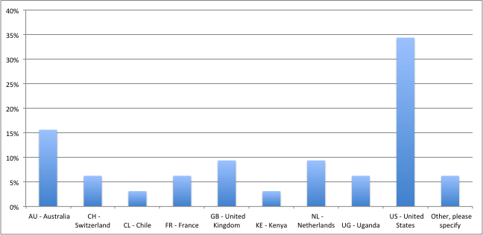

Respondents
In total, the survey and interviews had 36 respondents. The EPE consulted 20 individuals with strong credentials in the water sector in in-depth interview and 16 responses were obtained via the on-line survey. A substantial number of respondents (30%) hailed from NGOs. The following sections highlight responses to various questions in the survey.
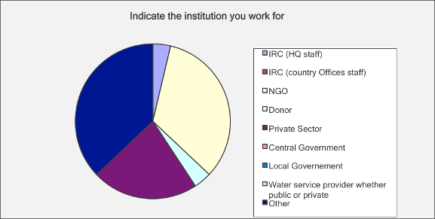

Key survey responses

How have they been involved in the Triple-S initiatives?
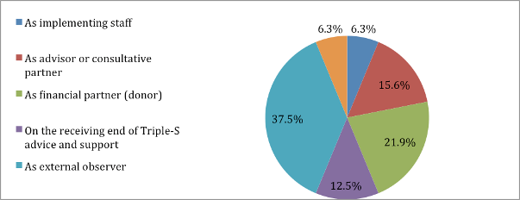

Which projects within the Triple-S initiative have they had most exposure to?
Most respondents were very familiar with Triple-S activities at international level, while many did not know of Triple-S’ involvement in Liberia, Sierra Leone, India or Kenya.
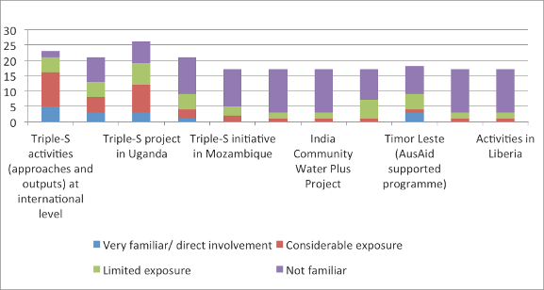

How long have you know the IRC’s Triple-S initiative?
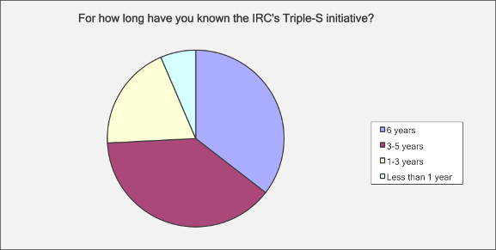

Does the Triple-S initiative fills a specific gap in thinking and practices about the rural WASH sector?
For most respondents (60%), Triple-S does fill a specific gap in thinking and practices in rural WASH. However a comment was that other initiatives were also contributing to filling the gap (40%). Many respondents who thought that Triple-S contributed to fill a specific gap also called for a nuanced response: Triple-S has managed to put the issue of sustainability on the map, but other institutions also did that. They pointed out that Triple-S was particularly good at “creating a buzz” around sustainability. One major gap that it filled was demonstrating that the Triple-S approach could work – as they showed in Ghana particularly.
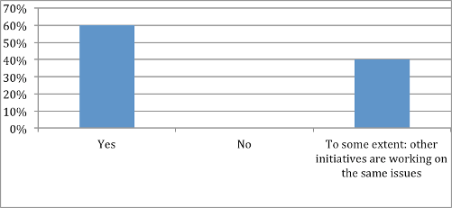
Comments
Specific comment | Type of  institution | Yes/No/Yes and No
There seems in specific country programs to be a recognition that it is important to look beyond implementation and infrastructure. This in itself is not new, but the way Triple-S has written about it and visualised it is new to the sector. | Survey respondent (anonymous)
It has helped raise the profile of rural WASH | Survey respondent (anonymous)
More relevant for work by NGO community | Survey respondent (anonymous)
Don’t know, have not been involved but Triple-S has not been very visible in the parts of the sector where I work | Survey respondent (anonymous)
Without a doubt, this is the case. It has transformed the language and paradigm of the global sector. The depth [of this transformation] is only beginning to be realized. | Survey respondent (anonymous)
As an intro sentence, I would say that others are not comprehensive enough – Triple-S introduced a change from product into service delivery. Gap= conceptual. Watsan focus was on hardware. The gap that was missing was how many other players need to contribute – to make smaller investments last. | Consultant – works a lot with USAID | Yes, conceptual gap (shifting concepts)
They filled a gap in terms of dissemination, not knowledge | UNICEF, NGO | Yes, in dissemination rather than substance
Nobody else is doing this innovative thinking and backing it up with research. Life cycle costing: would not say that it is a gap, only realise after the gap how important it is. | GWC, NGO partner of IRC | Yes
New buzz word = sustainability. No meaning, no common definition. Started talking to Patrick: could answer it in the way that made sense, not just buzz word, something they have been trying to address throughout Triple-S | Hilton Foundation | Yes, but concept needs to be clarified (beyond the buzz)
Ok at identifying gaps in community outreach. But we were not great at proposed solutions. We failed in our definition of focusing rather on HP SW - not on the future for a project that tries to project the sector bases for 10 years. Did not sufficiently discuss the question of scaling and not enough denunciation of the fact that hand pumps are a dead-end | IRC | Yes, but some implementation mistakes
6 years ago: not enough emphasis on this – ok to think of projects – parallel with Sanitation and Water for All (kind of conversations: government leadership, aid effectiveness, putting government in the driver seat, donors giving the right kind of money in the right place). SDA is fundamental to that (Sector Ministers’ meeting in April 2014: was about SDA – makes it easier to have conversations with donors, NGOs) | Consultant | Yes, conceptual shift, right terminology
Yes and no. The Triple -S initiative is not intended for structures like ours that already have strategic thinking in the sector. The innovative aspect of the approach is nuanced: Their service delivery approach is one that his NGO has been applying for 15 years in the water and sanitation sector. This is not a new idea. But it is true that are still a lot of actors who have a classical approach (infrastructure, engineering) without asking the bigger question of sustainability. Triple -S still has a big gap in thinking in terms of Public Policy / sector adapted to contexts taking into account accessibility issues.  AFD also considers this approach. Even relief NGOs are progressing in their strategic thinking. The discussion is now very appropriate and controlled. More and more people are talking about regulation, financial and technical monitoring. Only smaller NGOs continue to have a more traditional approach. | NGO | Yes, but only dissemination
It has changed the focus and helped in the process of decentralization (working at the district level and thinking on the practical way to attain sustainable services). Has helped move other actors into filling the gap there is in the wash sector. | USAID, donor | Yes
Involvement of the sustainability tool: largely inspired from Triple-S – Triple-S has put the concept of sustainability on the table. Has helped to create a significant buzz in addition to what the Dutch have done + Triple-S convening has been of the origins of sustainability discussion: started the conversation. | USAID | yes
Fills a gap in that it articulates the style of thinking that is required for everybody who is involved in the rural water sector. Triple-S is only ONE of the organizations that work on that, it contributes to but doesn’t fill the gap on its own. | EWB | Yes, but Triple-S is ONE institution doing that
Yes – there was a niche that they filled. Sustainability of services so widely discussed now – and it was not the case before. How do you prove attribution?? | Cranfield, academia | Yes, but difficult to prove attribution
Yes It did fill a gap. In some ways, demonstration that this can be done: what they have done in Ghana. If look at overall complex adaptive systems: possible to develop a good relationship with a local government – not out of reach for any type of organisation. But I have the interest of financing organisations (World Bank): demonstration that getting traction at District level + at national level – demonstrated that are intervening at all levels and get results is interesting. | Gates, Donor | Yes
Really useful contribution to pushing agenda of looking at issues of sustainability and services at scale, has come at the right time. Really important part of pushing the debate and really trying to challenge people to think more critically at the services perspective. | NGO | Yes

What is Triple-S’s most critical contribution?
Responses fall into the following categories: (1) research work (gathering evidence, publications and resources), (2) shifting concepts or mainstreaming the SDA approach (this is the SDA approach itself – but it is sometimes confused with WASHCost; shift in terminology), (3) Advocacy (generating debate, bringing forward the concept of sustainability of rural WASH services, building coalitions), (4) M&E tools (including the use of mobile phones for data reporting), (5) Local capacity building.
For nearly half of the respondents (48%), Triple-S’ contribution has been enabling a conceptual and terminological shift among donors and sector practitioners, particularly NGOs. The concept of SDA is recognised as a contribution to the sector. Many (28%) also recognised the important advocacy role Triple-S played in mainstreaming the “services” concept. Some also recognised the impact of Triple-S on the ground in Ghana, while others particularly highlighted Triple-S’s work for building local capacity. Another major contribution to the sector is the Triple-S approach for monitoring service delivery, including via mobile phone technology. It is interesting to highlight that Triple-S’ research work has been seen as a major contribution to only 11% of respondents.
Respondent | Response | Category
Survey | Suggested move from a focus on implementation towards focus on the full life-cycle of a service. | Shifting concepts
Survey | Generating the debate around sustainability of rural water systems - particularly looking a government - private sector relationships. | communications
Survey | Mobile phone for water | M&E tools
Survey | To shift the paradigm from an infrastructure/implementation focus, to one on on-going service delivery | Shifting concepts
Survey | Supporting the alignment rural water system monitoring frameworks - notably in Ghana | M&E tools
Survey | Getting NGOs to think about making systematic and sustainable changes and working through local governments. | Shifting concepts
Survey | New approaches to rural water programs | Shifting concepts
Survey | Triple-S provided leadership in unequivocally outlining the problems with the existing water sector, and then proceeded to provide concrete recommendations and tools which could be used to address these problems. | Not clear
Survey | To execute rigid research (breadth and depth, 6 yrs, many countries) to be able to make sound analysis and deskilling the key factors | Research
Survey | Don't know, probably publications | Research
Survey | Mainstreaming a "service delivery" approach. | Shifting concepts
Survey | Local capacity building | Local capacity building
Survey | The analytical framework that seeks an adaptive approach to looking at key gaps and focusing on critical issues, in situ, as they present themselves in terms of urgency. Working on this collaboratively. | Research and advocacy
Survey | I guess that some people are now using the term services. | Shifting concepts
Interview | Forcing that conceptual shift from product delivery to service delivery + having the support behind it to move that change across the globe. I’m impressed that GF took this on and depressed that they have turned their cheek on it. | Shifting concepts
Interview | Dissemination | Advocacy
Interview | I think its biggest contribution is through advocacy, events – blogs, less convinced about publications, changing projects for RWS, thinking about the service level + contributed to developing the management theme under the RWSN - | Advocacy
Interview | SDA – making it more mainstream.  Not about projects but it’s about services that last. Expect the tap to turn on. Service, not a handpump. Services have specific costs (WASHCost) – part of a broader system (system thinking and public finance: just missed the Triple-S window) – All built | Advocacy
Interview | IRC specialise in working with the governance aspects of delivering water services. To sustain it we need to look at how governments are structured, they are working at the municipal and district levels (where governments have delegated through Water Acts). | No clear
Interview | Provided some vocabulary for that + within USAID some changes: Water Strategy (developed by Water Office): most likely what Triple-S might have influenced – says a lot of sensible things, innovation and technology will save the world, mixes up water resources and WASH | Shifting concepts
Interview | Means implemented by IRC for communication on this approach which allowed for impact on the players. | Advocacy
Interview | Products such as the manual for district level in Uganda and the approach on monitoring for services. Appreciate the practicality of the approach and the tools developed by Triple-S. But it has been always reliance on old data in the WASH sector. It would have been useful if Triple S will have put together a more robust data case as for the sustainability of the rural water sector. | M&E tools
Interview | Fills a gap in that it articulates the style of thinking that is required for everybody who is involved in the rural water sector. | Shifting concepts
Interview | A big contributing factor to that has been resources: such a big budget and no physical hardware – can do an enormous amount of communication and influencing. Different from projects and programmes that are spending quite a lot in terms of service provision on the ground. There was a readiness to hear the message amongst those organisations – the way it’s been presented (with a good deal of analysis/authority and gravitas) has helped. Richard been writing about sustainability since the mid-1990s but was not a critical mass of debate that there is now. Triple-S should take a lot of credit for having placed it on the map. | Advocacy
Interview | Change in language first; switch to service-focused approach; influence on AusAID thinking, especially in Timor Leste; new phase of the civil society WASH programme after 2009-2011 phase: outcomes were changed/rephrased according to Triple-S thinking; also influence on the government about focus on infrastructure and recurrent budget | Shifting concepts
Interview | Helping the entire donor community with a vision of sustainable service a scale and showing different models where it is working. The principles developed by Triple-S can be adapted to local conditions. Triple-S has had a big impact in educating the sector and educating those who fund the sector. | Shifting concepts
Interview | They have demonstrated that you can intervene at all levels (district + national level) to achieve results - demonstrated that you can develop a good relationship with a local government | Research
Interview | Progress on the ground: what has been more interesting. Within the NGO community (tiny proportion of what goes in): much better understanding of sustainability, have been challenged to think differently, whether it makes a difference is a different question. | Shifting concepts

Which publications are you familiar with?
Most respondents were familiar with one or more type of publications. The most familiar type are publications related to the SDA approach (briefing notes, theory of change), followed by country-level case studies and blogs.
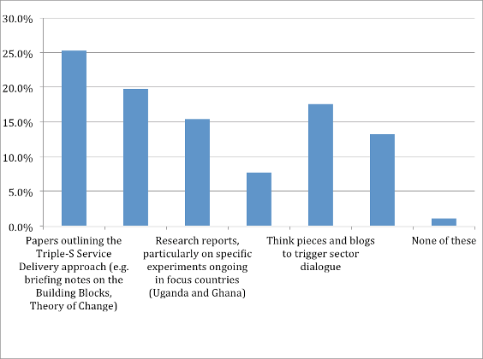

Have these publications proved useful for you as sector professional and practitioner?
Most respondents found many of Triple-S’ publications useful, in particular publications on the SDA approach, but also blogs and thought-provoking pieces.
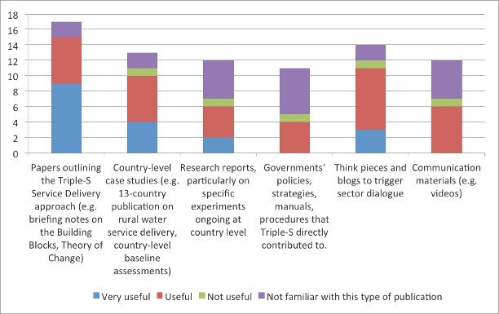

Which Triple-S concepts have proved useful?
Triple-S’ concepts which have had the most resonance among respondents are sustainability … and WASHCost! It is difficult to disentangle the WASHCost legacy from the impact of Triple-S as such – many respondents highlighted that the LCCA had a major impact on their work. For others, although a few, Triple-S’ concepts have not been that relevant. One NGO respondent stated: ”their approach according to which research can enrich public policy seems naïve:. Another NGO respondent stated: “Having money on the table rather than fine words at the beginning of a relationship. Have hardware first as well (put money on the table at the same time as offering the advice), then helps build a relationship that can outlast. It’s a negotiation and it’s very personal”.
Comments
Survey | The focus on full life-cycle cost.
Survey | Papers and country level studies have been useful in my work
Survey | Building blocks for a service delivery approach; Service delivery models
Survey | Good level of stakeholder analysis in Ghana and Burkina Faso reports. So mainly as research inputs.
Survey | Adopting a long term view for sustainability
Survey | The services (ladder) approach (instead of facilities), the crucial role of government, and the need for broad-based partnerships
Survey | Using the clearly defined phrase of "service delivery"
Survey | A different way of monitoring through the SenseMaker work, which was discontinued.
Interview | Yes, useful for achieving the purpose for which they are used for – not for other purposes.
Interview | There is a lot of focus on the SDA which is something that some of us was arguing – they called themselves Triple S so they came from somewhere. The diff areas they focused on where already discussed but they brought it together under one area.
Interview | Quite a superficial level, because a lot of it – I have to admit that a lot of what I read I’ found very woolly, language not very precise (as in concrete). It’s so broad, struggled for focus – management support team have tried to deal with a global problem, all scales, all tech types, as a result there is danger in the generalisation. But some interesting cross-fertilisation of the case study. Sometimes not sure what I could do with it.
Interview | LCCA
Interview | Not necessarily relevant for structures such as ours. Their thinking in terms of political economy is not very advanced. It lacks a reflection on how to develop public policy and to make sure that they are better adapted to local contexts. Enrich sectoral policies.  Their approach that research will enrich public policy seems naive. It Ignores the role of stakeholders, relationships of power. Need to better decipher the sets of stakeholders, political alliances. Triple -S does not have this level of thinking. Whilst for our NGO one of the central issues, is to know how to build public policy with an approach in terms of policy adjustments. This reflection is important in terms of wider impact, not just of the service but of public policy.
Interview | Yes, USAID is in the process of trying to develop their own approach about service delivery. So they are using the Triple-S materials they are looking at.
Interview | SDA, focus on O&M financing
Interview | WASHCost principles. Have also used Case studies that show sustainable services at scale or potential to scale, for their work.
Interview | Has found useful that Triple-S has done discussion around monitoring (WASHCost programme). Tools that have come out of these processes are providing frameworks and interesting ways to help people think and analyse in the areas where we are working. Provides food for thought.  BUT:  They never had any money to change the situation. Having money on the table rather than fine words at the beginning of a relationship. Have hardware first as well (put money on the table at the same time as offering the advice), then helps build a relationship that can outlast.

Have these publications had a significant impact in the way you conduct your work in the WASH sector?
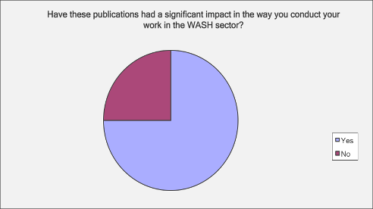

What is according to you, the usefulness of Triple-S publications compared to other sector publications?
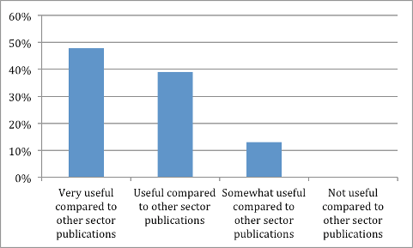
Comments
Interview | I think some of the format are useful (briefing, tech notes – easy to condense)
Interview | IRC publications that we go to the most often. Others publish 1-2 pages summaries (but can also be frustrating in how brief they are). Triple-S have the depth but need to have that entry point: half way to the perfect product.
Interview | Wonder how broadly people know about them. They know because they have been involved in sustainability, but not sure whether these products have been made broadly available among sector actors. But they are very practical compared to other more academic publications.
Interview | Generally Triple-S does some of the better publications.  Because they talk about the really hard problem that no one knows how to solve. The weakness may be the lack Technical specific documents -> ie hydrologic system in Malawi. There are more relevant publications of this type. Publications need to be a different mix of things of Triple-S and other actors' publication.
Interview | Do fill a gap that needs to be filled: set of publications specifically addressing sustainability
Interview | Very useful in comparison to some, because they really shin a light on what's working, why it's working and how that can be replicated.
Interview | Slightly jaundice way of resources: they push an agenda because they are there – people can blog about them and refer to them. How far people are actually using them is a whole different story.

How often do you visit the website of the Triple-S initiative www.waterservicesthatlast.org?
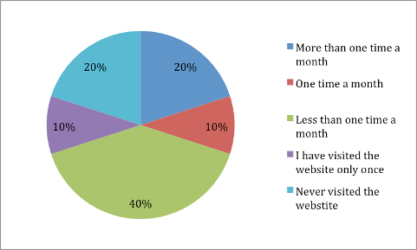

Do you consider this website as a good source of tips and methods to approach the water sector?
100% of respondents said yes and some said that they recommended to others.
Interview | Yes, it has useful issues. The building blocks. You could say there is too many of them: you would say where do you start? It says here they are – no link with one another – it would be more accessible if they were fewer.
Interview | Website: was difficult to navigate, to find what I was looking for.
Interview | Yes interesting website about certain contributors. Less rich than the PS -Eau portal that is older and has more information. French portal Triple- S is not as well equipped. There are interesting things on the English one.
Interview | Yes. At the beginning it was not a "great website", it was hard to get information. But has improved since the recommendations that were made during past assessment. But goes to this website fairly often.
Interview | Yes. Pretty standard website. When he goes, is because he knows what he is looking for. But consults more often the RWSN (they RWSN is very linked to Triple-S). But the Triple-S is : if you don't know Triple-s and don't understand the idea, you wouldn't know what to do with the resources that are on the website.
Interview | Difficult to answer – can’t remember the last time I looked at it. More familiar with the publications of RWSN: very applied, rural water focused material, more practitioner focused – does not cover exactly the same ground – space for both. Sustainability is not their exclusive focus. Small secretariat + one or two other part-time. They get some core funding from SDC + they have to match this core-funding. Keeping the core funding going for the secretariat is quite a challenge. They have been very effective in raising their profile in the last few years – publications are important.
Interview | Yes, I frequently recommend it to NGOs
Interview | Yes, because all their materials are on the site so that it is a comprehensive source of information.
Interview | Availability of the information very high – finding it in an organized way.  What is missing: basic items, 3 top things, 1-page blog. At the beginning: a lot of very technical documents but if you did not know all the building blocks: difficult to tease out what it means.  Working with smaller NGOs: figuring out how you can engage. More in verbal conversation: key pieces that would apply to you. Sending diagrams of the building blocks. Visual representation of WASHCost was very helpful, not enough of Triple-S.  Blogs were more helpful: highlights in more digestible format. Has shifted over time: US audience did not have much of an idea of what is happening with Triple-S until very recently. Field offices might know about it in the countries but not at HQ level. Become more well-known at the international level

What is the main information that you look for when visiting this website? Rank from 1 – 5 where 1 is most important
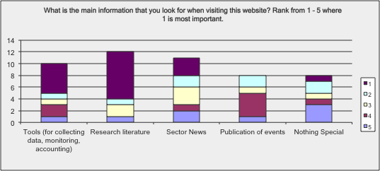

Have you taken part in any training session on "A service delivery Approach" organized by Triple-S or IRC?
Only a minority of respondents (32%) had received training.

How useful have you found this training event to be in terms of capacity building?
Of those who attended a Triple-S training event, 70% thought it was useful, while 30% thought it was very useful.

Would you say these training sessions have induced a change in your attitudes and practices as sector professional?
Nearly all (85%) thought that these trainings induced a change in their attitude and practices.

How what have these training sessions contributed to change in the way you approach the water sector?
The trainings seems to have been useful for provide a language to communicate with others on the need for systemic change. It also enabled gathering data and facts to support and legitimise the approach. Trainings are useful technically, “especially of you are in a situation where you have already built the system that has the political will to do it” But this is also a great limitation: “the hardest problem is not how to use the tool, but how to build the system in which you can use the tool.”
Survey | I found a new angle in my research
Survey | Very useful, particularly for my colleague. I enjoyed learning from other country experiences.
Survey | Helped provide a language to communicate with others in the sector about the systemic institutional changes needed to support better services.
Survey | to re-think my own approach to WASH activities and to working with WASH partners
Survey | Data, facts and information that support the approach and legitimize the sector.
Interview | Useful in a technical sense if you are in a situation where you have already built the system that has the political will to do it (implementing, organisational systems that have the capacity to absorb the results from it). Limitation: the hardest problem is not how to use the tool, but how to build the system in which you can use the tool.

Are you familiar with the Triple-S communication products such as videos, posters, cartoons, blogs?
Most respondents (81%) were familiar with Triple-S communication products such as videos and blogs. Blogs are particularly popular.

Do you think they are good quality communication products?
Nearly all respondents answered “yes”, with a few more contrasted comments:
Interview | Good but not great - great level of depth and thinking need to be laid out – but need for next level communication - availability of short training courses (USAID is now developing a new WASH training course. It would be fantastic if there was a component about building a SDA). There is university WASH consortium. It would be a great step for 3S to develop a short course summary. Why didn’t they do this? Maybe it wasn’t in their mandate. They accomplished in 5 years greatly. They managed to move this so far forward. 3S should have lasted for more than 3 years. They started literally from 0.
Interview | Really liked the video. Blogs: helpful and digestible. Something in between a blog and report is what they need. Shorter briefing notes
Interview | Triple-S is good in terms of marketing, they have good communication products. Regarding the content, it is difficult to see what new elements they bring compared to others. However, their products have a broad reach because they have privileged partnerships (as in the case of ONEA in Burkina Faso).
Interview | Good in some way. Good: clearly tells the story that they are trying to tell in a short and clear way - Negative: they don't tell what to do about the problem and don't really provoke a change in the way you understand the issue. But definitely gives you a general overview of the system.
Interview | They are always thought provoking. Sometimes feel that with blogs and online discussion: people come out with strong opinions that are inevitably based on somewhat limited experience, we are all under constraints. Danger of a small group vociferous opinionated individuals and others following or taking no notice rather than something more considered or more in-depth. Makes me nervous when read very strong opinions: get a ground-swell on opinion which is not based on any real evidence (when it is opinion/prejudice) – more care would need to be taken in writing blogs: be balanced, and not just opinionated.
Interview | Can't comment, don't know them enough
Interview | They are very good - blogs in particular

Do you consider these communication products have provoked changes in the way practitioners and people understand the development of water services?
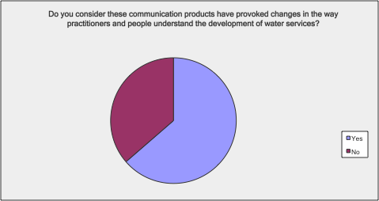

Comments
Survey | I have not used them so much, however I think they are probably very useful communications tools for others
Survey | Less impact by communication products than the research outcomes themselves
Survey | I have seen then used in international forums. They may have more applicability at the country level.
Survey | I don't work in WASH so would have liked the option of 'not able to say'.
Survey | Not sure
Interview | There is not one USAID proposal or RFP which not based on SDA – it’s not hard to make the link
Interview | Yes. They stand out among similar products on the water sector
Interview | Website: complicated to navigate – eventually give up or find it some other way - Don’t have a good enough overview – difficult to say whether they are the right products – a lot of effort into making them readable.

Have you participated in any sector dialogue meeting/event organized in the framework of the Triple-S initiative such as the Sustainability Forum, the Sustainable WASH Forum, the Rural Water Supply Network Forum, Ambassador's meeting, Learning retreats or similar?
80 % of the respondents had participated in some sort of Triple-S initiative:
Survey | RWSN
Survey | Ambassador's meeting
Survey | Ambassador’s meeting (London)
Survey | Ambassador’s meeting
Survey | Learning retreats
Survey | IRC Symposium in Addis
Interview | Symposiums
Interview | Ambassador's meetings, symposium
Interview | Sustainability forums, webinars
Interview | Sustainability forums, webinars
Interview | Ambassadors’ meetings
Interview | Ambassadors’ meetings + Brisbane conference + others
Interview | Conference Triple-S participated in 2012 (Australia)
Interview | Sustainable wash forum

Would you say these sector dialogue events have induced a change in your attitudes and practices as sector professional?
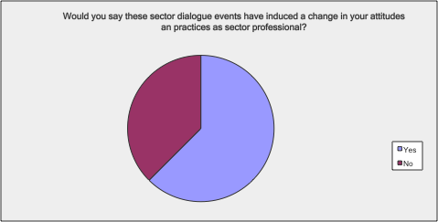
Comments / How have they contributed
Interview | The struggle in these events is that there is always almost the same people of partner institutions but not as much from government parts. Would be more useful that these people be engaged in these events in order to actually foster the change.
Interview | Events have been well-organised, good use of time: where do they lead? Where do they go? A little flurry of communication after the Ambassador’s meeting: not sure that it really led to anything: one feel that the momentum dropped…
Interview | Yes. One of the core services of these events is informing practitioners on sustainable practices and reorienting donors towards a service delivery approach.
Survey | I've written No above, however while not changing my attitude, I feel they have reinforced my thinking.
Survey | No comment- did not attend these events- marked that in previous question but was forced to answer these questions regardless.
Survey | No. Already aware of need for better sustainability outcomes in rural and urban WASH
Survey | see earlier: re-think our usual way of working, and the need to advocate for this new approach
Survey | Nothing to say as I have not been involved
Survey | Legitimizing the sector through data, facts, and analysis rather than simply reiterating the status quo.
Survey | I don't work in WASH but they have helped me realise the organisational constraints for adopting innovative, open-ended M&E.
Survey | I learned much about what is taking place with respect to monitoring in other places
Interview | They have been useful in term of bringing people together, getting people around the concept of SDA and getting people to talk about it.
Interview | Certainly – some of the most influential things: most of the changes in our organisation as a result of Sustainability Forums / webinars. Really hard to sit down and sit a report, easier to listen to Patrick talking at a conference – rather than reading a full report.
Interview | The struggle in these events is that there is always almost the same people of partner institutions but not as much from government parts. Would be more useful that these people be engaged in these events in order to actually foster the change.
I Interview | Yes, in many ways. But the more relevant question is in what way this relationship with triple S changed his insights on the sector. And gives also a concrete talking point to engage people onto something else i.e. link with Triple-S is globally relevant in a lot of places as opposed to just my own country.

Have you, over the past 5 years, witnessed changes at the international level (including in the country where you work) related to a shift towards the adoption of a Service Delivery Approach, which is to say changes in allocation of finance for capacity building; programme focus on supporting supply chain development; programme support for policy & strategy revision in partner countries... etc.?
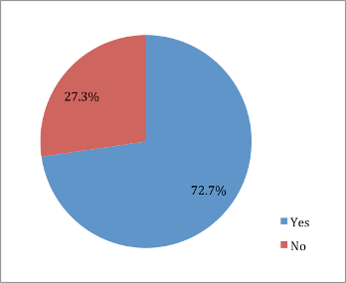

Where has this change occurred?
Survey | Timor-Leste
Survey | Within donors and within partner governments
Survey | Sector dialogues
Survey | Many countries in LAC
Survey | In the sustainability clause of DGIS, the sustainability compacts of UNICEF etc. Also the awareness overall: a debate in Stockholm, in the awareness by professionals for sustainability of services
Interview | Globally - among donors
Interview | I think there is a change – but difficulty is the timescale: it takes 10 to 15 years for those to be taken up – getting traction now 10m years after we started. Although there is a change of thinking in a lot of organisation, it will take time to filter down how programmes are designed and implemented, bearing in mind the turn over. You can completely send a concept to head office but in many case implementation decision are made at country level. That’s why the impact has been greatest where 3S is working, The legacy of 3S you will see in Ghana – a relationship that is funded to continue. Interesting to compare with Uganda. This will be the test of legacy, if Uganda looks for further support
Interview | US level: has changed  DGIS/ USAID taking it to heart – few agencies would talk about projects any more, a lot is due to triple-s. From my small perspective: has taken place. Service Delivery: was not much around before Triple-S – only origin for that idea. Heard about it from triple-S, giving it a name, fleshing out (back of everyone’s minds)
Interview | In Madagascar and Burkina Faso, for example, this approach is already in the sector politics. The question that arises is that of implementation. The theory is already there. But how do we move from theory to practice and how to encourage the players to be familiar with this approach. Triple -S helped to spread a number of concepts and models. But as for the impact, I do not think that TS has made a significant contribution.
Interview | Ethiopia and Ghana - not convinced about Uganda
Interview | In Canada in native communities. Trying to improve thinking and practices in asset management. Before they were building systems without answering to the question who is going to pay for it. But then a more global approach was introduced how to actually manage infrastructure. People recognized asset management as an issue.
Interview | AusAid, globally
Interview | Yes, it has happened. The approach is used by other implementing partners that GETF funds: Water for people, Water aid, World Vision (Ethiopia, where the program also focuses on sustainability of water services)... Most of their programmes already work that way. In most of the countries where they work, implementing partners are working on this approach.
Interview | There is more awareness on service delivery - now the next step has to in practice

To what extent do you believe this change has happened as a result of the Triple-S project?
For the majority of respondent (61%), the change towards the SDA approach was fostered by the Triple-S project, although it would have taken place anyway. As some said: “It’s difficult to answer. Triple-S may have had impact but difficult to see where sector discussions have also influenced”. Several respondent said that others were working in parallel towards sustainable services, albeit less visibly. Still, 23% of respondent said that the changes that occurred in the rural sector in recent year could be attributed to Triple-S’ influence: “No one talks about a WASH without SDA – it’s huge that the concept is everywhere. If you read through their strategy, the broad concepts are embedded in there – so no way it would have happened without Triple-S.” One respondent tempered the big shift in the sector: “Triple-S has had some influence in the right direction – but there is still a long way to go!” It remains that some (7%) didn’t think that Triple-S played a role in bringing change to the sector.

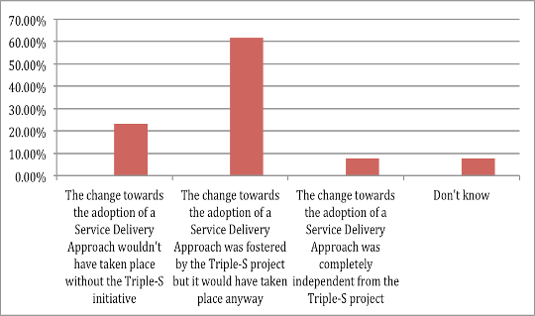
Comments
Survey | Being able to draw on the approach being promoted through Triple S has been very useful for us. I think the Triple S has also been influential with donors, which in turn supports a change in country level approaches.
Survey | The changes I have witnessed are not solely the result of Triple-S, but rather of Triple-S combined with other forces converging at the same time- creating reinforcement of the put forward by Triple-S.
Survey | The SDA was already a known and used concept in urban WASH. Triple-S has helped somewhat by getting the rural WASH sector to pay more attention to SDA.
Survey | Attribution is often difficult but this research, and the related advocacy, has certainly accelerated and contributed strongly to the emergent feeling that output-based interventions are not enough
Interview | No one talks about a WASH without SDA – it’s huge that the concept is everywhere, particularly in USAID. If you read through their strategy, the broad concepts are embedded in there – so no way it would have happened without Triple-S. Maybe the depth of it is missing.  Worked for Plan and USAID, the concepts are all in there – whether they will award us the contract will depend on how important these concepts are for USAID. Triple-S really focused on rural water service delivery – but this is also talked about in sanitation – Triple-S even had a role to play for sustainable sanitation – how CLTS creates demand for a service, then you create and provide that service. Hard for me to believe that this would have happened otherwise
Interview | That’s difficult to answer. Triple-S may have had impact but difficult to see where sector discussions have also influenced (UNICEF for example has done work around this)
Interview | I don’t think I can attribute changes to DPs (including ADB) to Triple-S – DPs are interested – but the NGOs make the difference. The most active, vocal = from NGOs. You don’t hear that much from DPs or government – but there are listing. My feeling is that these difference initiatives. W4P / Triple-S have been working together and amplify each other.  WaterAid involved at very high level and implement at low level –WaterAid have also a lot of influence and do it more quietly and subtly.
Interview | Triple-S has had some influence in the right direction – but there is still a long way to go! Even with that budget: still not enough to bring about that kind of change. More talk about SDA: phrase that I hear more and more – people don’t necessarily know what it means but at least they use the expression.
Interview | Difficult to say

Have you, over the past 5 years, witnessed changes at the international level (including in the country where you work) related to the emergence of a water sector with better ability to learn, innovate and adapt to circumstances and demands?
68.4% replied yes and 31.6% replied no.
Specific comments
Interview | Better ability to learn = yes – the sector has learnt, new concepts have emerged (from product to a service); Better ability to innovate = Yes – how do you put the concepts into practice will real NGO, government – but we’re just at the point where we want more guidance on how to do things, be innovative
Interview | Not convinced it’s relevant. Learning and piloting, testing generating evidence, knowledge – there may have been an increased emphasis but no change.
Interview | People are prepared to talk about coordination but much less about harmonisation and real alignment with single government-led programmes Learning: very easy to talk about it and really do, who really has the time to do it – quite abstract concepts – all 3 of them: Triple-S might have done differently - One criticism: not enough concrete action. Would rather see practical changes on the ground leading to policy changes rather than a lot of policy that is never implemented

Where has this change occurred?
Survey | Indonesia
Survey | Donors
Survey | in the debate amongst donors whether and how to include sustainability in their programs
Survey | In procurement language and emphases of international bilateral donors.
Survey | I think that as move from a post-conflict stage into a development stage they are more able to reflect rather than react

To what extent do you believe this change has happened as a result of the Triple-S project?
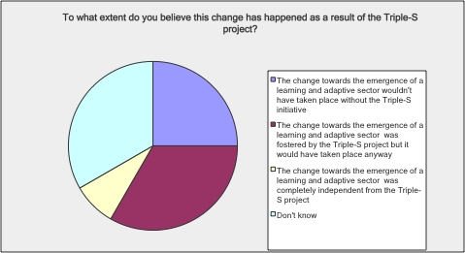
Comments:
Survey | I see it as a general movement in the sector. Triple-S has obvious been part of this movement and probably speeded it up.
Survey | There has been a lot more discussion and investment in understanding and building sustainability. As mentioned before, influencing donors, and multilateral WASH agencies has been critical.
Survey | The indicated statement is very clear. The hazard is that the change should not be expended to deepen and maintain the current level of data and rigor is the effort does receive incremental support.
Interview | Yes – Triple-S has been the foundation in the shift in concepts in the sector.
Interview | More of a focus on evidence – not clear that they are more ready to learn: the two are separate, not necessarily mean they are learning more. Triple-S did a good job pushing the need for evidence, change from business as usual: calling for more evidence-driven work.
Interview | I do not really see what it might have been promoting apart from through their training program. In Burkina they helped circulate information, they have an institutional anchoring. So they brought interesting material. But there are not really any examples.
Interview | Yes but Really hard to make that direct attribution to Triple-S project. So many people have been engaged in this. Triple-S has been right at the core of the conversation, but there is so many people who have been in this conversation it might not been directly attributable to IRC and Triple S.
Interview | It is more a logical evolution in the sector but it has been informed by the work of Triple-S.

Have you, over the past 5 years, witnessed changes related to a better harmonisation and alignment among water actors?
52.9% replied yes and 47.1% replied no.
Comments
Interview | If you just look at the donor world, it is much more harmonised - in people’s heads, USAID maybe does it a bit superficially – nobody who is a thought-leader doesn’t talk about sustainable service delivery – but this needs to be pushed to that next level. Would be ideal to push to it that next level where harmonisation becomes practice
Interview | Yes – I supposed so, that’s an increasing trend.

Where has this change occurred?
Survey | At conference level, email list, joint projects etc.
Survey | Timor-Leste
Survey | In Liberia
Survey | Through forums organized by the project.
Interview | Coca-Cola: work in 35 countries. In-country coordination is happening more – not clear about whether Triple-S played a role in that. Ghana/Uganda are very organised – work is very piece-meal, don’t get involved in sector coordination mechanisms.
Interview | Madagascar, no coordination of actors when they have no institutional leader. Burkina, fragmented market. Harmonisation and alignment cannot be done by a non-governmental player, but rather by a government actor who will implement an approach promoting harmonization and coordination. Needs a strong institutional leadership (government or donor)
Survey | In Timor Leste, change definitely occurred, difficult to attribute to Triple-S - In Indonesia (I did an evaluation for the World Bank) focus was on systemic level, withdrawing from a strictly infrastructure-focused approach

To what extent do you believe this change has happened as a result of the Triple-S project?
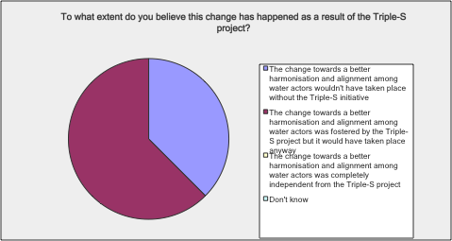

Comments:
Survey | I am not sure the extent it is depended on Triple S, however Triple S has been a big player in increased harmonisation & alignment.
Survey | Triple-S project inspired dialogue and focus on a service delivery approach amongst government, a large bilateral initiative and NGOs working in the sector.
Survey | The WASH sector would remain backward looking and content without the driving rigor from the initiative. This momentum - as high as it is - is at absolute risk of loss without the existence of the project or an equivalent forum of focus.
Interview | I would be a bit sceptical. It may have had an impact in Ghana and Uganda were thee had concerted efforts but don’t have the evidence to say that.
Interview | The main contribution of Triple-S here has been bringing donors and practitioners to the Sustainable Delivery Approach.

Are you aware of any other impacts (positive or negative) resulting from the Triple-S initiative? Please elaborate
Survey | I have found Triple S to have positive impact, as detailed before. Well done!!
Survey | The impacts I'm aware of have been positive – changing mind-sets and short-termed-ness within the aid and development community.
Survey | Not aware
Survey | Positive work with our institution
Survey | All 3 questions I have answered in the negative BECAUSE I DO NOT WORK IN THE WASH SECTOR. So I have skewed the survey with my answers but 'Yes' would have been incorrect.
Interview | All of the fractured discussions on sustainability of wash sector. Plenty of organisations have their own agenda. Negative impact of so many ways to achieve sustainability and indicators to measure achievements. Sustainability is very confusing right now. We have different models of sustainability. We need to put the practice in the message – what it took to achieve SS at scale. It’s another reason why this type of projects is important – it achieved this huge amount. But need to advance on the basis of what’s done on the ground. Plenty of org would say what sustainability is. What they were able to achieve at donors level – the shift in concept and language that had ramifications in multiple places. Triple-S has sown the seeds of good practices but too early to reap the benefits. How do these concepts become a new way of practice, that’s the question.
Interview | Triple-S, pressure on IRC to deliver according to Triple-S – they tried to get involve and gain ownership. Under the UNICEF programmes funded by Dutch government, we were required to do sustainability checks, it has a great impact, emphasis on sustainability (raising awareness among governments). That was a strong impact, which came from the Dutch government. Then IRC/Triple-S came in with strong opinions – they jumped on the band wagon, not asked where it came from. This created “bad feelings” between the UNICEF and IRC. They tried to boost the Triple-S brand.  Moriarty wrote a blog which was on Triple-S website and had a strong opinions about accountability of development agencies. Would have been good to get UNICEF’s views – not good to build partnerships with UNICEF. I know that the head of global WASH at UNICEF was not happy about it. It was about sustainability checks.
Interview | I don’t think I can attribute changes to DPs (including ADB) to Triple-S – DPS are interested – but the NGOs make the difference. The most active, vocal = from NGOs. You don’t hear that much from DPs or government – but there are listing. My feeling is that these difference initiatives. W4P/3S have been working together and amplify each other. WaterAid was involved at very high level and implement at low level –WaterAid have also a lot of influence and do it more quietly and subtly.  Triple-S tried and failed the SenseMaker. Talking to Ton who was very enthusiastic about it. I don’t know why It didn’t work, they tried something outside the box. I don’t think they should be criticised for failing this, they tried something different  What they tried to do = intangible.  The changes in the sector will take too long to be seen  The thing is that it’s important because traditional projects with log frames have not been working  You look at big funding going to Tanzania installing stuff – there might be some ideas but political pressures for implementers to do what they want.
Interview | Triple-S platform has been transformative. Independent platform for disseminating sustainability learning: Triple-S made the bridge when needed to be made (AguaConsult contributed)
Interview | Noticed: a lot of what has come out is “motherhood and apple pie” – cannot disagree with them: go beyond the generalities. Looking for tools: big concern about WASHCost. Was very keen, very important, we all needed it: never came out with anything that they could use. Hoping that Triple-S does not fall into the same trap.
Interview | They managed to popularize/ make more accessible a number of concepts on something very consistent. This unique performance. Even if there are players who already use this approach , they are the only ones to have developed an analytical framework set of tools for this approach.
Interview | Sustainability tool: laundry list of what should be in place – not seen the tool applied in a functional way – not seen it applied in the way it was supposed to be used. Not sure that they helped end it everywhere new. Not added much substance. Sustainability tool: a bit too complex – tried to work through it in contexts that are more country programmes. Hiring Harold’s company to design programmes based on observations (countries are very opinion – cannot be handed over to the user) – complex and too flexible: cannot provide any benchmarking with other programmes.
Interview | Monitoring: has gone furthest – quite a bit of emphasis on it – has been the most successful, has been taken forward under the SmarterWASH project. Will not lead to better services. Has been saying that from beginning – some nervousness: have to show that things are improving. Districts need other things as well. It’s a small piece of the puzzle: that’s not the whole puzzle. It's a little bit early to see the impact.
Interview | No negative impacts.  Greatest impact of Triple-S is not at the country level. They did not really achieve spectacular changes. But what Triple-S has certainly done very well has been to strengthen the existing community and adding people to this community, and making people work together with a common language. Water for people wouldn't been such a success without the Triple S contribution, they created that sort of space, that allowed global relationships that would not have existed with the same power.
Interview | One criticism: not enough concrete action. Would rather see practical changes on the ground leading to policy changes rather than a lot of policy that is never implemented. Uganda: seeing is believing – show me things that work on the ground, and then I will believe and I will change.

List of people consulted at international level
Name | Position
Chris McGahey | Independent Consultant
Peter Harvey | UNICEF, East Africa Regional coordinator
Sean Furey | Rural Water Services Network (Skat Foundation)
Brian Banks | Director of Strategic Initiatives  Global Environment and Technology Foundation (GETF)
Cassilde Brénière | Head of the Water and Sanitation Department,  Agence Française de Développement (AFD)
Chris Dunston | Senior (International) Programme Officer, Hilton Foundation
Clarissa Brocklehurst | Independent Consultant
Frédéric Naulet | WASH senior expert, GRET (French NGO)
Heather Skilling | USAID Global Water Team
Jesse Shapiro | USAID, WASH Advisor and Sanitation
Anthony Kolb | USAID, Urban Health Advisor
Mike Kang | Engineers Without Borders
Richard Carter | Independent Consultant
Juliet Willetts | Associate Professor, Research Director, Institute for Sustainable Futures (ISF), University of Technology, Sydney, Australia
Monica Ellis | CEO , Global Environment and Technology Foundation (GETF)
Elynn Walter | Sustainability Director, WASH Advocates
Jan Wilhem Rosenboom | Gates Foundation, Senior Program Officer – WASH
Nick Burn | Head of International Programmes , Water for People
Rachel Cardone | Independent Consultant  Former Program Officer, Gates Foundation
Additional stakeholders were contacted via the online survey. However, their names are not available since the answers were anonymised.
Project staff at international level consulted are included in the table below:
Name | Position
Patrick Moriarty | IRC, CEO
Christelle Pezon | IRC, Programme officer
Deirdre Casella | IRC, Programme Officer, Monitoring, Learning & Training
Ton Schouten | IRC, Triple-S former Programme Director
Christophe Nothomb | IRC, Triple-S Programme Manager (since 2010)
Harold Lockwood | Aguaconsult – Triple-S International Workstream Lead
Julia Boulenouar | Aguaconsult
Richard Ward | Aguaconsult
Ryan Schweitzer | Aguaconsult
Marieke Adank | IRC, Programme officer
Stef Smits | IRC, Triple-S research workstream
Sarah Carriger | IRC, Triple-S communication workstream
Elise Wach | IDS – International Learning Facilitator
Juste Nansi | IRC, Country Director Burkina Faso
Alana Potter | IRC South Africa / Mozambique
Kurian Baby | IRC India
Ruzica Jacimovic | IRC, worked on the QDA

See chapter B (Triple-S design) for a definition of this concept.
See for example: A principle-based approach to sustainable rural water services at scale: moving from vision to action, Working paper 1, Stef Smits, Harold Lockwood, Anna Le Gouais, Ton Schouten, Vida Duti and Jane Nabunnya, IRC International Water and Sanitation Centre, January 2012.
This is not specific to Triple-S but appears more like a general trend in the relationship between IRC and the Gates Foundation. The WASHCost EPE report also underlines that “the Gates Foundation’s engagement declined in the latter years of the project” (section 2.2).
The International Work Stream was not formally in place at the outset of the Triple-S project.
2011, IRC/Aguaconsult, Lessons for Rural Water Supply, Uganda Report
Ministry of Water and Environment, Network for Water and Sanitation (NETWAS), Uganda Water and Sanitation NGO Network (UWASNET), SNV Netherlands Development Organisation Uganda and IRC International Water and Sanitation Centre.
Since the field visit took place (July 2014), Triple-S has produced such a document (November 2014).
Based on Google Analytics figures.
See http://waterservicesthatlast.wordpress.com/2014/02/07/the-performance-of-piped-water-systems-versus-handpumps-in-growing-rural-growth-centres-2500-to-7500-people/
Incidentally, these initial ambitions are still reflected on the waterservicesthatlast.org website, which has not been updated since the start of the project and does not reflect that many of the initial plans were in fact not implemented.
Source: interview with Stef Smits, 1st of December 2014.

