November 2014

Turning CLTS Challenges into Opportunities for Success
  - Pan-African CLTS Programme: Empowering self-help sanitation of rural and peri-urban communities and schools in Africa.
Marielle Snel and Ruzica Jacimovic

Prepared by Snel, M., and Jacimovic, R.. For questions or clarifications, contact IRC here: www.ircwash.org/contact-us

This paper focuses on both the strengths and the challenges existing around Community Led-total Sanitation approach. This is done through the administration of two survey monkeys, in 2011 and 2012 to the PLAN country offices who have been involved in the Pan-Africa programme. This paper aims to help the different Plan Country Offices (CO) that are active within the Pan-African CLTS programme to find solutions for their challenges and also aims to be a useful document for other organisations that are implementing CLTS and are facing challenges.

IRC
Bezuidenhoutseweg 2
2594 AV The Hague
The Netherlands

T: +31 70 3044000
www.ircwash.org

Copyright © IRC, 2014.
This work is licensed under the Creative Commons License
Attribution-Non-Commercial-ShareAlike
View copyright terms here:
http://creativecommons.org/licenses/by-nc-sa/3.0/nl/deed.en

Contents
Abbreviations 4
Introduction 5
Background Information 6
The Pan-African CLTS Programme 6
Progress of the Programme after two and half years into the programme 6
Background CLTS 7
Main challenges and solutions 9
Pre-triggering phase 12
Challenges & Solutions 12
Triggering phase 14
Post-Triggering phase 16
Gender sensitive, pro-poor and community empowerment issues 18
Conclusions & Future Steps 20
References 22
Annex 1: Results from the Pan-Africa programme survey (October 2011) 23
Annex 2: Results on post-trigger from the Pan-Africa Programme per country 27
Annex 3: Taking Community Led Total Sanitation to scale with quality 34
Annex 4: CLTS debate at IRC (in IRC synergy week Oct. 2011) 38

Tables
Table 1 Overview of the CLTS approach 8
Table 2 Challenges in CLTS in the Pan-Africa Programme 11

Figures
Figure 1 The three phases of the CLTS Approach 9

Graphs
Graph 1 Accumulative overview of the experiences around the CLTS programme in 2011 and 2012 10
Graph 2 Accumulative overview of the experiences around the CLTS in the pre-trigger phase 12
Graph 3 Accumulative overview of the experiences around the CLTS in the trigger phase 14
Graph 4 Accumulative overview of the experiences around the CLTS in the post-trigger phase 16
Graph 5 Accumulative overview of the experiences around the CLTS in terms of gender sensitivity, pro-poor and community empowerment issues 18
Graph 6 Accumulative overview on if the poor and marginalized group benefit from the CLTS programme 19
Graph 7 Accumulative overview on up gradation of their sanitation facility 19
Graph 8 Accumulative overview on what CLTS would achieve 20

Abbreviations
CLTS: Community-Led Total Sanitation
IDS: Institute of Development Studies
IRC: IRC International Water and Sanitation Centre
OD: Open Defecation
ODF: Open Defecation Free
RESA: Plan Regional East and Southern Africa office
SLTS: School-Led Total Sanitation

Introduction
It is increasingly recognised that sanitation remains the big gap in achieving the WASH Millennium Development Goals (MDGs). In response, various water and sanitation organisations have almost exclusively focused their efforts and resources on sanitation as a new niche area (Smet, et al., 2011, more references). One of the MDG targets is to halve the proportion of people without access to sanitation by the year 2015. Estimates made by the Joint Monitoring Programme (JMP) on Water Supply and Sanitation, co-ordinated by the United Nations Children’s Fund (UNICEF) and the World Health Organization, indicate that at the current rate of progress, the world will miss the target by 1 billion people (WHO/UNICEF, 2010). If this occurs, approximately 2.7 billion people will still lack adequate sanitation in 2015. At the current rate, this modest target, which still denies 50 (percent or %) of people in need, will not be met until the year 2072 particularly in sub-Saharan Africa. Meanwhile, with diarrhoea remaining the second highest single cause of child mortality worldwide (Bryce et al., 2005), increasing access to sanitation is imperative. Given the slow rate of increase in sanitation provision, it is clear that conventional approaches are inadequate and new strategies are required to accelerate coverage.
Over the past decades, governments and development organisations have mainly focused their attention on improving the drinking water supply. However, it has been proven that improving the sanitation and hygiene situation is a much more effective way to reduce water-related diseases. Unfortunately, improving the sanitation and hygiene situation in developing countries isn’t easy and is a slow process. It entails changings people’s behaviour toward very personal and cultural habits. And, because the subject is often still taboo, it’s a less attractive topic for politicians and donors. Many methods have been used to improve the sanitation situation; free toilets were built, or poor households received subsidies in order to construct their own latrines. But very often, households would continue their cultural habit of open defecation in the bush and the free or subsidized toilet buildings were converted to shops or used as chicken runs (IDS, 2012).
This is why Plan has chosen to improve the sanitation and hygiene situation in developing countries without any subsidies. Plan uses the Community Led Total Sanitation (CLTS) approach that focuses on igniting a change in sanitation behaviour. CLTS focuses on educating about the dangers of open defecations and emphasizes the sense of disgust about this practice. This in turn builds and encourages eliminating open defecation and adopting improved sanitation. When people observe and measure the negative effects of open defecation by themselves, they often decide on their own that they want to change this situation. The CLTS approach focuses on local ownership to end open defecation and adopt improved sanitation and hygiene without external subsidies. CLTS was first implemented in Bangladesh in 1999 and has since spread to other parts of Asia, Africa and Latin America. In 2010 the Dutch Plan launched a large regional Community Led Total Sanitation (CLTS) programme in eight countries in Africa in order to reduce risky sanitation and hygiene, and so lower infant and child morbidity and mortality. Because the programme is active in East and West Africa, it is called ’The Pan-African CLTS programme’.
The CLTS approach is a relatively new approach which offers many opportunities, but also many challenges (Haq and Bode, 2008). In order to overcome these challenges and improve the CLTS approach, Plan has asked IRC, International Water and Sanitation Centre, to monitor the challenges that the 8 different country offices encounter within the Pan-African CLTS programme each year, and to look at the solutions that they have found themselves or that other organisations have used to overcome these challenges.
In October 2011 the IRC International Water and Sanitation Centre, conducted the first inventory of the different challenges and solutions of the Pan-African CLTS programme. The outcome of this inventory is described in this paper. A second questionnaire was sent out in August/September 2012. Based on results from both questionnaires (and internal discussions) this paper was developed in 2013. This paper aims to help the different Plan Country Offices (CO) that are active within the Pan-African CLTS programme to find solutions for their challenges and also aims to be a useful document for other organisations that are implementing CLTS and are facing challenges.

Background Information

The Pan-African CLTS Programme
In 2010, Plan launched a large regional Community Led Total Sanitation (CLTS) programme in eight countries in Africa. The general objectives of the Pan-African CLTS programme are to reduce infant and child morbidity and mortality in Ethiopia, Uganda, Kenya, Malawi, Zambia, Ghana, Sierra Leone and Niger. To accomplish this, Plan wants to empower 2.6 million people living within 805 rural and 36 peri-urban communities, including 742 schools to improve their sanitation and hygiene situation through the use of CLTS. In addition to this general objective, the programme also aims to improve the CLTS approach by sharing experiences through learning alliances, action learning, and promoting the CLTS approach internationally, in order to increase usage with/through more organisations and in more countries.
The Pan-African CLTS programme is co-financed by the Dutch Ministry of Foreign Affairs and is being implemented between January 2010 and December 2014. During the first two years, a solid basis has been laid and good progress has been made. Also, lessons have been learned that can be used to improve the reimplementation of the Pan-African programme, from which other CLTS programmes can benefit as well.

Progress of the Programme after two and half years into the programme
In the first and second year, over 400 communities of the targeted 805 communities have attained the ODF status and many more are awaiting ODF verification. Households in the ODF communities are demonstrating good hygiene practices and national governments in five of the eight countries in the programme have recognized CLTS as an effective, low-cost approach to promoting good sanitation and have incorporated it in their national policies and plans. Plan is working with health centres to improve their record keeping for monitoring the health impact of the programme. Preliminary data has indicated a reduction in the number of cases of water-borne diseases in those communities that have attained the ODF status.
Besides the Plan Country Offices, other partners in the programme include the Plan Netherlands office, Plan Regional East and Southern Africa office (RESA), IRC International Water and Sanitation Centre (IRC) and the Institute of Development Studies (IDS), which all provide back-up support to the Plan country offices. Since the programme has now run for two and a half years, it was decided that now would be a useful time to reflect on the initial reactions on the functionality of the Community-Led Total Sanitation (CLTS) approach in the programme.

Background CLTS
CLTS focuses on the behavioural change needed to ensure real and sustainable sanitation and hygiene improvements. It invests in community mobilisation instead of hardware, and shifts the focus from toilet construction for individual households to the creation of “open defecation-free” villages. By raising awareness within communities that as long as even a minority of its population continues to defecate in the open, everyone is at risk, CLTS triggers the community’s desire for change and propels them into action until freedom from open defecation has been achieved.
Box 1: CLTS in a nutshell
CLTS builds on participatory approaches such as PRA (Participatory Rural Appraisal). The following six factors are cited by CLTS promoters as key characteristics of the approach:
1. The community is seen as the key driver for safe sanitation efforts;
2. The community is the unit of assessment for monitoring open defecation;
3. Facilitators enable communities to do their own analysis and planning;
4. Low-cost local latrine designs are encouraged;
5. No hardware-related subsidy, but triggering collective analysis and commitment to change;
6. Households maintain and improve their toilet facility themselves so that separation from faeces is maintained.
For further information on CLTS see: http://www.communityledtotalsanitation.org/
Source: Kar, K. and Chambers, R. 2008.
Igniting the community. This approach empowers the community to build and use latrines without prescribing standards or designs. It emphasizes innovation, mutual support and appropriate local solutions; encouraging greater ownership and sustainability. CLTS facilitators help communities to analyse their sanitation “profile” and highlight the links between open defecation and the faecal–oral transmission of diarrhoeal diseases. A common way of capturing people’s interest is for facilitators and community members to conduct a transect walk through the village. A discussion of village sanitation is easily prompted by asking questions to establish who uses which areas for defecation, which different types of latrines are in use, where women go, and what happens during the night or in bad weather. The unpleasant sight and smell of large-scale open defecation in the presence of a visitor to the community are key factors in triggering community action; disgust and embarrassment generally result in an immediate desire to stop open defecation.
Mapping is also a useful tool for involving all community members in a practical and visual analysis of their sanitation situation. A simple map of the community is drawn, usually on the ground, and all households are asked to locate their homes, indicating whether they have latrines and where they go for defecation. The map can highlight how people are defecating virtually on each other’s doorstep, how far they have to walk to defecate, and how their water sources are at risk of contamination. Other health-related safety issues can include demonstrating the distances that flies can cover between excreta and food storage and supplies.
Calculating the amount of faeces produced and deposited by all open defecators helps to illustrate the magnitude of the problem. The resulting high quantities shock the community and lead to questions about where it all goes and the possible effects of having so much of it in their surroundings. These types of inquiries get the community thinking about the possible effects, without any need for preaching or teaching from the facilitators. CLTS is not about persuading communities to stop open defecation and start constructing toilets – it’s about igniting a sense of impurity, often deeply linked to religious or cultural beliefs, which itself compels people to shift to fixed-point defecation in a covered pit. With the realisation that everyone is virtually ingesting each other’s faeces, intense arguments begin about how the situation can be improved. If questions are directed at the facilitators, they reply that, as outsiders, they have little knowledge of the local situation and that the community itself knows the best course of action, and is free to choose action, including continuing open defecation. However, the disgust people feel when they are confronted with the reality of their waste usually leads to immediate collective action based on local expertise and materials to build simple toilets. Instead of waiting for funding to build expensive toilet facilities, they build their own basic latrines and, more importantly, start using them – often in a matter of weeks or months. Over time, and using examples and advice from the more skilled builders, many households move to more durable, hygienic and advanced toilet models (Bongartz, 2008). Although CLTS is relatively expensive because it requires trained staff support over a relatively long period, it maintains the absence of external subsidy and offers long-term effectiveness and sustainability due to behaviour change, making it an attractive approach to improving sanitation.
The following table gives an overview of the CLTS approach in relation to traditional sanitation.
Table 1 Overview of the CLTS approach
Major shifts from the traditional sanitation approach to CLTS | Traditional Sanitation | CLTS approach
Major emphasis given on | Toilet construction | Empowerment of people
Mode of learning | Verbal | Visual
Role of community | Passive recipient of ideas, technologies and subsidies | Active analysts and innovators
Areas of major shift | Traditional Sanitation (TDPS) | CLTS approach
Outsider’s role | Teaching, advising, prescribing and supplying hardware | Facilitating a process of change and empowerment
Major outcome | Increased number of latrines | ODF communities and no faeces in the open
Areas of major shift | Traditional Sanitation(TDPS) | CLTS approach
Toilet designs are undertaken by | Out side engineers | Insiders and community engineers
Indicators of measurement of change | Number of toilets built | Number of ODF communities
Major inputs | Sanitary hardware, subsidies in cash or materials | Software/ training and capacity building
Source: Peal, A., Evans, B., and Voorden, C. van der. 2011.

Main challenges and solutions
In order to better understand the issues around CLTS and identify the main challenges in the Pan-Africa programme, preliminary discussions were held with the country team leaders (see Table 1 below). Thereafter, an electronic questionnaire (via Survey Monkey) was designed and conducted in September and October 2011. The target audience who completed the survey were the Plan country officers who are leading the Pan-Africa programme in their countries. Although the sample size was relatively small (16 respondents), the response rate was very good (100%). The sample size was limited to key Plan country officers because they have been heavily involved in each part of the project design; implementation as well as field work.
Based on discussions between IRC and the eight Country Offices of Plan, IRC developed an overview of the main challenges mentioned within the three different phases of the CLTS approach; the pre-triggering, triggering and post-triggering phase during the first two years of the project.
Figure 1 The three phases of the CLTS Approach
- Pre-triggering phase

- Triggering phase

- Post-triggering phase

Source: Kar, and Chambers.2008
Figure 1 gives an overview of the issues and challenges in the Pan-Africa programme, within the three phases of the CLTS approach, as cited by Plan country teams. Based on these challenges, a further analysis of the types of stumbling blocks, as well as possible solutions, was conducted using an electronic survey (survey monkey) sent to each of the Plan country offices. In addition, possible solutions were discovered on the basis of back to office reports, field notes, other literature and further information from the Plan country offices.
During the electronic survey, Country Offices were also asked to rate their experiences with the overview of the experiences around the CLTS programme in 2011 and 2012. CLTS approach within the Pan-African Programme. The table below provides an accumulative overview.

Graph 1 Accumulative overview of the experiences around the CLTS programme in 2011 and 2012
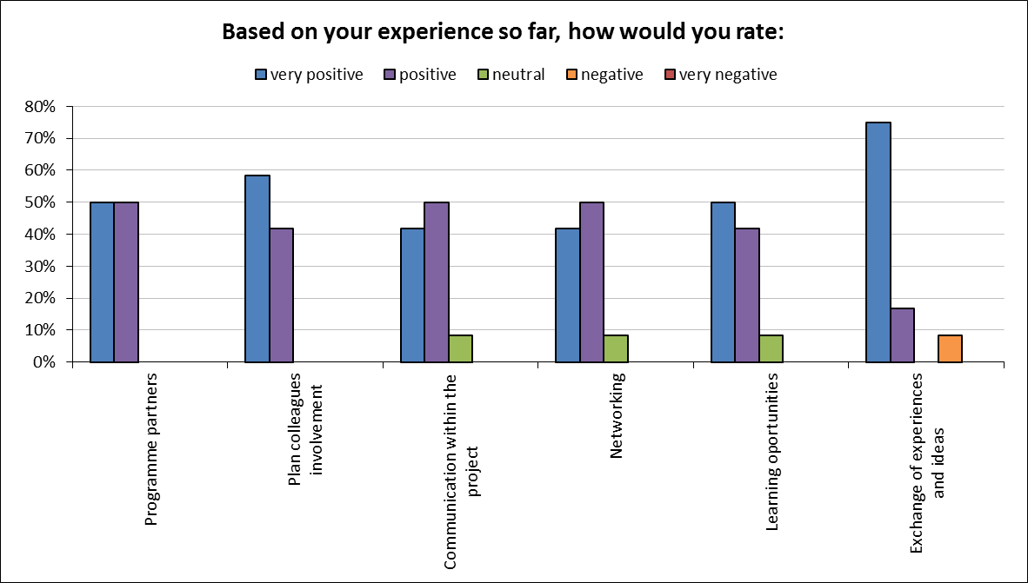
Source: Snel and Jacimovic. 2012.

From the results, it is clear that the Plan country offices are generally satisfied, with the exception of between 41% and 58% regarding the work of programme partners. However, there seems to be a need for more networking, communication, and exchange of experiences in the programme.
In the following table, a focus is placed on the challenges around CLTS in the Pan-Africa programme. It brings to light some of the key areas which need to be addressed in the pre-triggering, triggering and post-triggering phase.
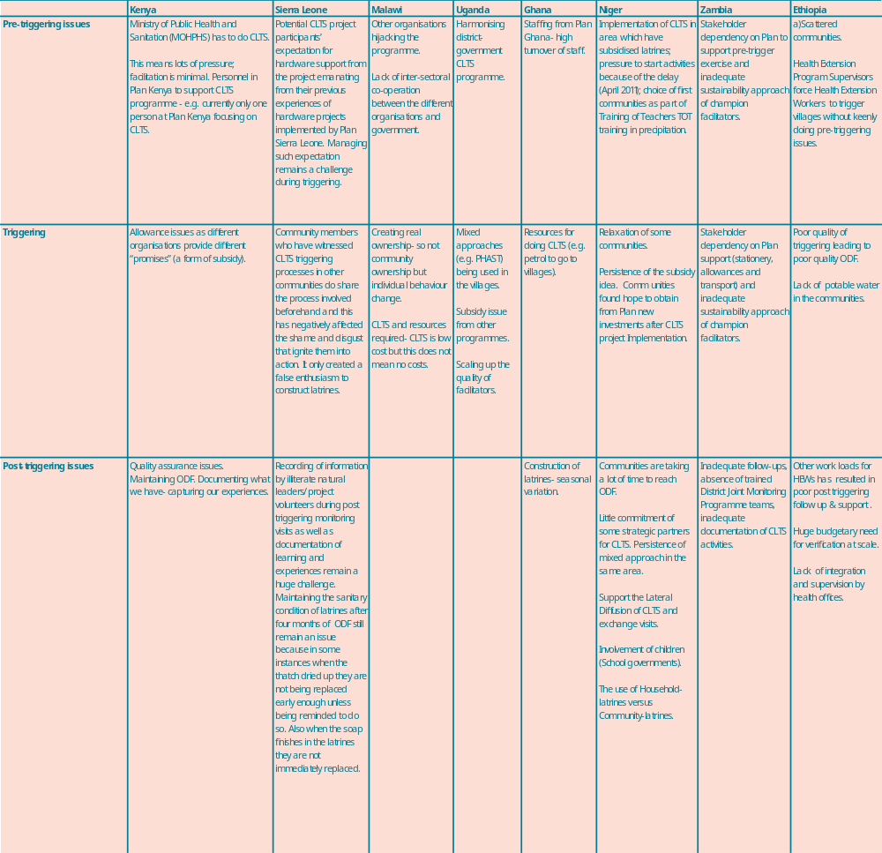
Table 2 Challenges in CLTS in the Pan-Africa Programme

Pre-triggering phase
The pre-triggering phase refers to the preparation phase of raising awareness of the risk that open defecation presents and to reinforce a natural sense of ‘disgust’. Within the context of the two surveys over the period 2010-2011, namely lack of government support and inter-sectoral communication within government were considered key issues by all the Plan country offices in terms of why CLTS was not fully getting off the ground (refer to graph 2).
Graph 2 Accumulative overview of the experiences around the CLTS in the pre-trigger phase
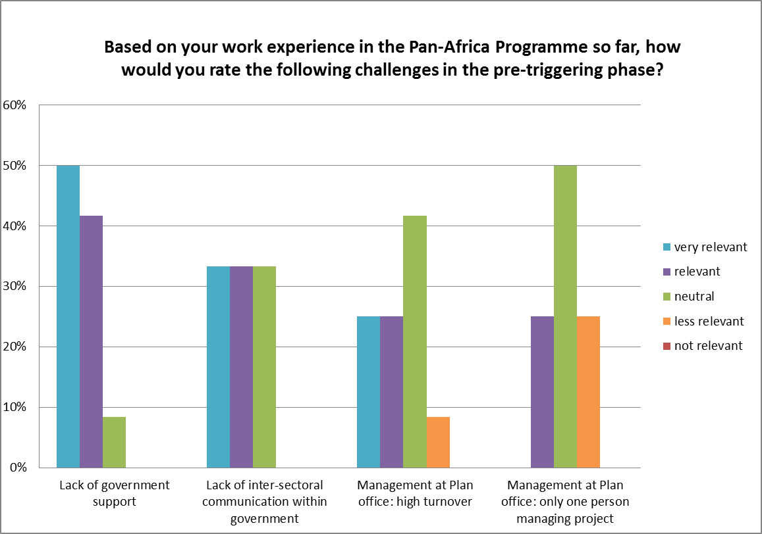
Source:: Snel and Jacimovic. 2012.

Challenges & Solutions
CLTS is a very labour intensive approach, which means that it is necessary to have sufficient manpower within the Plan office dedicated to the programme. High turnover within Plan country offices can be a major problem, especially because personnel need to be trained in order to implement the CLTS approach effectively. Plan Kenya, in the second survey, noted the need to find ways for motivating and retaining staff who have been trained. Recruiting more staff at the Project Unit (PU) level who are fully engaged in doing CLTS work with partners is essential. In terms of solutions, two of the Plan country offices cite practical solutions; namely: Plan Kenya has identified champions who understand the philosophy behind CLTS and are able to monitor and support frontline staff. Plan Malawi has identified a focus on capacity building of a selected team of individuals for continuity and institutional memory.
In order to increase government support, different COs mention that they have involved the government right from the beginning of the programme, so that they can have real ownership in the Pan-African programme. In East Africa, Plan Kenya has, for example, trained the District health workers to conduct triggering sessions and supported village leaders while triggering. Plan Kenya also requested that certain staff members in government who are passionate about CLTS, should get the opportunity to work full-time to support the CLTS. In the second year of the survey, Plan Kenya also noted the need for using evidence-based advocacy, e.g. research and documentation, to reflect the cost benefit analysis of CLTS. There is a great need to invest in monitoring and evaluation, research and knowledge management of CLTS, of which there is not enough currently taking place. Plan Malawi has a rural sanitation strategy, which links CLTS by government staff, to raise demand to local supply services to meet those demands by local private sector. Plan Zambia, in the second survey, cited the “three tier approach”, which they use that involved Chiefs, extension staff and civic leaders, including natural leaders. Plan Malawi notes that a system could be created that ensures full engagement of government and its ownership by ensuring that roles and description of certain activities with regards to CLTS are part of Government. Plan Uganda, in the second survey, cites government should be involved from the project inception, up to end, so that they take ownership and scale up CLTS in other areas. Therefore, during pre-triggering, inception meetings are held with government/local government to agree on roles and responsibilities in the project.
According to Plan Uganda, capacity building of relevant government officials in CLTS processes is also considered vital to enhance buy in. Plan Ethiopia cites in both surveys that they make a point to plan together with government bodies and continue dialogue and good relations with government stakeholders, which as a result has meant the acceptance of CLTS (formally and informally) at the national level. In West Africa, Plan Sierra Leone cites the need to engage and support capacity building of government officials. They state specifically that the Ministry of Health and Sanitation and district councils have provided essential support for implementing CLTS and bringing it to scale. In addition, there is significant attention made to build capacity of government partners involved in CLTS. Plan Niger, although it does not cite a specific solution, it does note that through cluster WASH planning, there is a pledge for supporting the approach CLTS at different key WASH occasions, such as the forum on Water and Sanitation in Niamey-2012.
In terms of lack of inter-sectoral communication within government in East Africa, Plan Zambia notes the important role that government has taken to make sector reforms, especially in launching the National Rural Water Supply and Sanitation Programme (2006-2015). Similarly, Plan Malawi notes a clear national ODF strategy for better inter-sectoral communication and mentions a number of unique features, namely scaling up implementation of CLTS in a cost-effective way to increase demand for basic sanitation, which is the current strategy. In the West Africa region, Plan Sierra Leone also cites that there is currently coordination of a national strategy as a means of bridging the gap of inter-sectoral communication within government. In the second survey, Plan Sierra Leone cites that government line ministries like the Ministry of Health and Sanitation need to strengthen the coordination of inter-sectoral communication through sharing of updates and the coordination of activities of implementing partners in health. This could be done through the development of a communication wing that is responsible for the planning and coordination of inter-sectoral activities. In Niger, the Plan office notes that although a policy on CLTS in the rural areas exists, it is not yet clearly adopted. This entails not only the formal recognition of the policy, but also the informal commitment of those in power to support others in spreading this approach.

Triggering phase
The triggering phase of CLTS refers to the community members analysing their own sanitation situation, including the extent of open defecation and the spread of faecal-oral contamination that detrimentally affects everyone. A variety of tools are used in the triggering phase including: focus group discussions, transect walks, mapping of open defecation sites, and faecal calculations (that calculate the total weight of faeces produced and circulating in the community). Throughout, the crude local equivalent word for ‘faeces’ is always used. The approach aims to generate a sense of ‘disgust’ and ‘shame’ amongst the community. They collectively realise the terrible impact that open defecation is having, leading to a moment of ‘ignition’ when the community initiates collective local action to improve sanitation within their community.
Within the context of this survey, lack of resources for undertaking CLTS was considered the key issues in terms of what is required in the triggering phase (refer to graph 3).
Graph 3 Accumulative overview of the experiences around the CLTS in the trigger phase
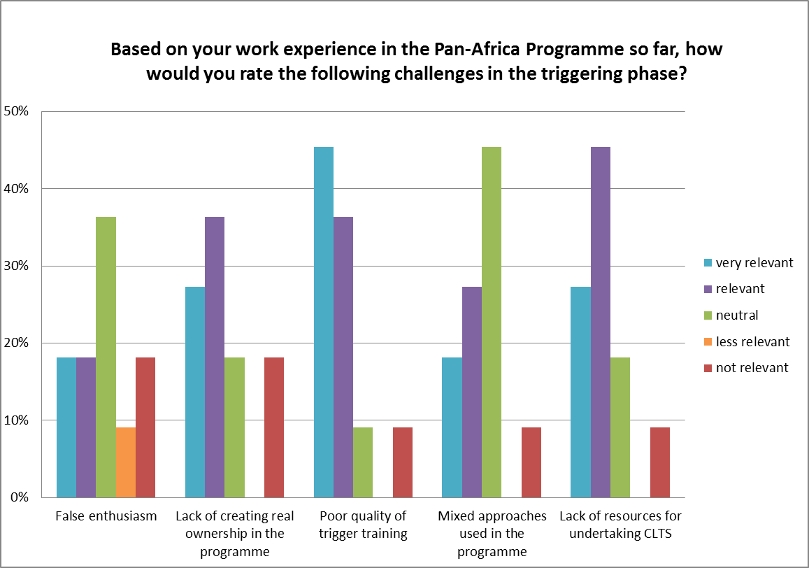
Source: Snel and Jacimovic. 2012.
Clearly the triggering part of the CLTS approach is critical for its success. Inevitably lack of resources remains a key challenge, but some of the Plan country offices in East Africa have come up with some interesting solutions. Plan Ethiopia has established faeces (chilo in Ethiopian) eradication school clubs that promote CLTS in Fura and Taremessa. Plan Malawi has mentioned the important role of traditional and religious leaders to promote communities to mobilise their own resources. In Kenya, organisations in Plan’s project are involved in different resource mobilization endeavours to fill the financial gap. They also collaborate in order to benefit from the synergy of working together and have adopted innovative ways of cutting down on costs. In West Africa, Plan Sierra Leone organises awareness raising and sensitization meetings for neighbouring communities, inviting them to witness ODF celebrations. They also facilitate community learning and experience sharing visits to post ODF communities.
In East Africa, Plan Kenya mentions that there is a need to use different entry points with multiple players and not rely solely on the Ministry of Public Health and Sanitation. In the second survey, Plan Kenya mentioned the need for quality assurance- the need to institute some standards of measurement e.g. set aside some resources to support natural leaders and partners to follow-up after triggering. In Plan Uganda, a mention is made on trigger training which has to be conducted by an experienced and knowledgeable facilitator in CLTS. Plan Uganda emphasises the importance for the facilitator to avoid using lecture method and mixing approaches. As far as practical solutions to create real ownership of the CLTS approach, the teams from Plan Kenya in Kilifi and Homa Bay have decided to work with staff from other line ministries, the local administration (chiefs and village elders), community health workers, youth and children for triggering more villages and to undertake follow-up, monitoring, evaluation and simple documentation. Plan Malawi reports the involvement of traditional and religious leaders to accelerate community-level progress. In the second survey, Plan Malawi emphasises the need to focus on one CLTS approach initially and once people have adopted their behaviour around this concept, to then focus on other approaches such as sanitation marketing, etc. Plan Zambia cites the emphasis on follow-up after triggering. Plan Ethiopia mentions how ODF-communities in Fura and Taremessan district stimulate CLTS initiatives by involving neighbouring villages. In the second survey, Plan Ethiopia emphasises the need for quality triggering not only for communities to be ODF faster but also towards long term sustainability. In West Africa, Plan Sierra Leone includes improvement of long term sustainability by quality constructed latrines in their sensitization and awareness training. In the case of Plan Niger, there is the suggestion of getting other colleagues from other development projects to integrate the CLTS approach in their programmes.
To counteract poor quality triggering, in West Africa, Plan Sierra Leone mentions organizing hands-on training around CLTS. In the second survey, Plan Sierra Leone mentions the need to involve community members from the inception of the project with the use of an experienced trainer. Plan Sierra Leone also cites the need at this phase to advocate to the central government and local councils to increase budgets around CLTS activities. Plan Niger made a careful selection of trainers to have quality triggering training for those communities that joined the programme in 2011. In East Africa, Plan Kenya has corrected poor quality triggering through training for improved triggering skills. In Plan Ethiopia, there is a trend that kebeles reach the ODF-status within two months after they have been triggered. This is faster than with the regular CLTS approach and requires more careful triggering training to help communities understand and practice CLTS more rapidly. For Plan Zambia, the Ministry of Local Government is currently training and retraining district CLTS facilitators who will be able to equally train the grassroots so that there is quality assurance. Plan Malawi has taken another approach, with most efforts on sensitization and awareness training taking place at community level.
Finally, different solutions are under testing to counteract false enthusiasm. In East Africa- Plan Kenya has focused on regular meetings with stakeholders to create a sense of programme ownership. The government line ministries and the provincial administration have been involved in these meetings, because they are main duty bearers in improving sanitation services in the rural communities. Through their participation in the CLTS process the communities themselves also now appreciate that good sanitation is in their own interests. These factors contribute to enhancing ownership of the programme. Plan Malawi has focused on working in close collaboration with government extension workers, such as health surveillance assistants. As part of their job descriptions, these assistants must focus on ensuring that communities have adopted good sanitation and hygiene practices. Plan Ethiopia has focused on a mass campaign in which more kebeles are triggered at the same time many government staff, not just a few trained CLTS facilitators. The CLTS approach is also taught by school teachers, with the idea of creating a great sense of clear ownership by all members of the community, including students and thereby eliminating any false enthusiasm. Plan Sierra Leone mentions awareness raising and sensitization meetings and inviting community members to witness ODF celebrations. Another means has been through post-ODF visits, by making sure that communities remain motivated and constant in their efforts to remain ODF.

Post-Triggering phase
The post-triggering phase of CLTS refers to the translation of the awareness and momentum from the triggering into action plans and the implementation of these plans and monitoring the results to make and keep the community open defecation free (ODF). Importantly, CLTS facilitators steer towards ignition, but they never lead or enforce a decision to take action, as this has to come from the household members themselves. After assessing the sanitation situation in their community, the household members develop a community plan to stop open defecation and promote more hygienic behaviour, which eventually leads to the construction and universal and hygienic use of latrines by all households.
The survey shows how in this stage, maintaining the ODF status and assuring the quality of the toilets are the main challenges to CLTS in the post-triggering phase (refer graph 4)
Graph 4 Accumulative overview of the experiences around the CLTS in the post-trigger phase
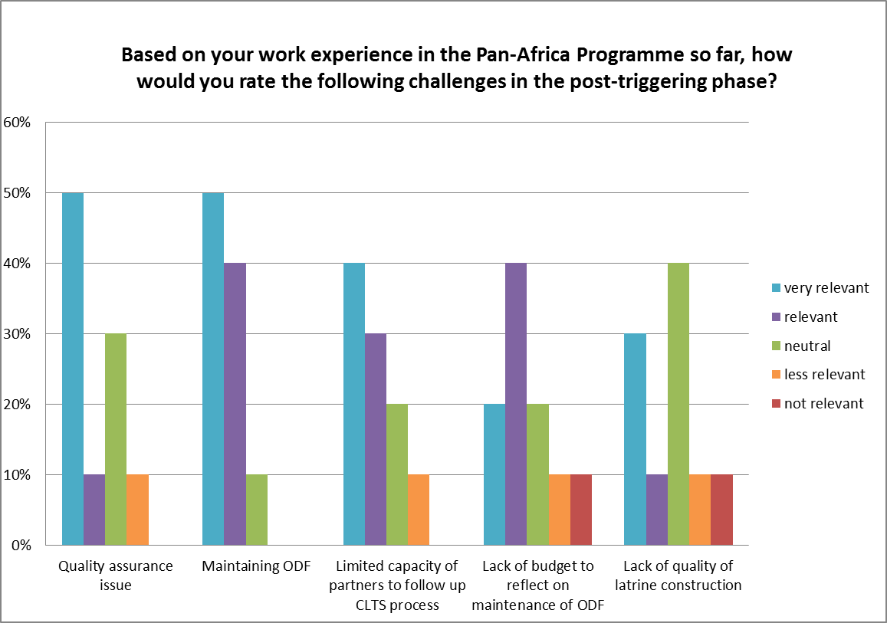
Source: Snel and Jacimovic. 2012.

Some of the practical solutions found in East Africa are the following. Plan Kenya focuses on high commitment from regular follow-ups by the natural leaders. For effective follow-up support, there is a need for careful monitoring, evaluation and documentation of the post triggering phase. They have learnt that there is a need to set aside time and resources for these activities. In the second survey, Plan Kenya cited community-led periodic reflections to take stoke on their status, identify weakness and how these could be addressed. Their suggestion is that this be done during, for example, the World Toilet Day Week or another special day focusing on health-related issues. Plan Uganda cites a need for a quality assurance a team of community-based persons/volunteers needs to be assembled and build their capacity to monitor community action plans developed during triggering and ODF progress. Plan Malawi focuses on working in close coordination with Government extension workers, such as Health Surveillance Assistants. Following up conditions after achieving an ODF status is part of their work to ensure that communities adopt good sanitation and hygiene practices and maintain ODF behaviours. Plan Zambia makes efforts to develop the capacities of the grass root Sanitation Action Groups for monitoring ODF behaviours and the conditions of the latrines. The capacity building is to enable these local groups to make effective follow-ups with support from the district teams. District Joint Monitoring Programme teams are trained in order to strengthen legal enforcement aspects of CLTS and also help in ODF certifications. In the same context, Plan Zambia is working closely with the field-based Environmental Health Technologists (EHTS), who are now documenting CLTS activities at the Rural Health Centre level. Plan Zambia in the second survey cites the creation of a third-party certification to ensure quality assurance issues. In addition, Plan Zambia also cites budgeting for post ODF verification should be done after one or two years after ODF with the introduction of sanitation marketing. Plan Ethiopia has focused on establishing and following up on natural leaders’ networks to improve the maintenance of the ODF status. In the second survey, Plan Ethiopia cites using a number of platforms such as the community conversation family dialogue, coffee ceremonies, as a means of reflecting if ODF has taken place over a period of time. Meanwhile, Plan Uganda has designed a range of interventions beyond ODF to keep the established momentum, such as hygiene promotion, sanitation marketing, and intervening through cooperation with local organisations created by other sectors such as the agricultural groups, etc.
To improve the quality of constructed toilets, Plan Zambia states that the Government has come up with latrine standards. Latrines that are considered adequate are Ventilated Improved Pit (VIP) latrines, Sanplat latrines with reinforced concrete sanitary platforms, traditional latrines with smooth (cemented) floors, Ecosan toilets in which urine is collected separately to be used as free natural fertiliser and allow the remaining faeces to compost faster, and pour flush toilets with a pan and a water-seal. However, most latrines that are under CLTS are traditional latrines. The programme now needs to encourage households to move up the sanitation ladder through sanitation marketing and the creation of Public Private Partnerships, or PPP, between the government and local businesses interested in including or expanding a line of low-cost sanitation services. This can include explaining models and bills of quantities, selling parts and materials, and providing building, repair and emptying services. Plan Kenya has reflected that one of the key factors that has led to successful quality assurance has been the regular follow-ups and high commitment on the part of the natural leaders. In West Africa, Plan Niger focuses on strengthening the quality of latrines through implementing exchange visits between communities in order to share experience on the design and construction of the latrines. Plan Sierra Leone has taken an alternative approach, which is to focus on local artisans who will fabricate and sell high-quality sanitation facilities, e.g. slabs, roofing material and sitting type toilets, but for a low-cost that is affordable for community members.

Gender sensitive, pro-poor and community empowerment issues
Within the context of the second 2012 survey, a number of key questions were also asked regarding gender sensitivity, pro-poor and community empowerment issues. Based on the survey results which have been transformed into a bar chart, the role that women play within the Pan-Africa programme is considered quite strong with around 44% compared to only around 22% amounts men (graph 5).
Graph 5 Accumulative overview of the experiences around the CLTS in terms of gender sensitivity, pro-poor and community empowerment issues
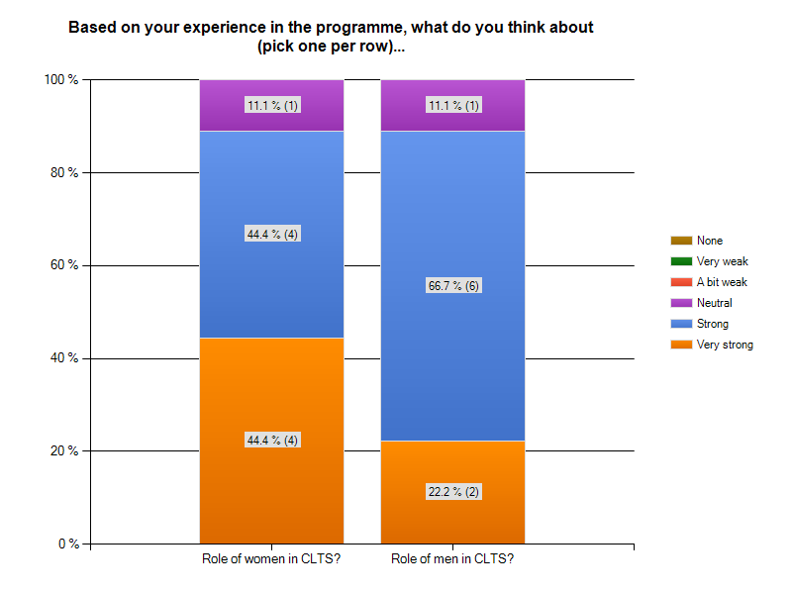
Source: Snel and Jacimovic. 2012.
When asked if the poor and marginalized group benefit from the CLTS programme, there was 100% positive response. In terms of reasons why, more than 77% cited a combination of feeling self-empowerment, lack of open defecation and overall better health (graph 6).

Graph 6 Accumulative overview on if the poor and marginalized group benefit from the CLTS programme
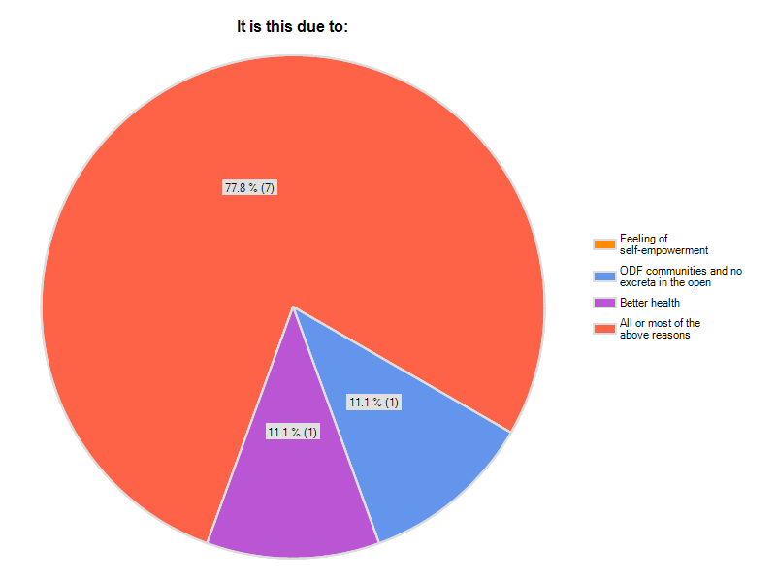

Source: Snel and Jacimovic. 2012.
In terms of the issue of empowerment, over 44% of the respondents stated that over half of the households in the programme would build or upgrade their latrine to other sanitary models. The main reason the respondents considered empowerment was not strong was due to a lack of understanding regarding possible health benefits (graph 7).
Graph 7 Accumulative overview on up gradation of their sanitation facility
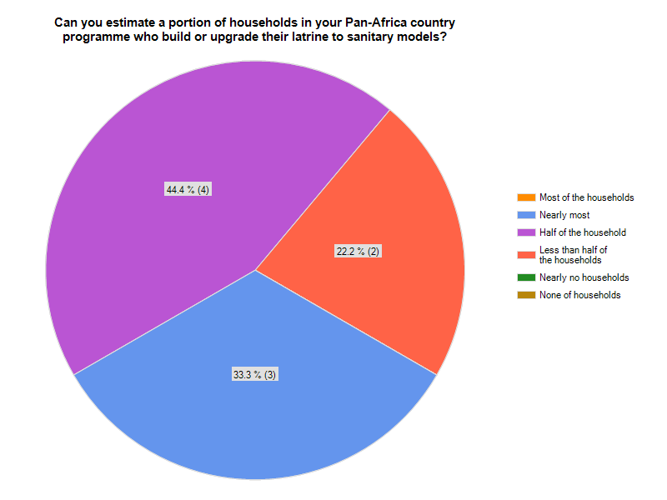

Source: Snel and Jacimovic. 2012.

A final set of questions were asked regarding what the CLTS programme would achieve, with over 66% stating achieving and maintaining ODF, improving the quality of their latrines and undertaking their own monitoring of sanitation conditions and behaviour over time. A total of 22% stated achieving and remaining ODF and around 11% noted that the programme would allow people to undertake their own monitoring on sanitation conditions and behaviour over time. This clearly shows a strong focus on feeling empowered through the Pan-Africa programme (graph 8).
Graph 8 Accumulative overview on what CLTS would achieve
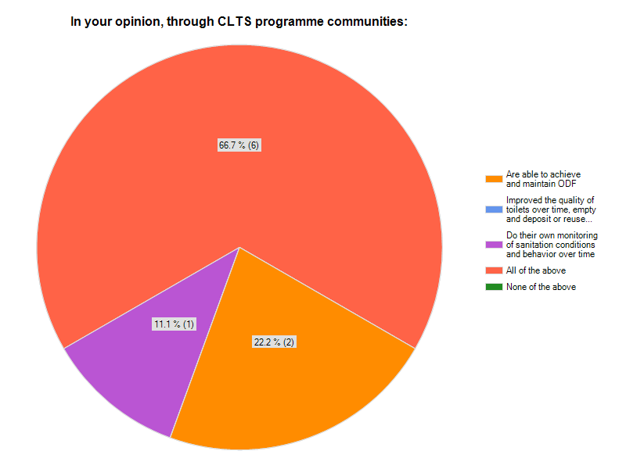
Source: Snel and Jacimovic. 2012.

Conclusions & Future Steps
Based on the outcomes of the survey and discussions with the eight Plan Country Offices, it is clear that CLTS is beyond an approach to sanitation provision. It can become a powerful community empowerment and development tool, which can improve the health and well-being of communities, thereby helping to lift them out of poverty. Within the context of the electronic survey however, it is clear that there are some key issues that need to be addressed in order to make CLTS an effective and sustainable approach. It is also clear from the data that CLTS should be given chances to succeed through further evidence gathering.
This paper confirms that the Pan-Africa programme (or any other CLTS programme for that matter) is not a series of short-term sanitation campaigns. Not only does the Pan-Africa programme aim at achieving Open Defecation Free (ODF) communities, but once this status is attained, it also aspires to sustain this. Evidence-based results of the progress towards ODF communities in large areas and the preservation of the ODF status over time are scarce. This paper therefore provides some initial evidence on key issues that need further work to make the CLTS approach work more effectively.

References
Bongartz, P. 2008. Community led-total sanitation. Global future. No. 1.
Bryce, J., Boschi-Pinto, C., Shibuya, K. & Black, R.E., 2005. WHO Child Health Epidemiology Reference Group. WHO estimates of the causes of death in children. Lancet, 365, pp.1147–52.
Haq, Anowarul and Bode, Brigitta. 2008. ‘Hunger, Subsidies and Process
Facilitation: The Challenges for CLTS’, paper for the conference on CLTS, IDS,
Sussex, December.

Kar, K. and Chambers, R. 2008. Handbook on community-led total sanitation. IDS- Institute of Development Studies IDS. Sussex.
Kar, K. & Pasteur, K., 2005. Subsidy or self-respect? Community-led total sanitation. An update on recent developments. IDS Working Paper 257. Brighton: IDS.
Peal, A., Evans, B., and Voorden, C. van der. 2011. Hygiene and sanitation software : an overview of approaches. Geneva.
Sah, S. & Negussie, A., 2009. Community led total sanitation (CLTS): Addressing the challenges of scale and sustainability in rural Africa. Desalination, 000 (2009), pp.1–8.
Smits, S., Dietvorst, C., Verhoeven, J. & Butterworth, J., 2011. Scanning the 2020 horizon: an analysis of trends and scenarios in the water, sanitation and hygiene sector. (Occasional paper series / IRC ; no. 45). The Hague, The Netherlands, IRC International Water and Sanitation Centre.
Snel, M., and Jacimovic, R. 2012. Survey results on the role of CLTS in the Pan-Africa programme: period 2011-2012. Unpublished paper.
WHO/UNICEF. 2010. Progress on sanitation and drinking-water: 2010 update. WHO/UNICEF Joint Monitoring Programme for Water Supply and Sanitation. Geneva.

Annex 1: Results from the Pan Africa programme survey (October 2011)
Question 1
Which country are you coming from?
Answer Options | Response Percent | Response Count
Kenya | 23.1% | 3
Uganda | 7.7% | 1
Ethiopia | 15.4% | 2
Sierra Leon | 7.7% | 1
Niger | 15.4% | 2
Malawi | 15.4% | 2
Zambia | 15.4% | 2
answered question |  | 13
skipped question |  | 0
Question 2
Would you like to share experiences regarding ...
Answer Options | Response Percent | Response Count
CLTS Approach | 83.3% | 10
SLTS approach | 0.0% | 0
Learning Alliances Approach | 8.3% | 1
Communication Strategy | 8.3% | 1
answered question |  | 12
skipped question |  | 1
Question 3 (open-ended)
You meet some colleagues and want to convince them that the Pan-Africa Programme is worth or not worth being part of. Please write below a short but true example from your experience that you would use for this purpose.

Question 4
Have you been directly involved in the Programme?
Answer Options | Response Percent | Response Count
Yes | 100.0% | 13
No | 0.0% | 0
answered question |  | 13
skipped question |  | 0
Question 5
Based on your experience so far, how would you rate:
Answer Options | very negative |  | negative |  | neutral |  | positive |  | very positive |  |  | Response Count
Programme partners | 0 | 0% | 0 | 0% | 0 | 0% | 10 | 77% | 3 |  | 23% | 13
Plan colleagues involvement | 0 | 0% | 1 | 8% | 0 | 0% | 5 | 38% | 7 |  | 54% | 13
Communication within the project | 0 | 0% | 1 | 8% | 0 | 0% | 7 | 58% | 4 |  | 33% | 12
Networking | 0 | 0% | 0 | 0% | 1 | 8% | 7 | 54% | 5 |  | 38% | 13
Learning opportunities | 0 | 0% | 0 | 0% | 1 | 8% | 8 | 62% | 4 |  | 31% | 13
Exchange of experiences and ideas | 0 | 0% | 0 | 0% | 0 | 0% | 7 | 54% | 6 |  | 46% | 13
answered question |  |  |  |  |  |  |  |  |  |  |  | 13
skipped question |  |  |  |  |  |  |  |  |  |  |  | 0

Question 6
Based on your work experience in the Pan-Africa Programme so far, how would you rate the following challenges in the pre-triggering phase?
Answer Options | not relevant | less relevant | neutral | relevant | very relevant | Rating Average | Response Count
Lack of government support | 1 | 0 | 4 | 6 | 2 | 3.62 | 13
Lack of inter-sectoral communication within government | 2 | 1 | 3 | 5 | 2 | 3.31 | 13
Management at Plan office: high turnover | 3 | 3 | 4 | 3 | 0 | 2.54 | 13
Management at Plan office: only one person managing project | 3 | 1 | 5 | 1 | 3 | 3.00 | 13
Other (please specify) | 1 | 0 | 1 | 0 | 2 | NA | 4
answered question |  |  |  |  |  |  | 13
skipped question |  |  |  |  |  |  | 0
Question 7 & 8
Based on your work experience in the Pan-Africa Programme so far, how would you rate the following challenges in the triggering phase?
Answer Options | not relevant | less relevant | neutral | relevant | very relevant | Rating Average | Response Count
False enthusiasm | 2 | 3 | 2 | 3 | 3 | 3.15 | 13
Lack of creating real ownership in the programme | 4 | 1 | 1 | 4 | 3 | 3.08 | 13
Poor quality of trigger training | 4 | 1 | 2 | 4 | 2 | 2.92 | 13
Mixed approaches used in the programme | 4 | 1 | 2 | 5 | 1 | 2.85 | 13
Lack of resources for undertaking CLTS | 4 | 1 | 0 | 6 | 2 | 3.08 | 13
Other (please specify) | 0 | 0 | 0 | 1 | 0 | 4.00 | 1
answered question |  |  |  |  |  |  | 13
skipped question |  |  |  |  |  |  | 0

Question 10
Can you please propose possible solutions for the most relevant challenge above?
Based on your work experience in the Pan-Africa Programme so far, how would you rate the following challenges in the post-triggering phase?
Answer Options | not relevant | less relevant | neutral | relevant | very relevant | Rating Average | Response Count
Quality assurance issue | 1 | 1 | 3 | 5 | 3 | 3.62 | 13
Maintaining ODF | 0 | 0 | 2 | 5 | 6 | 4.31 | 13
Limited capacity of partners to follow up CLTS process | 0 | 3 | 2 | 4 | 4 | 3.69 | 13
Lack of budget to reflect on maintenance of ODF | 1 | 1 | 2 | 7 | 2 | 3.62 | 13
Lack of quality of latrine construction | 1 | 2 | 3 | 6 | 1 | 3.31 | 13
answered question |  |  |  |  |  |  | 13
skipped question |  |  |  |  |  |  | 0
Question 11 & 12
Can you please propose possible solutions for the most relevant challenge above?
Would you say that there is false sense of enthusiasm about the Programme?
Answer Options | Response Percent | Response Count
Yes | 7.7% | 1
No | 92.3% | 12
answered question |  | 13
skipped question |  | 0

Annex 2: Results on post-trigger from the Pan-Africa Programme per country

Ethiopia (2011)
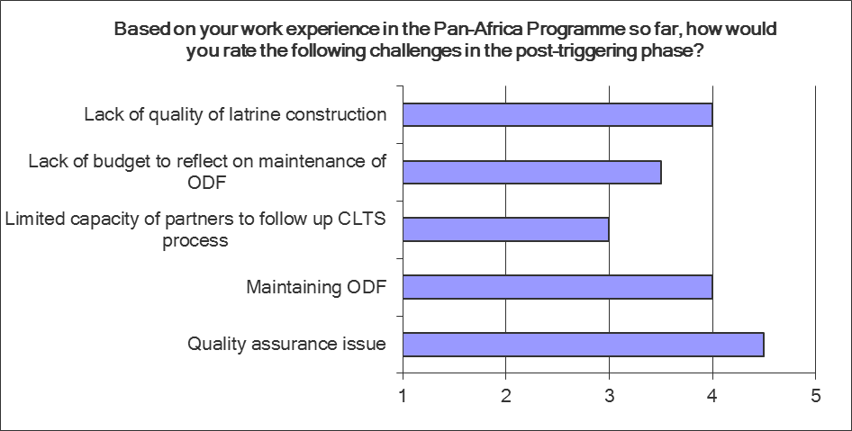
Ethiopia (2012)
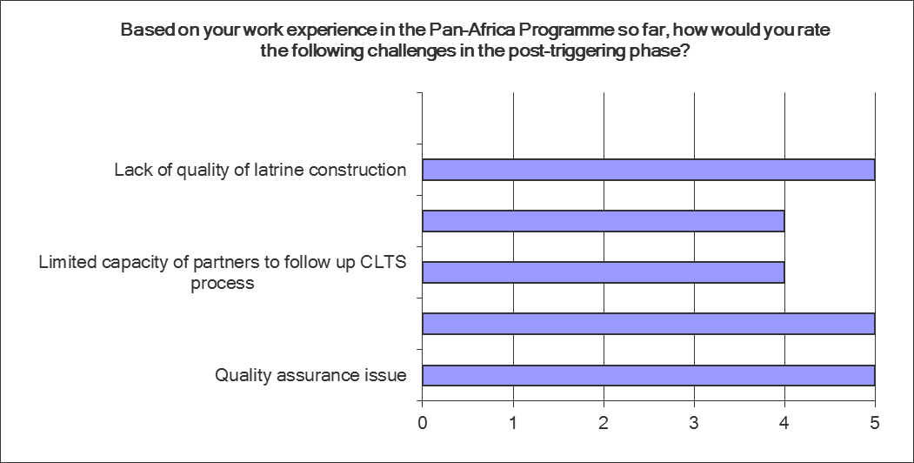

Kenya (2011)
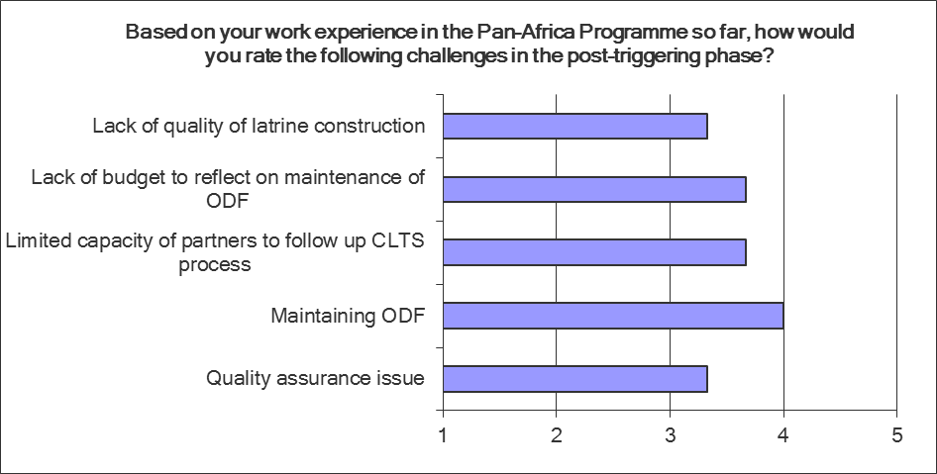
Kenya (2012)
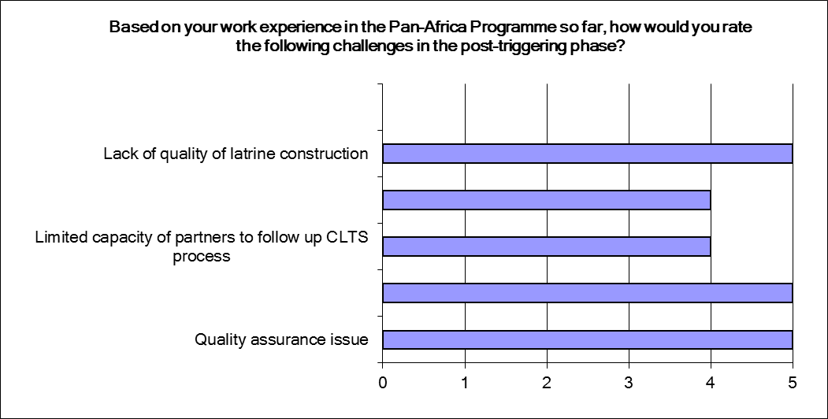
Malawi (2011)
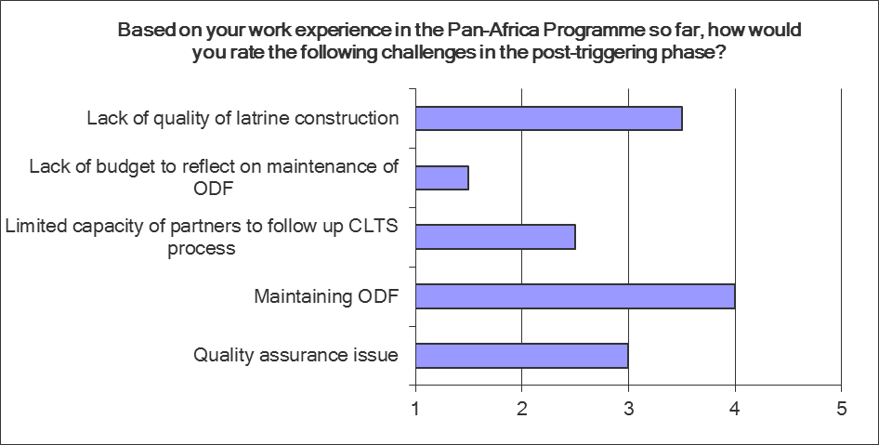
Malawi (2012)
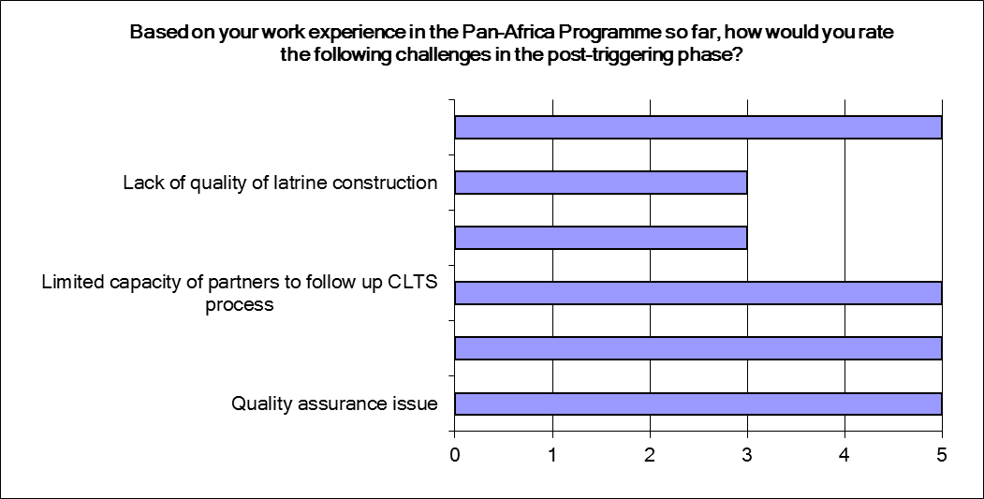

Niger 2011
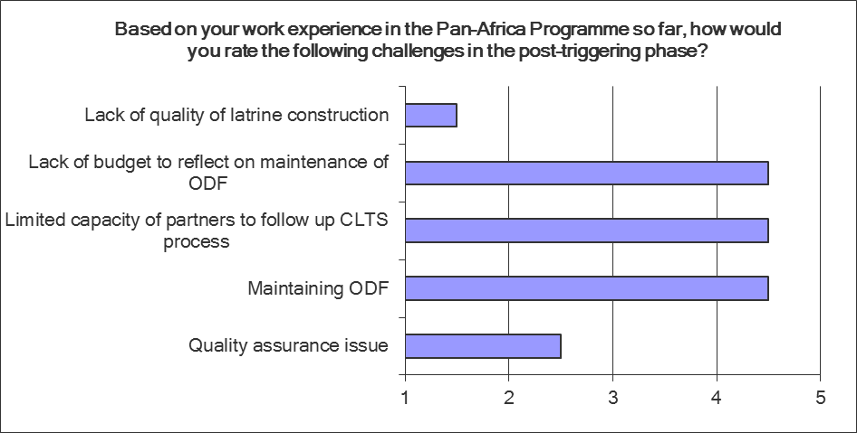

Niger (2012)
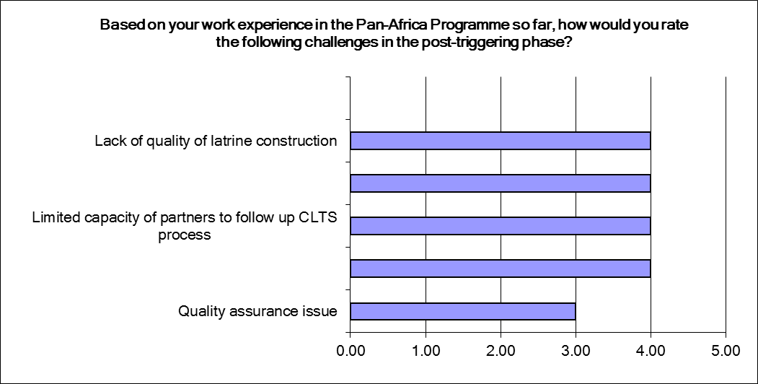

Sierra Leone (2011)
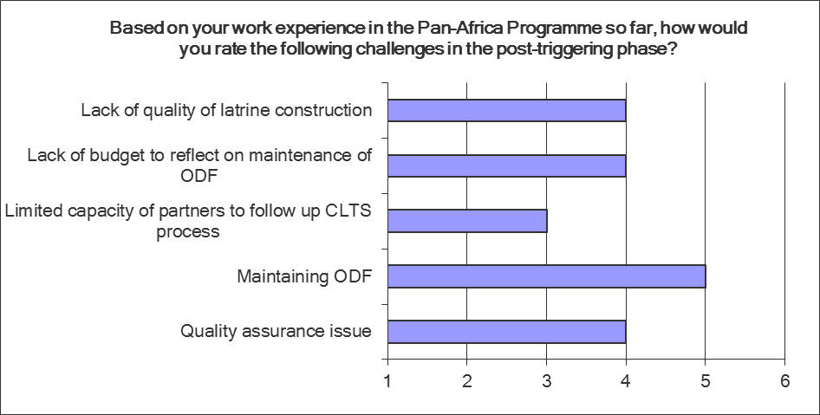
Sierra Leone (2012)
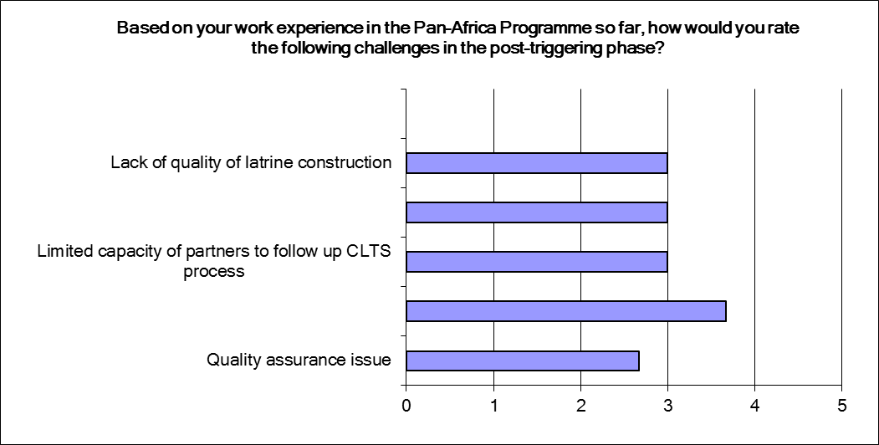
Uganda (2011)
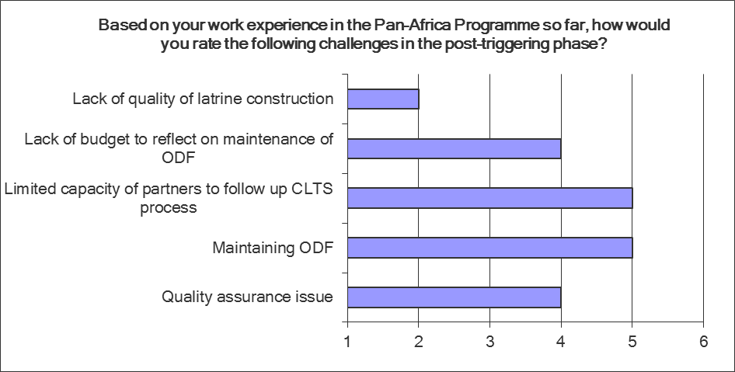
Uganda (2012)
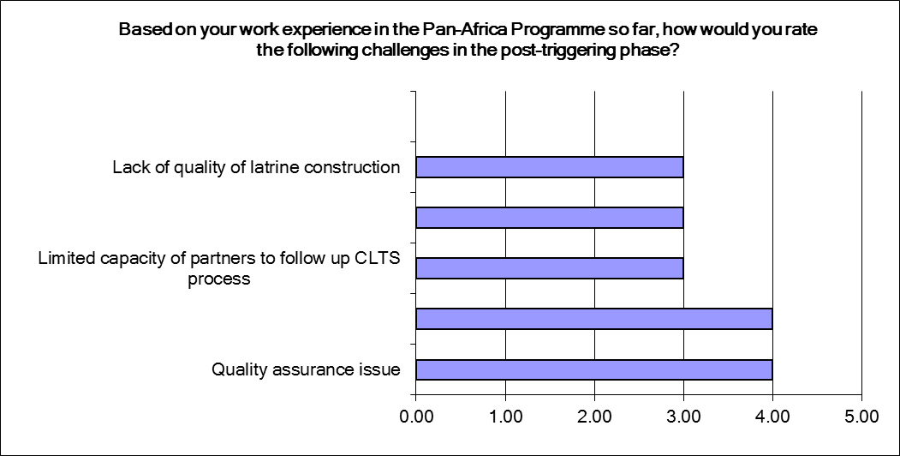

Zambia (2011)
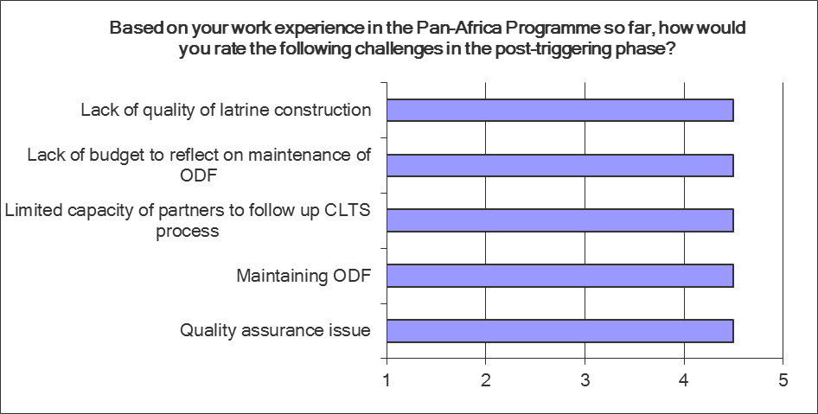

Zambia (2012)
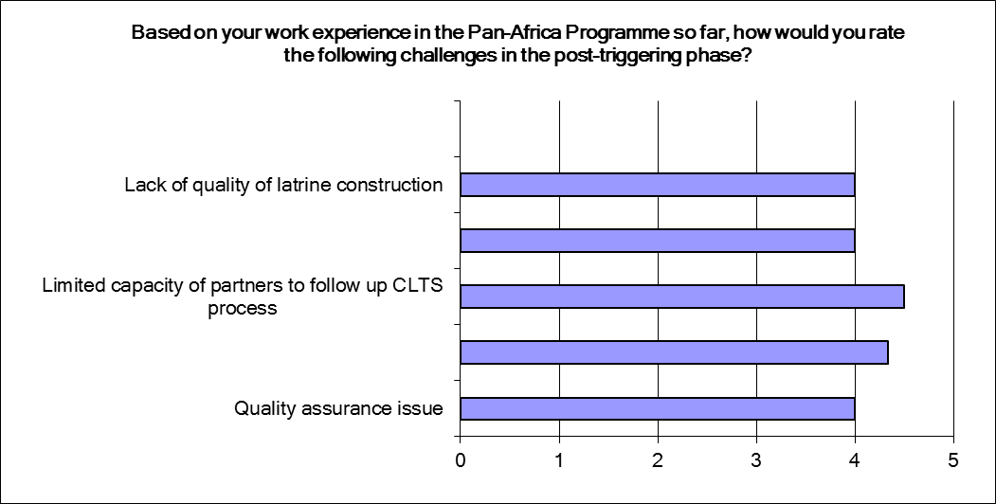

Annex 3: Taking Community Led Total Sanitation to scale with quality
An Executive Summary of the Lukenya Meeting convened by IDS, July 2011
This document is a summary of the key recommendations from the IDS meeting of CLTS practitioners held in Lukenya Nairobi in July 2011, immediately after the AfricaSan3 meeting. The aim of the workshop was to focus on the key challenges we all face in taking CLTS to scale. In this context, seven focus areas were collectively chosen to concentrate our debate. This document provides an overview of the recommendations made in each section – the examples, discussion and more details can be found in the full report (http://www.communityledtotalsanitation.org/resource/lukenya-notes-taking-clts-scale-quality ).
1. Institutional support for scaling up CLTS
- Creation and ‘enforcement’ of a national policy for sanitation and hygiene with clear guidelines for implementers and donors.
- Agree upon outcomes and goals for the country in terms of CLTS, sanitation and hygiene: disseminate to all stakeholders to increase coordination.
- Establish a national coordination unit to oversee all sanitation and hygiene activities
- Strike a balance between the need to aim high in order to achieve the MDG targets and the realism of what is feasible.
- Recognise and reward honest reporting of shortfalls and achievements.
- Include CLTS activities in job descriptions and performance contracts of relevant government staff at all levels.
- Make political leaders accountable for effective support for CLTS.
- Provide management capacity building/coaching for CLTS managers at all levels.
- Advocacy needs to be strengthened for government officials to convince the relevant and decisive officials to be champions of CLTS.
- District level staff including extension workers, NGOs and decentralised structures to work together to make sanitation and hygiene part of their daily activities.
- Increase government allocation of resources for sanitation and hygiene in order to aim to meet the MDG targets.

2. CLTS training, triggering and follow-up
- Hold a sanitation stakeholders’ workshop to review the capacity of each stakeholder to implement CLTS, fill in any gaps and map out areas of work for each to facilitate scaling up.
- Encouraging governments to embrace CLTS and adopt it as a national sanitation strategy gives the approach the necessary legitimacy that is conducive for scaling up triggering.
- Only train CLTS facilitators if there is an immediate plan to enable them to carry out the work for which they have been trained.
- Ensure that all training includes hands-on practice in real time in communities.
- Natural leaders and other CLTS facilitators should be passionate and committed about their work. They should be able to demonstrate that they practice what they advocate.
- Key trainers need to have track records of triggered communities becoming ODF.

3. Strategies for ODF verification at scale
- Plan ahead anticipating the need to go to scale with verification, including financial and human resources.
- Prefer third party verifiers, train and monitor, and reward for impartial thoroughness.
- Encourage community involvement as part of the learning process. Whether failing or passing, make verifications positive experiences, looking to pride, self-respect and sustainability.
- Do not treat verification as a one-off but part of a continuing process.
- Probe very high overall rates of communities passing or failing in the country (over 70 per cent).
- Use celebrations after verification to build community pride and confidence, and to encourage others. Masons and others may use the occasion to promote improvements.
- Recognise that in going to scale, communities may increasingly have to organise their own celebrations with less outside involvement - provide encouragement and support.

4. Governments, funding agencies and CLTS
- Governments and funding agencies should be alert to new subsidy-driven projects and decisive in intervening to prevent or reverse any such commitments to household hardware subsidy, and to be proactive in developing proposals to take to funding agencies.
- Investment plans should be clear about commitment to CLTS, and the dialogue could further consider how to convert former budgets for hardware to staff-intensive software support.
- Governments can arm themselves with policies, evidence and champions to defend their strategies to banks and donors and help them in turn to change their policies and practices.
- Enable key policy-makers to experience CLTS for themselves in the field, visiting and listening to ODF communities, and being present at triggerings.
- Recognise problems of contrasting approaches between Ministries. An interagency coordination involving all major stakeholders can provide a forum for national policy to be discussed and joint agreements be worked out.
- Recognition that CLTS requires substantial funding, estimating multi-year requirements and working out how best these can be met.
- Sensitive awareness on both Government and funding agency sides of the need for government ownership.
- Banks, donors and governments to be sensitive to field realities and the need to assure and seek feedback on the timely arrival of funds at the local level.
- Urgent discussions about cost-effective ways of peer sharing and learning between governments. Promote exchange learning visits where promising practices are identified.
- One or more workshops at appropriate levels for mutual learning, brainstorming, documenting, and identifying priorities for moving forward.

5. Pro-poor sanitation marketing and sustainability beyond ODF
- With CLTS, behaviour change has taken place – trust communities to maintain ODF and to upgrade their latrines as required
- Support this social norm change through communication campaigns and the availability of low-cost sanitation improvement options in the local market
- Undertake formative research and supply chain assessment to identify financially viable pro-poor sanitation marketing strategies – ideally participative with natural leaders/masons to have a full understanding of the various technology options already being promoted.
- Market research should begin before demand creation through CLTS, to allow time for the market capacity to be developed.
- Sequence so that promotion and selling are not combined with CLTS triggering.
- Put in place a continuous follow-up mechanism to support sustained behavioural change and sanitation and hygiene improvements beyond ODF.
- Recognise that scaling up with marketing is likely to require financing mechanisms for both providers and consumers.

6. Monitoring, Evaluation, Learning and Information Management Systems
- Monitor input and outcome indicators for CLTS. Institutionalise regular reporting at all levels – sub-district, district and national.
- Monitor the duration between triggering and ODF. Where the gap between triggered and verified becomes wide, investigate the reasons and take remedial action.
- Further health and livelihood impact studies are needed for the evidence base, and the development of specific health and livelihood monitoring indicators.
- Invest in innovative research methodologies and participatory approaches to gather evidence at lower cost, while scaling up learning by stakeholders about what works.
- For monitoring hand washing with soap: try surveys with soap vendors reviewing sales before and after triggering.
- An international workshop is proposed in Africa to share and compare M&E systems for CLTS, innovations and experiences.

7. Emerging issues and scaling up CLTS into different contexts
a) Equity
- Issues of equity and access to be considered in every context and activity – in all stages of the CLTS approach.
- Accessible and convenient toilet designs for those who are disabled could emerge from participatory processes which can also heighten awareness.
- Special initiatives to offset or eliminate vulnerabilities and meet the needs of those at risk, especially women and girls.

b) Urban CLTS
- Strategically use a Rights Based Framework and Government and municipal by-laws to support claims for services such as connections to sewers. Build on already existing public health instruments and human settlement laws.
- Create an enabling environment with all the many different stakeholders involved, and convene meetings and facilitate exchanges and negotiations.
- Create a sense of awareness to ensure that citizens know their rights so they can claim them.
- Cluster or subdivide specific urban/peri-urban areas to reach ODF, as far as possible where there is a degree of community coherence.
- Mobilise and encourage youth groups to become involved (e.g. Muthare).
- Urban CLTS is a tough nut to crack: we need to share experiences to improve our approaches.

c) Emergencies
- Be bold in seeking to introduce CLTS in a range of conditions - document and compare the experiences.
- Learn from current practices and experiences with participation and self-help by affected populations.
- Strive for rapid and accurate learning about types of conditions and key parameters and develop a typology of situations which can be used prescriptively.
- Assess the requirements for going to scale in displacement conditions.

d) Nomadic populations
- Gain experience with CLTS where nomads have settled in communities where some spend all or most of their time, while others return seasonally.
- Use media, especially radio, to communicate with nomadic populations.
- In CLTS follow up and triggering in places where passers-by, or migrants practise OD, encourage the practice of maintaining roadside or other latrines.
- Make it clear that shallow trenches and the cat method, may often be the best feasible solution, and can be acceptable and hygienic where other options are not realistic.

Annex 4: CLTS debate at IRC (in IRC synergy week Oct. 2011)
Debate: Should CLTS be implemented in its purest form?
One of the interesting and innovative sessions during the IRC synergy week was a debate on the Community-Led Total Sanitation (CLTS) titled: ‘CLTS should be implemented in its purest form’.
Community-Led Total Sanitation (CLTS) focuses on igniting a change in sanitation behaviour rather than constructing toilets. It does this through a process of social awakening that is stimulated by facilitators from within or outside the community. It concentrates on the whole community rather than on individual behaviours. Collective benefit from stopping open defecation (OD) can encourage a more cooperative approach. People decide together how they will create a clean and hygienic environment that benefits everyone. Ref: Kamal Kar with R. Chambers, 2008.
Participants were divided into four groups: a group arguing in favour of the motion, a group against the motion, judges that have to come to a verdict and the audience that can vote at the end.
The rules for the debate were as follows:
- Groups were given two short rounds each to argue.
- Five minutes for preparation at both sides.
- Five minutes for both sides in round one to argue out their petition (three minutes for main points and two for additional points).
- Two minutes recession to prepare for final argument.
- Four minutes for round two i.e. each side had two minutes for main points and two for minor points.
Arguments
Very interesting arguments were raised by both groups.
Points raised for the motion | Points raised against the motion
- CLTS is suitable in all cultures.  - It is beneficial to the local communities.  - It is a powerful tool for promoting good sanitation.  - The Community is kept active during the process. | - Community members have a lot of pride and cannot stand being shamed.  - On the issue of sustainability, the technical aspect is not clear.  - Community health clubs are the best approach because it builds on the culture.  - You cannot eradicate open defecation only without addressing the other issues.

The group arguing against CLTS in its purest form based their plea on culture and sustainability issues that are hampering CLTS. This group supported their arguments with a number of examples from Africa and Asia.
Verdict
Before the verdict, the judges observed that:

- There was little evidence from both groups in terms of studies and theories.
- Why CLTS is different from other approaches was not clearly made
- The issue of shame was not fully answered by the group arguing for CLTS.

Visiting address
Bezuidenhoutseweg 2
2594 AV The Hague
The Netherlands

Postal address
P.O. Box 82327
2508 EH The Hague
The Netherlands

T +31 70 3044000
info@ircwash.org
www.ircwash.org

Learning alliances are a series of connected stakeholder platforms, created at key institutional levels (typically national, intermediate and local/community) and designed to break down barriers to both horizontal and vertical information sharing and thus to speed up the process of identification, development and uptake of innovation. Each platform is intended to group together a range of partners with complementary capabilities in such areas as implementation, regulation, policy and legislation, research and learning and documentation and dissemination.
Action learning is an approach to solving real problems that involves taking action and reflecting upon the results. The learning that results helps improve the problem-solving process as well as the solutions the team develops.
The discussion on challenges took place in the learning alliance workshop held in the beginning of September in Kampala, Uganda. For those country teams that were not there, their responses were sent per e-mail.
Executive summary compiled by J Bevan (UNICEF WCARO) with review by Jolly-Ann Maulit (EWB, Malawi), September 2011. For further information see the IDS website: http://www.communityledtotalsanitation.org/

