PRESS RELEASE


Wetlands International commits to reduce water scarcity by restoring wetlands during Clinton Global Initiative Annual Meeting 2015
Global NGO with head office in The Netherlands, calls for ecosystem approach to tackle growing water risks

From Saturday 26 till Tuesday 29 September the 2015 Clinton Global Initiative (CGI) Annual Meeting is taking place in New York. On Monday, September 28 Jane Madgwick, CEO of Wetlands International, a CGI member, spoke about one of the central themes ‘Water Scarcity’. With 20 percent of the world’s GDP and 36 percent of the global population located in severely water stressed areas, the growing demand and competition for freshwater will be one of the biggest global challenges we face. She emphasizes that wetland ecosystems are essential for storing and regulating water and the continuing loss and degradation of wetlands is a strong driver of increasing water risks.
Reaching the Sustainable Development Goals (decided during the UN Sustainable Development Summit 2015), will depend on reversing the current trend of loss and degradation of ecosystems – and especially wetlands. She calls to action businesses, governments and civil society to reinstate wetlands as key, natural infrastructure that will help enable equitable access to clean water, reduce the risks of floods and droughts, plus reverse land degradation and meet future food needs.
Wetlands International is announcing a new CGI Commitment to Action to reshape policies, investments and practices in three highly vulnerable watersheds in Kenya and Uganda. Demonstrating an ecosystem approach to increase water security and community resilience, the intention is to attract interest of global leaders and to stimulate replication and scaling up of the approach elsewhere. The commitment will be featured as an exemplary approach to addressing critical challenges during the session on Climate Change and Resiliency: Redefining Business as Usual, also on Monday September 28.
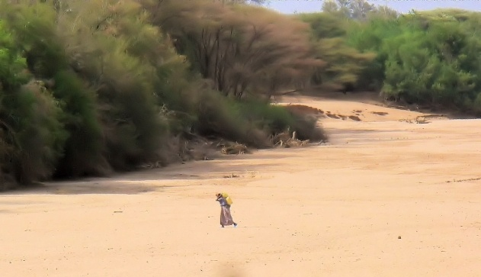

Water Scarcity: from the Wetlands to the Water Glass
We all depend on water and yet we use it, waste it and degrade it without realizing its true value. The question of how best to manage water risks is high on the agenda of businesses. Water scarcity is set to intensify over the coming decade while the risks of devastating floods are also increasing. Climate change will add to the severity of the impacts. Joined up approaches between the public, private, and nonprofit sectors are urgently needed to design and implement solutions.
Drawing on the experience of Wetlands International, Jane will engage will engage with CGI members to discuss how to
- connect public, private and nonprofit actors spanning the life cycle of water use,
- improve industrial and agricultural water use to ensure clean water for communities, and
- invest in solutions that incentivize ecosystem conservation and access for all.

Water secure, resilient communities in Kenya and Uganda
According to the World Health Organization, in Kenya and Uganda about one-third of the population lack access to clean water and two-thirds lack proper sanitation. Working here in three vulnerable watersheds, Wetlands International, through a new CGI Commitment to Action, will empower civil society to engage with governments and the private sector and stimulate informed choices for equitable water sharing, land use and infrastructure development. Tools such as mapping wetland functions and values across watersheds and undertaking risk screening of investment plans, are applied, as well as ensuring that vulnerable groups, such as downstream communities, and women, are given voice. The benefits of better watershed management will impact the lives of thousands, safeguarding water supplies and reducing disaster risks. The estimated investment of the commitment is 2.5 million US dollars.
Wetlands International is supported in this commitment by two new multi-year, multi-million Strategic Partnerships with the Dutch Ministry of Foreign Affairs: Partners for Resilience, led by the Netherlands Red Cross, also with the Red Cross Climate Centre, Cordaid, CARE Netherlands, and many Kenyan and Uganda partners, and WASH IT!, led by IRC, joined by SIMAVI, AKVO, and a wide range of local and regional partners.
Wetlands International at the Clinton Global Initiative 2015 Annual Meeting
Wetlands International has been a member of CGI for five years in a row (since 2011). During this time we have made three Commitments to Action: ‘Securing Wetlands Carbon Stores for Climate, which seeks to conserve and restore global peatlands. Our second commitment (2014) ‘Restoring Vulnerable Coasts for Economic and Ecosystem Value’, was made in response to the continuing vulnerability of communities in Aceh ten years after the Asian tsunami. Now we announce ‘Water secure, resilient communities in Kenya and Uganda’. Two of these three commitments have been selected as exemplary approaches to tackling these important global issues.
About Wetlands International (no translation needed, already approved and no reference to CGI)
Wetlands International, gevestigd in Ede, is een NGO die zich al sinds 1937 inzet om wetlands en haar functies en biodiversiteit te behouden en te herstellen voor mens en natuur. Wetlands mogen geen bijzaak zijn. Deze prachtige natuurgebieden spelen een uitermate belangrijke rol bij het voorkomen van natuurrampen zoals overstromingen en droogtes. Maar nog steeds zijn wetlands één van de verborgen succesfactoren als het gaat om enorme issues en rampen (water, voeding, klimaat en handel) te voorkomen. En dat terwijl een derde van Nederland uit wetlands bestaat. Voorbeelden zijn de Biesbos, Waddenzee en de Zeeuwse delta (o.a. Grevelingen en Oosterschelde). Veel kennis en expertise over de ontwikkeling van wetlands komt uit Nederland. Nederlandse specialisten zorgen dat deze kennis wereldwijd gedeeld wordt. More information on wetlands.org.
About the Clinton Global Initiative
Established in 2005 by President Bill Clinton, the Clinton Global Initiative (CGI), an initiative of the Clinton Foundation, convenes global leaders to create and implement solutions to the world's most pressing challenges. CGI Annual Meetings have brought together 190 sitting and former heads of state, more than 20 Nobel Prize laureates, and hundreds of leading CEOs, heads of foundations and NGOs, major philanthropists, and members of the media. To date, members of the CGI community have made more than 3,200 Commitments to Action, which have improved the lives of over 430 million people in more than 180 countries. The central theme of the Annual Meeting of 2015 is ‘The future of impact’.
For more information, visit clintonglobalinitiative.org and follow Twitter @ClintonGlobal and Facebook at facebook.com/clintonglobalinitiative.

Editorial note, not for publication
For further information and interviews with Jane Madgwick, please contact:
SiS.PR
Inge Baars
T: 010 240 00 03 /06 21 86 51 37
E: inge@sispr.nl

